**Bear Break-ins in Pointe au Baril 2025**

By Scott Weir

We had a bear break-in at Barronsbrae (1550 Georgian Bay Water – north shore of main channel near Poplar Island). The break-in likely occurred on the night of June 24th when we were away. Apparently bears move about from dusk to dawn, and we’ve been hearing that this bear has been visiting our neighbours’ cottages at around midnight. After fending the bear off from their cottage next door, our fantastic neighbours checked on our place the next day and found the screen out and one of our doors bashed open with a trail of honey, peanut butter and ice cream on the deck.

While growing up we had occasional “bear summers” in Muskoka, and I remember my mother banging pots on a few occasions to scare them away from the kitchen door, as well as gradually changing our practices to no longer storing garbage in the shed and clearing away food scraps from outdoor areas as quickly as possible.

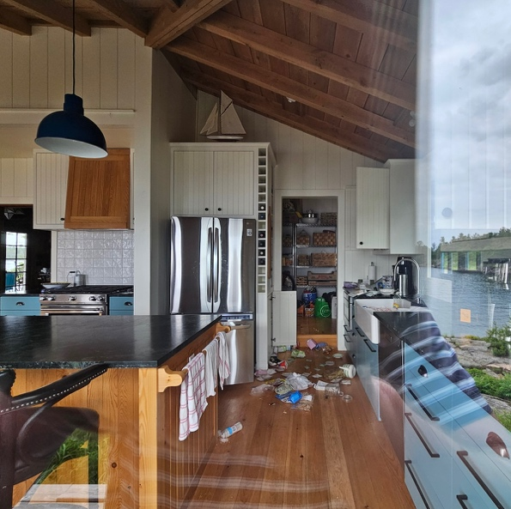In our case this June, the bear was precise and looked like it knew roughly where to go in the cottage, going directly to two kitchen cupboards that each had peanut butter, honey or snacks, clearing out our Tupperware of cookies and crackers, and rooting through the freezer drawer for ice cream, butter and hamburgers. It knew how to open the freezer drawer and cupboard doors and reach shelves up to about a 6’ height, getting what it wanted and leaving. It ignored the vacuum-packed meat in the same freezer drawer yet didn’t open the fridge. It opened and ignored cabinets of dishes and smelled bottles of vinegars etc. but left them alone. Other than damaging the door it came in and knocking some things out of the cupboards, we have little damage; and it appears to have not ventured into other parts of the cottage. However, this isn’t the case in other cottages where a lot of damage has been done. And so far, we have had just one visit, but other cottages have had three break-ins in a short period of time.

We have since heard that from fall of 2024 to spring of 2025 there have been many bear break-ins at Pointe au Baril. Break-ins on Oberlin Bay, Ojibway Island, Mud Channel, Shawanaga (both shores), The Wreck, Sturgeon Bay, Champlain Monument Island and the Main Channel indicates a wide spread of break-ins over a short period of time. This is concerning, as it indicates that the bear now views cottages as being a primary source of food, transitioning it to being what the MNR calls a ‘nuisance bear’. And apparently, it is unusual for bears to break into cottages, so this is likely one bear or family group who have developed a taste for peanut butter, ice cream, Cumbrae’s sausages, and Summerhill snacks. The bears have smashed windows, opened lever handled sliding doors and are not afraid of approaching cottages with people in them. I haven’t heard any reports of attacks on humans or pets so far but have heard about many rummaged kitchens.

We reported the break-in to MNR (contact info below) and would recommend that everyone who has been broken into report the incident. Huge thanks to Graeme and John Bate who notified us about the break in and to Dave Ballentine who secured the perimeter for us. We repaired the damage as soon as was possible and are rethinking our lock up approach to certain more vulnerable windows and doors. We had an easy re-entry upon our return compared to a lot of people.

On the mainland, MNR will trap a nuisance bear and take it away, but they will not do this in water access locations. It is legal to use lethal means against a bear in defence of human life or property damage but that generally necessitates that one knows how to shoot well. To a certain extent we are on our own, but you can make your cottage less appealing to the bear, and more reports in the Archipelago might add some urgency to the MNR’s response approach. MNR recommended a few things:

1. If a bear is entering your cottage, **blow loud whistles/make loud sounds/shine bright lights,** then **call 911**. (This will record the incident but will not bring MNR out to the islands.) Prioritize your safety and bring your pets and children inside to somewhere secure. The bear will likely want to escape – don’t get between it and the exit. Try not to interact with it any more than you must to scare it off.
2. **Register your address** with Ministry of Natural Resources (MNR) on the report line if your place has been entered or there was an entry attempt. “Bear Wise” report line is 1-866-514-2327 or TTY 705-945-7641. Their page about bear encounters is [**here**](https://www.ontario.ca/page/prevent-bear-encounters-bear-wise)**.**
3. PABIA would also like to **make a map** for MNR **of bear break-ins or attempted break-ins last fall and this year** - if you’ve had one recently and don’t mind sharing the info then please send to [**PaBIA**](http://contact.pabia@gmail.com) these 5 pieces of information: your (1) property address, the (2) day/month/year that you think the break in occurred, your (3) email address, 4) make note of anything you noticed about the break-in (like did they beeline toward the peanut butter, composter or other food items with scent?) and (5) do you use a garburator or FoodCycler or the like: Yes or No. PaBIA will put together a map pinning just the locations of the bear(s)’s trails to be shared with everyone.
4. A can of insect repellent and a can of insect repellent

   AI-generated content may be incorrect.Keep **bear spray** on hand and know how to use it. Keep them in different places in the cottage (*but maybe don’t store them with the sunscreen sprays!).* Show your guests how to use it and keep it away from young kids – it is quite toxic. Note that it is intended for use outdoors – the last thing you want is an upset disoriented maced bear panicking in your kitchen.
5. **Keep loud whistles, air horns and strong flashlight on hand** – bears don’t like loud noises or bright lights. You might want to have one for each bedroom. Pointe au Baril’s CCY sells them as do all the major hardware stores in Parry Sound.
6. A green surface with nails sticking out of it

   AI-generated content may be incorrect.A blue door with green shutters

   AI-generated content may be incorrect.For the next level of security for vulnerable openings while you are away, **make a bear-board** – 4x4’ sheet of plywood that you either nail or screw through in a 2” grid, that you leave with points facing upward under the door or window that the bear might have come through, or you think is vulnerable. Anchor it with a block or screw it down so it can’t be pushed out of the way. Make sure that everyone knows where it is and to avoid it – they look like a medieval torture device and are dangerous in their own right.
7. **Motion-activated lights** can apparently be helpful. Until this is cleared up, we’re also planning to leave low lights on in the kitchen in case we hear something and need to see what is happening. *Some have suggested that bears don’t like heavy metal music, but then neither do I so this won’t be the tip that saves our bacon...*
8. **Check the security of your locks and latches.** If a bear really wants to get in then it will, but if you make things difficult for them then there is a better chance that it will move on to an easier location. If you have sliding glass doors, put an angled pole between the frame and door so the door cannot slide open.
9. **You might want to remove or consider:**

* Food items like peanut butter that have an appealing scent when you leave the area
* Layers of containment like vacuum sealing freezer meats.
* Bird feeders (a full bird feeder can hold 30,000 calories which attracts a hungry bear), and
* Removing garbage from your site.

1. We’ve also heard that if you have already been broken into and fear them coming back, that **mixing a pound of hamburger with a large bottle of cayenne pepper** and putting it out behind your cottage will make your cottage less appealing. (*story in the eBlast*).
2. **Check in with your neighbours** – this is a great community of people ready to help if needed and you’re not alone.

Good luck out there!