Ontario Birds - Raven or Crow
(Click on the name of the bird below to listen to one of its calls.)

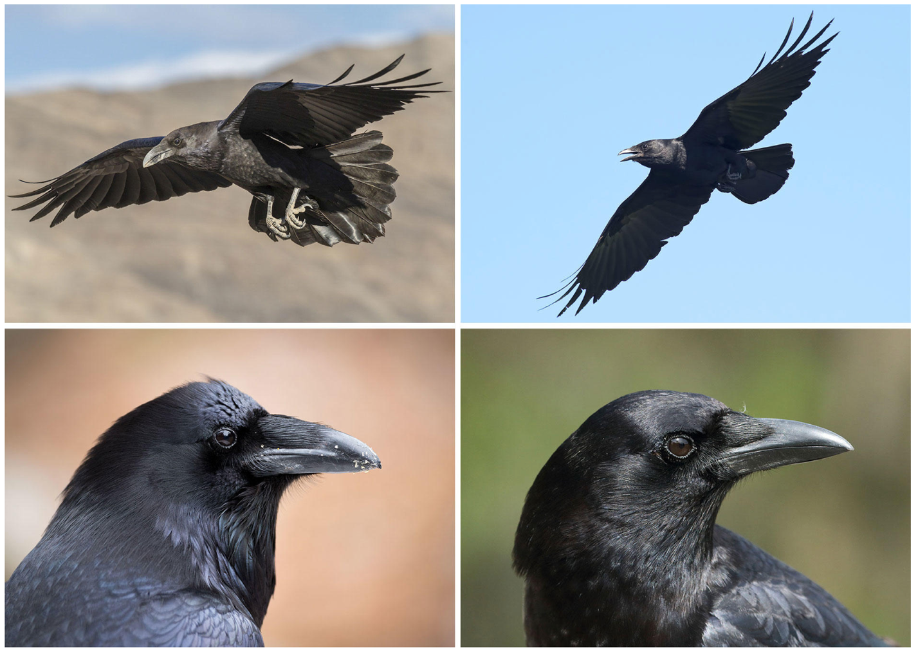

The Raven is on the Left and the Crow is on the right!

Is it a crow or a raven flying overhead?

The two species, Common Ravens and American Crows, overlap widely throughout North America, and they look quite similar. But how can you tell them apart?

Size:
Ravens are larger, the size of a Red-tailed Hawk and often travel in pairs.
Crows are seen in larger groups.

Tail:
The crow has tail feathers are basically the same length, so when the bird spreads its tail, it opens like a fan.
Ravens, however, have longer middle feathers in their tails, so their tail appears wedge-shaped when open.

Calls:
Crows give a cawing sound.
Ravens produce a lower croaking sound.

In flight:
Ravens ride the thermals and soar,
Crows do more flapping.

Beaks & Bristles & Throat Feathers:
Ravens have bigger, curvier beaks and although both have bristles at the base of the beak, the raven's are noticeably longer. Its throat feathers are also quite shaggy.

Location:
Common Ravens are much less common than American Crows in Eastern North America.
Taken from Birdnote.

