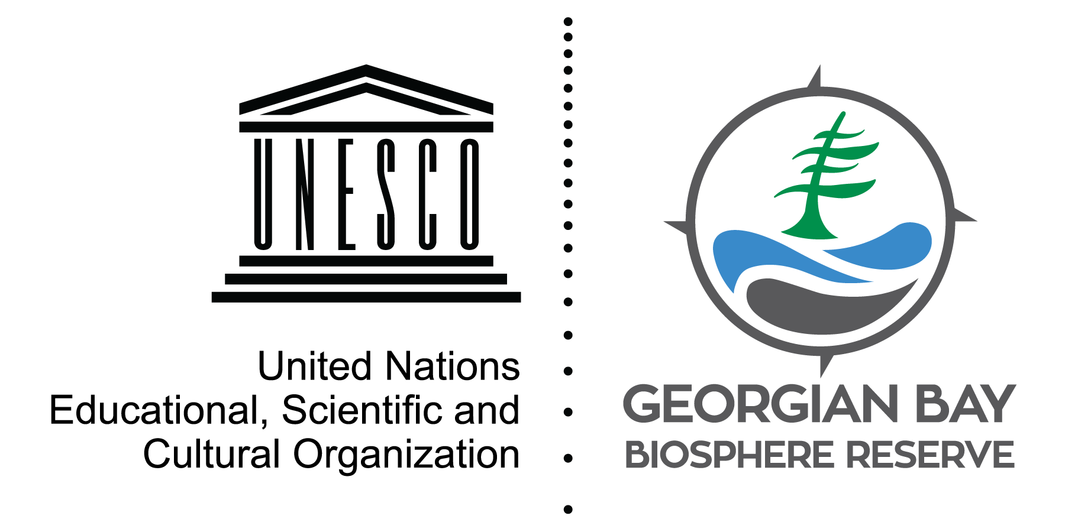
State of the Bay: Water Quality

Many of us love hearing the call of a loon or seeing a majestic bald eagle. These species are at the top of the food chain, relying on a healthy diet of fish. But what feeds the fish that they eat?

At the bottom there are the producers, the algae and microscopic plants that use nutrients and sunlight to grow. The next level is made up of consumers, zooplankton and benthic organisms that eat phytoplankton.

Sadly, decades of research have shown that species in the lower food web of Lake Huron have all been declining. Phytoplankton levels have significantly decreased, possibly because of low nutrient levels in some offshore areas, invasions by zebra and quagga mussels, and warming water temperatures. Zooplankton has seen declines of up to 95% over the past 20 years.

The population of Diporeia, a freshwater shrimp-like crustacean, and major food source for small fish, has completely collapsed today after declining since the 1990s. As a result, in 2003 and 2005, the alewife, and chinook salmon populations collapsed.

Are invasive species, combined with climate change, creating a biological desert on the bottom of Georgian Bay? What will be the effects on species higher in the food web?
Check out the State of the Bay magazine!
David Bywater is the State of the Bay Project Manager for the Georgian Bay Biosphere Reserve, a not-for-profit dedicated to environmental and community well-being. He can be reached at conservation@gbbr.ca

Water quality monitoring shows current (green) and recommended (red) sites
