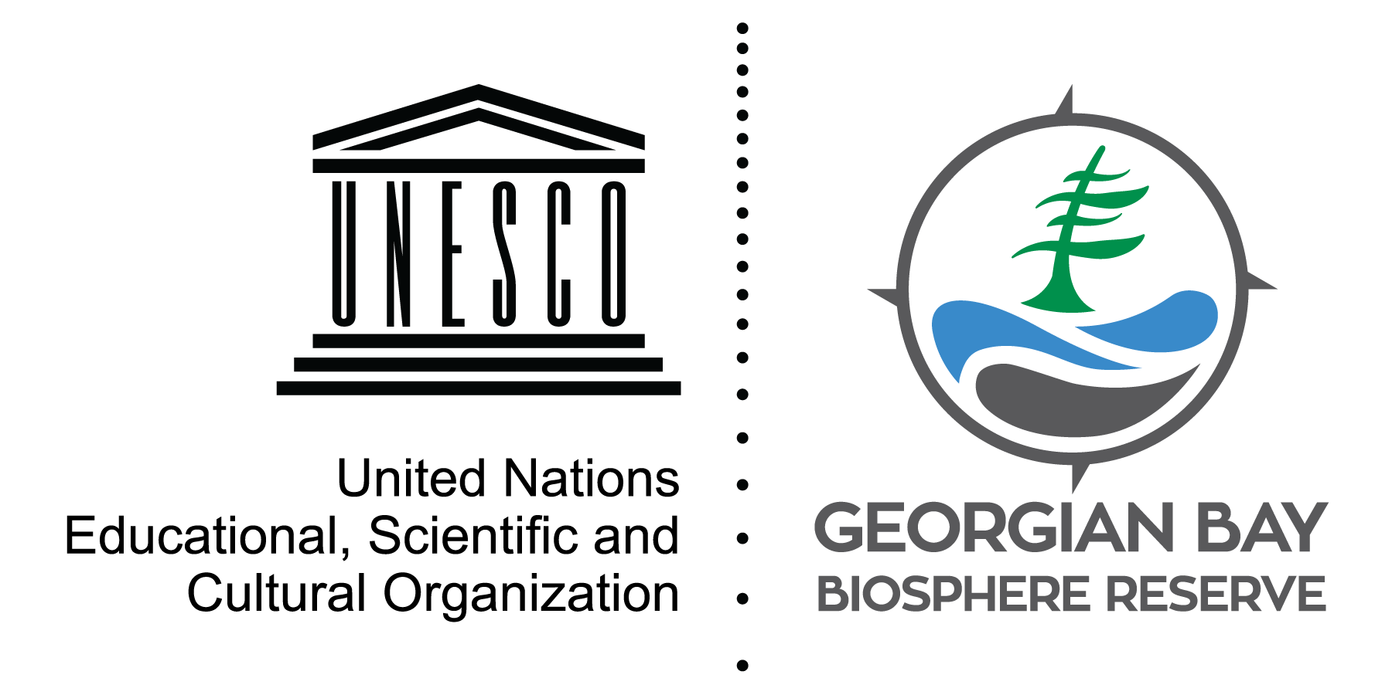
State of the Bay: Wetlands

The coastal wetlands of Georgian Bay are essential for numerous amphibians, birds and reptiles. They also help to control floods and filter pollutants from rainfall. Unfortunately, wetlands are at risk from shoreline modifications, invasive species and climate change.
Using satellite images, a study by Georgian Bay Forever found that between 1987 and 2013, there was a 7% increase in wetland cover in northern Georgian Bay and a 10.8% loss in southern Georgian Bay, with an overall net loss of 3.8%.
It is important to understand that it isn’t the overall loss that we should focus on, but the local environmental impact. Changes to water levels and wetlands affects the types of plants and animals that can survive.
Focusing on local impacts also means we can get involved in protecting and monitoring wetlands. The Marsh Monitoring Program encourages volunteers to record trends in marsh birds and amphibians around the Great Lakes.
The Early Detection and Distribution Mapping System is another reporting tool where you can submit invasive species sightings by uploading a photo. This information is then readily available for scientists and the public so invasive species are more easily managed.
Visit stateofthebay.ca to find more ways to get involved in wetland conservation and monitoring.

David Bywater is the State of the Bay Project Manager for the Georgian Bay Biosphere Reserve, a not-for-profit dedicated to environmental and community well-being. He can be reached at conservation@gbbr.ca

