Ontario Birds - Ruby Throated Hummingbird
(Click on the picture to listen to its call.)
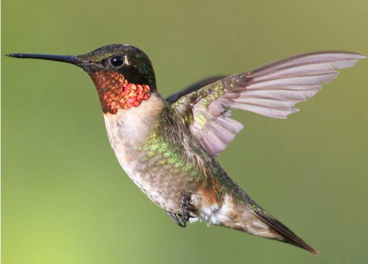
Feeding Behavior - At flowers, usually feeds while hovering, extending its bill and long tongue deep into the center of the flower. At feeders, may either hover or perch. To catch small insects, may fly out and take them in midair, or hover to pluck them from foliage. Sometimes takes spiders (or trapped insects) from spider webs.

Eggs - White. Incubation is by female only, 11-16 days. Young: Female feeds the young. Nest stretches as young grow. Age of young at first flight about 20-22 days. Usually 1-2 broods per year, sometimes 3. Female may begin building second nest while still feeding young in the first.

Young - Female feeds the young. Nest stretches as young grow. Age of young at first flight about 20-22 days. Usually 1-2 broods per year, sometimes 3. Female may begin building second nest while still feeding young in the first.

Diet - Mostly nectar and insects. Takes nectar from flowers, and will feed on tiny insects as well. Favors tubular flowers such as those of trumpet vine. Will also feed on sugar-water mixtures in hummingbird feeders.

Nesting - In courtship display, male flies back and forth in front of female in wide U-shaped "pendulum" arc, making a whirring sound on each dive. Also buzzes back and forth in short passes in front of perched female. Nest site is in a tree or large shrub, 5-50 feet above the ground, usually 10-20 feet. Placed on horizontal branch or one that slopes down from tree, usually well surrounded by leafy cover. Nest (built by female) is a compact cup of grasses, plant fibers, spider webs, lined with plant down. The outside is camouflaged with lichens and dead leaves.
﻿
Conservation status: Thought to have declined in some regions in recent years, but surveys show no distinct downward trend.

Habitat - Gardens, wood edges. Summers in a variety of semi-open habitats, including open woods, clearings and edges in forest, gardens, city parks. Winters mostly in rather open or dry tropical scrub, not usually in rain forest. Migrants may pause in any open habitat with flowers.

Hundreds of kinds of hummingbirds nest in the American tropics, and more than a dozen in the western U.S., but east of the Great Plains there is only the Ruby-throat. There it is fairly common in summer in open woods and gardens. Hovering in front of a flower to sip nectar, it beats its wings more than 50 times per second. Impressive migrants despite their small size, some Ruby-throats may travel from Canada to Costa Rica.

