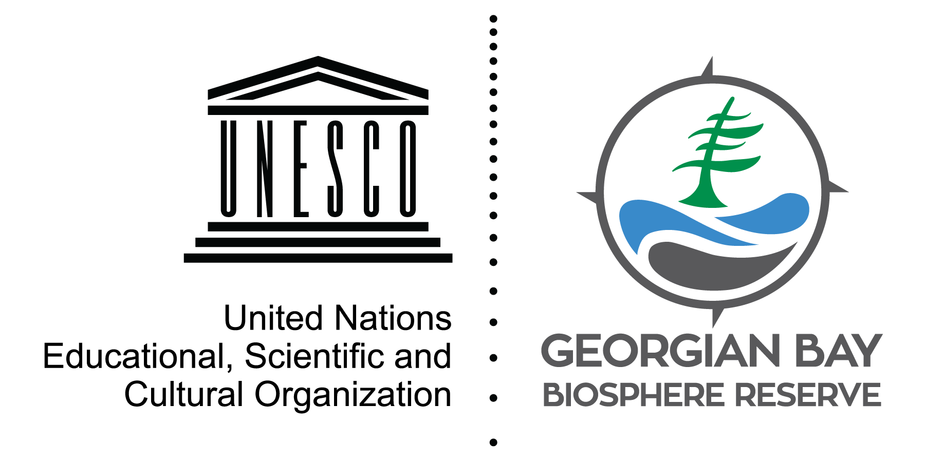
State of the Bay: Fish

One of the best ways to study the state of Georgian Bay is to look at the fish community, specifically whether species are naturally reproducing.
Historically, prey fish were in balance with predator species. However, with overharvest of some species, introductions of new fish, stocking, and invasive species, that system fell out of balance, creating a food web with less food energy for predators. The only substantial native prey species that remains in the offshore is the bloater – a deepwater cisco.
Smallmouth bass, one of the more abundant species, are also affected by warming temperatures, changing water levels, and shoreline development. Walleye were plentiful until the early 1900s, when most stocks began to decline due to many human activities, and invasive species.
The northern pike and muskellunge are top predators that live in near shore waters and are reliant on coastal wetlands for successful spawning and nursery habitat.
Declines in most major native species indicate that the aquatic system has changed significantly in the past few decades. Despite restocking efforts and some habitat restoration work, the stress from invasive species and habitat and nutrient loss create an enormous challenge for sustaining fish populations.

Visit stateofthebay.ca to learn more!

David Bywater is the State of the Bay Project Manager for the Georgian Bay Biosphere Reserve, a not-for-profit dedicated to environmental and community well-being. He can be reached at conservation@gbbr.ca

