VCS EP Liaison Leads
Terms of Reference

Role title | VCS EP Liaison Lead
Reporting lines (direct) | VCS EP Regional Tactical Cell
Reporting lines (indirect) | VCS EP membership; NAVCA
Reporting lines to be developed with the VCS EP Liaison Leads.

Context

Situational Context
The local VCS response to COVID-19 continues to be incredibly strong and far reaching. However, we know that sometimes there may be needs that cannot be met at a local level. For example, where demand for support outweighs the local capacity available, or where needs are of a particularly specialist nature. In some areas strong links exist between the local VCS and Local Authority hubs and/or Local Resilience Fora, however this is not the case everywhere.

The Voluntary and Community Sector Emergencies Partnership (VCS EP) was founded in 2018 to foster an alliance between the voluntary and community sector organisations. The role of VCS EP Liaison Leads has developed as part of this initiative, to provide a route through which to escalate referrals where needs cannot be met at a local level, to regional Tactical Cells where appropriate support can be brokered.

What we seek to do
We need people who are well connected in their local communities to act as key contact points for information on the needs of local organisations. Specifically, to: report insights and escalate concerns that will help the VCSEP to broker regional and national support and resources to meet local needs and; make it easier for grassroots and local organisations to escalate issues that they might need additional support with during an emergency.

For example:
- Insight on wider trend that need national attention
- Groups of individuals with specific needs that cannot be met locally
- When there is a clear demand for a service or social need that cannot be met locally or demand locally is greater than the resource.
- If there is a significant need (individual, organisational or community) that cannot be met locally
- Organisation or sector issues/impact which aren’t being dealt with locally
- When a significant service has reduced or stopped due to volunteers, staff or funding level
- Concerns about a whole group of people e.g. refugees not getting the support they need
- Responses that are not sustainable locally.

Where would you sit in the ecosystem?

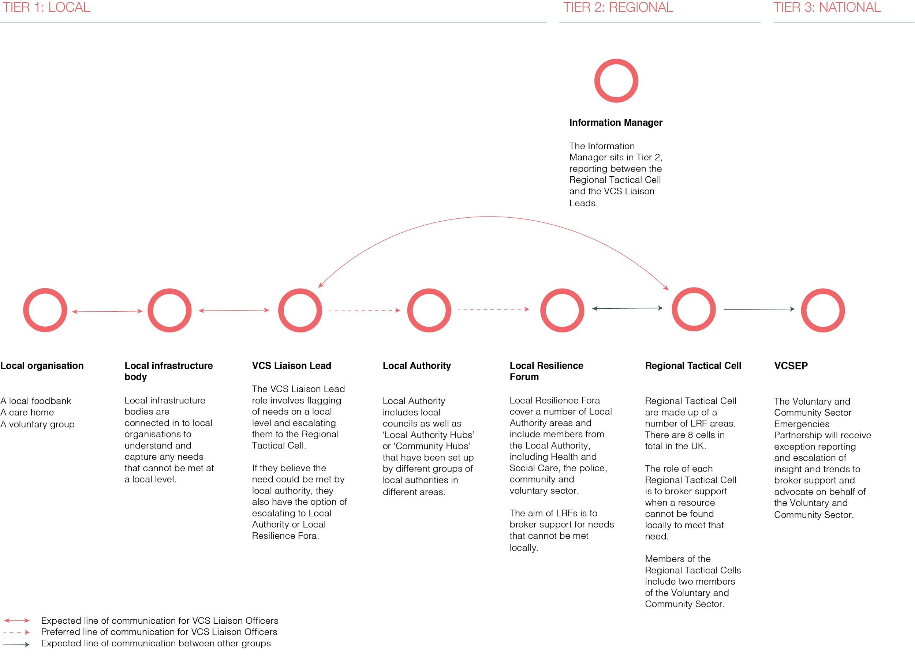

Purpose
The VCS EP Liaison Lead is responsible for being the point of contact and information sharing between the local and regional level.

As a VCS EP Liaison Lead you will represent an area covered by a Local Resilience Forum and report into one of eight Regional Tactical Cells. The VCS EP Liaison Lead has two key areas of responsibility:

- Exception reporting and escalation
Exception reporting is where an organisation and Liaison Lead have exhausted all local support options to meet a need which remains unmet, and as such escalates this need to a regional level for assistance.
The VCS EP Liaison Lead will identify, via engagement with local infrastructure organisations in their LRF area, other stakeholders and (where appropriate) grassroots organisations, and report to the tactical cell needs that are currently, or not planned to be met within a locality. This would take place after adequate time for a local organisation to meet the need.
The VCS EP Liaison Lead will act as a local broker of needs, and when it is identified that a need cannot be met locally will act as an escalator to a regional tactical cell for a national response.

- Insights and Trends
The VCS EP Liaison Lead will act as a central point of knowledge with regards to trends, intelligence and local insight for unmet needs.
The VCS EP Liaison Lead will be able to identify needs (e.g. emerging, or being unmet) within a locality or region that no organisation or authority is meeting currently or planned that should be escalated to a regional or national level.
The VCS EP Liaison Lead will act as a voice of local needs.

VCS EP Platform
The VCS EP are creating a platform with the aim of providing an overview of the needs related to COVID across the UK. There are two services it is currently looking to offer (See Annex 2):

- ‘Get Help as an Organisation’ service
This is related to the ‘exception reporting and escalation’ activities the Liaison Leads will be involved in. The ‘Get Help as an Organisation’ service allows Liaison Leads/ local organisations to make requests for support via an online form. These requests can then be escalated to the Regional Tactical Cell if they can’t be met locally. Please note - as this service is not yet live, we ask you not to share the link with any organisations.

- ‘Insights and Trends’ service
The second, ‘Insights and Trends’ allows Liaison Leads to report on any trends (e.g. systematic, emerging, or being unmet) they notice relating to needs in their local area via the Survey for Liaison Leads to Report Issues Related to COVID. These needs would not be specific to a volunteer or community group but still require escalation to a regional or national stage. This insight will help VCSEP build a picture of trends together with information from national organisations and government, and can advocate for change to the relevant departments, non-governmental bodies and statutory agencies at a national level.

The VCS EP Liaison lead will be supported by the VCS EP Regional Tactical Cell Information Manager with regards to the VCS EP Platform inputs, outputs and use.

Please note - both the ‘Get Help as an Organisation’ and ‘Insights and Trends’ services are currently under development. The questions in each of the service forms are being tested and iterated based on local organisation and Liaison Leads feedback.

Duties/ Responsibilities
- The VCS EP Liaison Lead has a coordination role and acts as a focal point for VCS local organisations that report unmet needs. They will coordinate between the local and regional level to identify and maintain contact and engagement with organisations (and stakeholders) that have reported needs that are not being met at a local level. They will be the reference point to engage and communicate with the local organisations, local authority and the Local Resilience Forum if possible, as well as to the tactical cell, to avoid duplication and ensure an efficient system.
- The VCS EP Liaison Lead acts as a coordination point and supports the tactical cell to scope the resource required to meet needs, reporting this using the relevant channels, providing feedback to the relevant stakeholders and disseminating any relevant information.
- Identify and report local insights and intelligence between the local and regional level to a national level for advocacy via the VCS EP Platform
- Support local infrastructure organisations and other stakeholders reporting unmet need to understand the purpose and process of the VCS EP Platform and what it can offer.
- The VCS EP Liaison Lead would ensure that unmet needs and trends are relevant, timely, accurate and comprehensible.
- The VCS EP Liaison Lead will ensure information is fed into either the ‘Get Help as an Organisation’ service (for exception reporting and escalation) or via the ‘Survey for Liaison Leads to Report Issues Related to COVID’ (for insights and trends identification), enabling an efficient response or advocacy at a national or sub-national level.
- Identify the risks, harm and opportunities of/for the VCS EP Platform
- Ensure that lessons learnt are captured and fed to the VCS EP members for future preparedness and response activities.
- The VCS EP Liaison Lead would work alongside VCS EP Liaison Leads and VCS EP members to co-produce and further develop the VCS EP Platform, ensuring that the designed services are most relevant for operational decision making. This includes processes and tools, for it to be efficient, effective and meeting the needs of the local reporting organisations and VCS EP Liaison Leads.

Annex - Example Scenarios:

Scenario 1​ - Exception reporting and escalation

Local voluntary and community groups need to arrange food drop offs for households that are self-isolating and unable to leave the house to shop for food. These are potentially vulnerable people and the local groups want the assurance of having volunteers with up to date DBS checks but are struggling to identify enough people to complete all the drop offs. They raise this with their local infrastructure body which in turn sends this request to the Liaison Lead. The Liaison lead tries to broker this request locally through the networks that they are involved in (VCS groups, Local Authority, LRF). If they are unable to solve the need locally, they can escalate this to a regional tactical cell. The Liaison Lead completes a short online form ‘Request for Help for an Organisation’. This form is received by the Information Manager who works alongside the Liaison Lead to triage and ensure they have clear requirements to meet the request. The brokers within the tactical cell identify and brief a small team of DBS checked volunteers and they’re deployed the next day to start the food drop offs. The Information Manager notifies the Liaison Lead so that they’re aware the request has been actioned.

Scenario 2 - Insights and Trends
A CVS highlights to their area Liaison Lead that links with the BAME community in the area, which they usually are very well connected to, have become very quiet. Knowing that the BAME community have been disproportionately affected by Covid-19 this is concerning for the CVS as they are keen to ensure that any support and resources needed are reaching them. The Liaison Lead, with information from the CVS, completes the Survey for Liaison Leads to Report Issues Related to COVID which is received by the Information Manager in the regional tactical cell. The Information Manager includes this in their report which is escalated up to the Voluntary and Community Sector Emergencies Partnership (VCS EP). The impact on the BAME community and the lack of insight about how well groups and communities are being supported is highlighted as an issue of concern in a number of areas. The VCS EP commissions a small team to do a rapid exploration into this and to share insights and recommendations with the VCS EP and cascade this down to regional and local levels. ​

The VCS EP also identifies and works with national organisations and bodies as well as have links with the government, who can advocate this trend to the relevant departments, non-governmental bodies and statutory agencies at a national level.

Annex 2: Forms currently being tested
