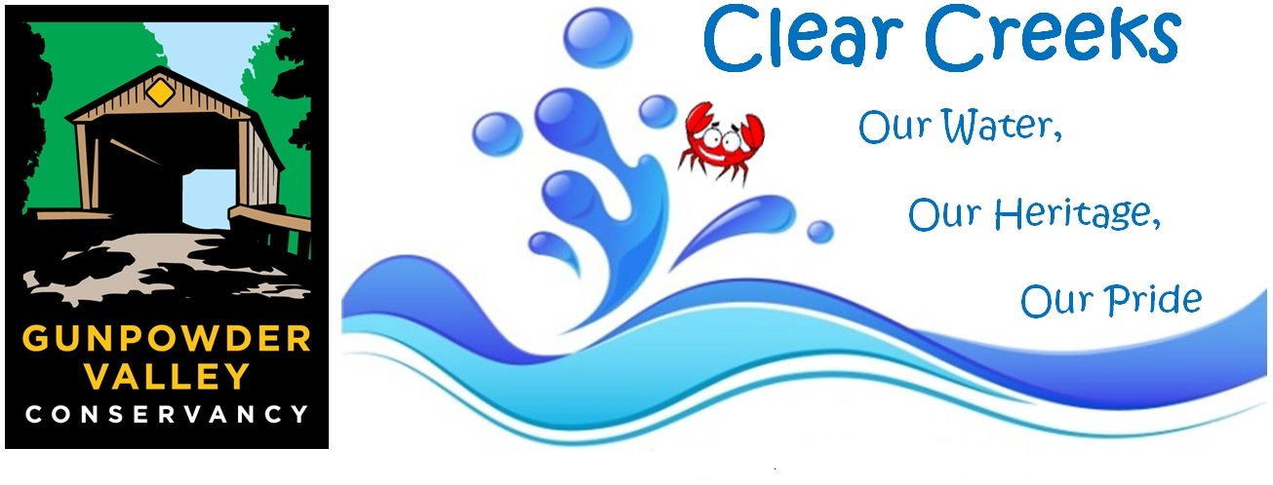2018-2019 Clear Creeks Project pre-assessment form
Please fill out this form to be considered for a 2018-2019 Clear Creeks Project conservation garden. Submit your completed form via email to Amy Young at ayoung@gunpowdervc.org.
To receive a Clear Creeks Project garden installation, your property must be located within the Bird River, Lower Gunpowder Falls, Middle River, or Tidal Gunpowder watersheds. You must also commit to hosting a workshop (ideally including lunch for participants) and recruiting 5 people to help with the garden installation.
CLIENT INFORMATION | Watershed your property is in  (Check if known)
Name: | Bird River
Address: | Lower Gunpowder Falls
Community: | Middle River
Email: | Tidal Gunpowder
Phone:
SITE ANALYSIS
What are your Storm Water Issues/Problems?

What is the proximity of your property to the water?

How visible is your problem area to the community?

CLEAR CREEKS PROJECT PROMOTION | Yes/No
Will you assist in promoting your Clear Creeks Project garden workshop (post flyers, invite neighbors, family, friends?)
Are you willing to have your Clear Creeks Project garden be part of a Garden Tour?
Are you interested in participating in a do-it-yourself Design Workshop if you are not able to receive an installation this year?
If you cannot receive an installation this year due to lack of Clear Creeks Project funding, are you interested in being added to our waiting list should additional funding become available?

Bay-Wise Practices offered by the Clear Creeks Project | Check Techniques that You Are Interested In
Rain Barrel (50% cost-share)
Bayscape Garden (60% cost-share)
Edible Bayscape Garden (60% cost-share)
Rain Garden (80% cost-share)
Microbioretention Practice (70% cost-share)
Bay-Wise Certification
Other Comments:

Thank you for your interest in the Clear Creeks Project! www.gunpowdervalleyconservancy.org/clearcreeks

