It’s hard to believe we are wrapping up this wonderul year! I hope you are able to take some time this summer to enjoy the beautiful weather.

Please work on your Immunizations and Care Plans and have them ready BEFORE Passport Day.

If you have any questions, you can always send me an email.
njohnson@asd.wednet.edu or call 360-618-6454.

Medication
If you have medication at Post, please come before the last day of school to pick it up!

Care Plans
For our students that need a care plan for the upcoming school year! I will be sending paperwork home with your student to take to your doctors. Please call your doctor as soon as possible to get an appointment. Please CALL NOW to get this set up so we are ready to go before September.

YOUR STUDENT WILL NOT BE ABLE TO START SCHOOL UNLESS THE CARE PLAN AND MEDICATION ARE UP TO DATE!
Immunizations
6th GRADERS! YOU WILL NEED A TDAP VACCINE TO START 7th GRADE! This is a new vaccine for you!
STAY CURRENT on your vaccines. We will be following the States guidelines for vaccinations for the upcoming school year. CALL NOW to get these scheduled. Don’t forget, many pharmacies also do vaccinations and process payment with your insurance.

YOU WILL NEED CURRENT/UPDATED VACCINES TO GET A SCHEDULE!


* * VACCINES ARE STATE REQUIRED TO ATTEND THE FIRST DAY OF SCHOOL * *

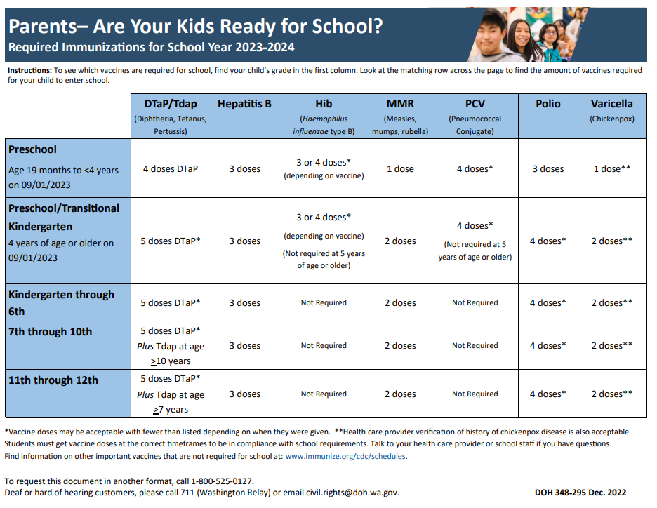

HAVE A GREAT SUMMER and WE WILL SEE YOU IN SEPTEMBER!



