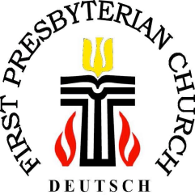
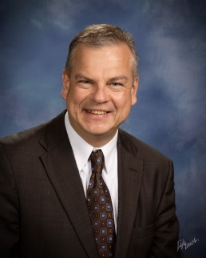
10 Years “First Pres Deutsch”
at First Presbyterian Church in Tuscaloosa

Rev. Dr. Thomas Herwig, Parrish Associate at First Presbyterian Church Tuscaloosa

“Herzlichen Dank!” (translated: “Thank you very much!”) …
… for ten years of faithful hospitality to First Pres Deutsch! Ten years ago, First Presbyterian Church in Tuscaloosa opened the doors for a new German-speaking ministry, which in between has touched hundreds of lives. Responding to expressed need in the community, former pastor Charlie Durham shared the idea with me to start this program not long after Lou Ann began serving this church as Associate Pastor. I immediately said, “yes.” The first “Christvesper” (Christmas Eve service) – held on Christmas Eve 2008 in the Westervelt-Warner Chapel - was packed. “Fröhliche Weihnachten!” (Merry Christmas!), the Tuscaloosa News titled the article about the new church project. And since then the German program rolled. I am very glad that our new head pastor, Michael Bailey, embraced this work from his first days with us.
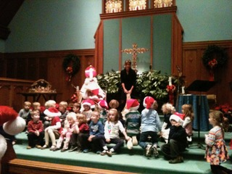
Of course, German ex-pats, working for Mercedes or supplier companies, belong to our primary target group, as well as, Germans serving our university and the schools in T’town. But there have also been Americans and other people who spent time in Germany, Austria or Switzerland or studied German in school or at the university, who have come to refresh their language or to simply enjoy German language, traditions, and hymns. The German worship service held every first Sunday in the month gives our ministry its rhythm. We also socialize in other places, organizing excursions and informal meetings, pool parties and cultural events. St. Martin-parades, St. Nikolaus-celebrations, and First-Day-of-School-services have been and continue to be organized in cooperation with local Tuscaloosa Academy and the Capitol School, attracting good crowds of all ages. It has also been nice to see that some of our members became interested in church life of the hosting congregation. And there has been mutual visiting of services and church life between the German and hosting congregation.
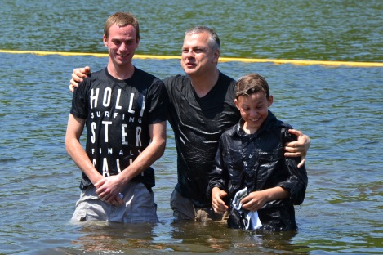
Many stories can be told about these ten years. We have worshiped together, celebrated new life and baptisms, taught and confirmed youth in the context of four one-year-confirmation classes. We have offered thanksgiving as we prayed for healing and consolation.
Two stories are especially moving and may well symbolize the amazing service, First Pres Deutsch was able to grant in extraordinarily dire situations. At first, it was the loss actually of one of our “founding mothers”, Barbara Fischer, professor in the German department of our university, who fell victim to a car accident three weeks after we confirmed her daughter Katharina in the chapel. Unforgettable for us was the funeral service in the well-filled sanctuary where we celebrated Barbara’s life with her husband and children in two languages, English and German, enabling all participants to understand and to be understood. We are directly connected with the Fischer-Fox family through Barbara’s ashes that found their rest in our columbarium in the rose garden.
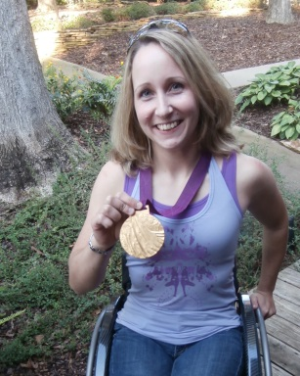
The other moving story was that First Pres Deutsch accompanied the Winkler family when Mario who worked for a German supplier company for Mercedes almost died as a victim of a mass shooting at the Copper Top bar here in Tuscaloosa. We had to thank God for Mario’s survival after months of great sorrow and many prayers. This experience is the reason Mario chose to donate money for FPD’s thank-you gift to First Pres - in the form of a foosball table for the youth of First Pres to be used in the confirmation room of the church.
But we also used state of the art technology for keeping families connected around the globe, when we arranged skype conferences that made it possible to get Godmother and grandmother from different places in Germany involved in the baptism of little David.
And we even had an Olympic Gold medalist with us. Annika Zeyen, who played for the UA wheelchair basketball team and kept us connected with this amazing athletic branch at our university, reached the highest Olympic accolades with the German national team at the Paralympics in London 2012.
I take the occasion of this short review of 10 years of First Pres Deutsch to invite to our events in December 2018. But I also would be glad to take the contact information for those who are interested in the ongoing program and put it in the distribution list for our monthly newsletter.
I have to thank Tine Hoffmeister and AGP for the opportunity to get your attention for First Pres Deutsch in Tuscaloosa.
Merry Christmas and a Happy New Year!
Yours sincerely, Thomas Herwig.

