RAPA Awarded with the Daimler Special Award for Innovation
Once a year, Daimler presents its Daimler Supplier Award to acknowledge the exceptional services and partnerships with ten suppliers over the previous year. Their services are rated in the categories of quality, partnership and innovation, profitability, reliability and sustainability based on trust and communication are also evaluated.

In the last five years, Rausch & Pausch has developed a unique engine-pump unit referred to as the E-ACTIVE BODY CONTROL chassis, with a finely-tuned and intelligent control which enables the leveling of the vehicle in any driving situation. The vehicle can also take any challenging or switchback turn safely. For this high-tech, innovative development for the new Mercedes-Benz GLE, RAPA has received the Special Award for Innovation from Daimler.

On the evening of Wednesday, 20 February 2019, Horst Pausch and Dr. Roman Pausch traveled to the presentation event of this year’s Daimler Awards in Stuttgart, Germany. After an evening of celebration around the vast improvements within Daimler as a whole, the trophy was presented to Dr. Roman Pausch by Ola Källenius, Manager of Daimler AG for Group Research and Mercedes-Benz Cars Development. “This award goes in particular to our RAPA project team who have been working on the development of this worldwide innovation with enthusiasm and a lot of perspiration over the last few years”, the RAPA CEO said proudly. Dr. Pausch is the 4th generation of his family to manage the family-owned company based in Selb, Southeast Germany.

The 2018 innovation, the fully networked, 48 Volt active eABC chassis, is the only system available on the market which can individually regulate the spring and suspension forces on each wheel. This new system can reduce body roll as well as pitch and yaw impacts to improve driving comfort and agility. On roads with poor driving conditions, the system can even recuperate electric power, helping to reduce the energy consumption of the previous S Class models by half. The system is available in the new Mercedes GLE which has now been launched on the market.

About RAPA:
Rausch & Pausch (RAPA) is a family-owned mid-sized business which will soon be celebrating 100 years of business success. An innovative employer with a workforce of 950 employees at sites in Germany and the U.S., RAPA supplies high-tech products to leading, premium vehicle manufacturers such as Porsche, Mercedes, Audi, BMW, Bentley, VW, Ferrari, Chrysler, Tesla and Jaguar - Land Rover. Headquartered in Selb (Bavaria, Germany), the family-owned company develops and manufactures solenoid valves and valve systems for hydraulic and pneumatic applications in the chassis, convertible tops and driveline components to reduce CO₂ emissions and fuel consumption. RAPA products are used in a variety of sectors ranging from automotive, medical technology and a variety of industrial applications. More information available at www.rapa.com.

Information:
Rausch & Pausch GmbH, Aileen Sammler, Albert-Pausch-Ring 1, 95100 Selb, Germany, Telephone +49(0)92 87/88 4-240, e-mail: asammler@rapa.com
Rausch & Pausch LP, Giuliana Mendenhall, 2450 Paul Parks Lane, Auburn, AL 36832, Telephone 334.321.0875, e-mail: gmendenhall@rapa.com

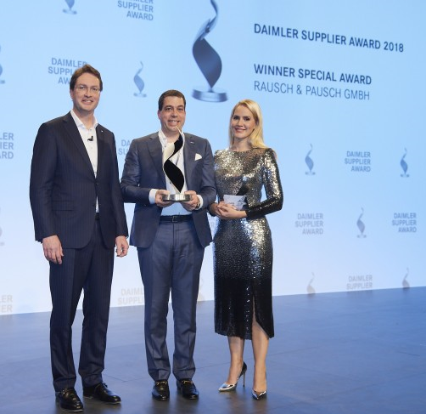
Caption:
Dr. Roman Pausch accepts the prestigious Daimler trophy: Winner of the Special Award category: Rausch & Pausch GmbH. From left to right: Ola Källenius, Manager of Daimler AG for Group Research and Mercedes-Benz Cars Development, Dr. Roman Pausch, Rausch & Pausch GmbH, Judith Rakers.

February 25, 2019

