Please note! If your classified is no longer active, please let Carrie know that it can be removed! (518) 608-1246
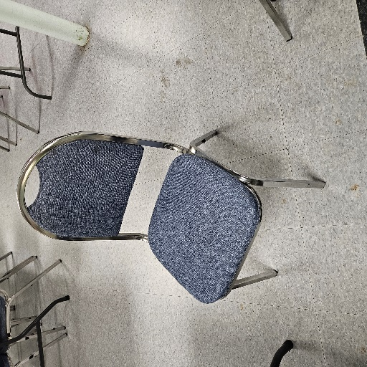
Approximately 50 chairs for free.
Contact:
Roger Ellis
United Church of Granville
Rgellis6@gmail.com
518-744-4288 voice or text

(New) Church looking for The Faith We Sing hymnals
Does your church have a few Faith We Sing hymnals you’d be willing to part with? A small church in the Adirondack District is looking for a dozen to enhance their worship service. Please be in touch with Carrie at the District Office if you’d be willing to donate any. (518) 608-1246.
Saratoga Springs UMC seeks Office Manager
Saratoga Springs UMC, 175 Fifth Ave., Saratoga Springs (Adirondack District), is looking for an Office Manager: 20 hours per week - 9:30 AM- 2:30 PM, Tuesday, Wednesday and Thursday. Some flexibility with summer hours and school vacations. Need to possess skills with computers, databases, websites, and other electronic forms of communication. For more information or to submit a resume, contact pastorheather@saratogaumc.org or 518-584-3720.
Teachers sought for Day Care Program at Salem UMC in West Sand Lake
Salem UMC West Sand Lake is actively seeking 2 lead teachers (toddler and preschool) to join a dedicated team of caring educators for its NYS licensed Jubilee Day Care program. Candidates must be committed to the education, growth and development of young children and meet NYS qualifications. Our day care ministry meets the needs of families with young children by providing quality, loving childcare for up to 27 children ages 18 months through 5 years of age. These positions are full time with benefits. Please contact Jubilee Day Care at 518-674-2705 or jubileeny@msn.com
﻿Argyle church looking for assistance in developing website
If you can lend expertise in helping the Argyle UMC (in the Adirondack District) develop a website of in updating their Facebook page, please contact Roberta Collins at (518) 538-5362 or rlcollins2011@gmail.com
Fortsville UMC collection
The Fortsville UMC collects metal lids (jelly jar, pickle jars, screw tops) and pop tabs from soda and other cans for their mission. They benefit The Ronald McDonald House in Albany. Donations can be left on the side porch on the parking lot, or if large amounts need collection,, they can call the church at (518) 793-7095 and leave a message for pick up. The church is located at 402 Fortsville Road, Gansevoort.
Space Heater Available at cost A 30,000 BTU Blue Flame Natural Gas space heater was purchased in error- available at cost if you can use it in your area. Call First UMC of Ticonderoga, (518) 585-7995 for details.
Part-time sexton sought for Calvary UMC in Latham
Calvary UMC, 15 Ridge Place, Latham, is looking for a part-time sextion (24 hours per week). Click here for the job posting.
Treasurer sought for Niverville-Chatham Center UMC
The Niverville-Chatham Center UMC, 28 Church St., Niverville, is looking for a new treasurer from outside the congregation to begin serving January 1, 2024. If you would be willing to fill that position or know someone who might be interested, please e-mail us at niverchatcentumc@gmail.com.
Niverville-Chatham Center UMC looking for contractor
We need work done on our steeple and are having a problem finding a contractor willing to do it. If anyone has had steeple work done and could give us the name of someone you used, it would be very helpful for us.
E-mail us at niverchatcentumc@gmail.com
Organist/Choir Director sought - Trinity UMC, Albany
Trinity United Methodist Church in Albany is seeking an organist and choir director to provide instrumental music and lead our small choir in a weekly Sunday worship service as well as one weeknight rehearsal.
Responsibilities
- Playing the pipe organ during services.
- Planning the music for worship in coordination with the pastor.
- Maintaining the music library.
- Diagnosing issues and arranging for the care and maintenance of the church’s instruments including our 1933 four rank, two console Moeller Pipe organ.
- Leading the choir.
- Recruiting section leaders and handling the budget for section leader pay.
Qualifications
Music training or experience, the ability to play the piano and lead the choir and the ability to play the pipe organ or willingness to learn.
Please contact Nancy Lott if interested, nancy531@yahoo.com.
Pianos and organ free for the asking to any church
Grace UMC, 16 Hillcrest Dr., Ravena is downsizing and have two upright pianos--a Yamaha and unmarked -- and one Hammond organ that are free to any church that can use them. You would need to pick them up.. Pictures are attached. If interested, please contact our church secretary at the church number (518) 756-6688. She has office hours Tuesday and Thursday from 9 to noon, but checks messages on other days.
Hymnals free for the asking
Burnt Hills UMC has approximately 60 dark red United Methodist hymnals available at no charge to any church that wants them. Some have broken spines, but they’ve been repaired. If interested, please call Bert Longbotham at (518) 852-9375.

Information sought about Electric Altar Candles
Pine Grove UMC is interested in electric altar candles, and we are curious if any other churches have found some to be of higher quality and more "realistic" than others. Please email pgumcoffice2@gmail.com with any info.
Calvary UMC: Latham looking for a Nursery Coordinator
Calvary UMC, 15 Ridge Place, Latham, is looking to fill the Nursery Coordinator position to start as soon as possible. The Nursery Coordinator provides child care for children under 3 years old each Sunday from 9:45 AM – 11:15 AM. If you are interested in the position or have any questions, please contact Jane Glassman at mathteach12@gmail.com or the church office at calvaryumclatham@gmail.com.

