88 Claremont Road, Bernardsville, NJ 07924
The Fourth Sunday of Easter
Episcopal Community Services of NJ Sunday
May 8, 2022

10:00 a.m. Holy Eucharist

Welcome to St. Bernard’s Episcopal Church. Thank you for sharing in our worship today.

PRELUDE
PROCESSIONAL HYMN 410 Praise my soul, the King of heaven
1 | Praise my soul, the King of heaven;  to his feet thy tribute bring;  ransomed, healed, restored, forgiven,  evermore his praises sing:  Alleluia, alleluia!  Praise the everlasting King. | 2 | Praise him for his grace and favor  to his people in distress;  praise him still the same as ever,  slow to chide, and swift to bless:  Alleluia, alleluia!  Glorious in his faithfulness.
3 | Fatherlike he tends and spares us;  well our feeble frame he knows;  in his hand he gently bears us,  rescues us from all our foes.  Alleluia, alleluia!  Widely yet his mercy flows. | 4 | Angels, helps us to adore him;  ye behold him face to face;  sun and moon, bow down before him,  dwellers all in time and space.  Alleluia, alleluia!  Praise with us the God of grace.

EASTER ACCLAMATION BCP p. 355
Celebrant Alleluia! Christ is risen!
People The Lord is risen indeed! Alleluia!
COLLECT FOR PURITY said by all
Almighty God, / to you all hearts are open, / all desires known, / and from you no secrets are hid: / Cleanse the thoughts of our hearts / by the inspiration of your Holy Spirit, / that we may perfectly love you, / and worthily magnify your holy Name; / through Christ our Lord. Amen.
GLORIA S 280 Gloria in excelsis found in the blue hymnal
Glory to God in the highest, and peace to his people on earth. Lord God, heavenly King,
almighty God and Father, we worship you, we give you thanks, we praise you for your glory.
Lord Jesus Christ, only Son of the Father, Lord God, Lamb of God, you take away the sin of the world: have mercy on us; you are seated at the right hand of the Father: receive our prayer.
For you alone are the Holy One, you alone are the Lord, you alone are the Most High,
Jesus Christ, with the Holy Spirit, in the glory of God the Father. Amen.
ECS SUNDAY COLLECT by The Reverend Andrew D. Kruger
Celebrant The Lord be with you. People And also with you.
Let us pray. Compassionate God, you called us to establish Episcopal Community Services of the Diocese of New Jersey: endow us with the vision to balance charitable giving with advocating justice, so that both the source and symptoms of oppression will be overcome; through Jesus Christ our Lord, who lives and reigns with you and the Holy Spirit, one God, now and for ever. Amen.
MOTHER’S DAY PRAYER
Gracious God, giver of life and love, bless all of our mothers, those living on earth and those who have died and are alive in you. We give thanks for those mothers who have loved us and for those who have fallen short of loving us fully; for all who hope to be mothers someday and for those whose hope to have children has been frustrated; for all mothers who have lost children; for all those who have mothered others in any way; and for your Creation and your Church which nourish and sustain us. Help us to know your nurturing love, O God, as we seek to guide and encourage one another in the power of the Holy Spirit, following the example of Jesus and his mother, Mary. We ask this in Christ’s Name. Amen.

FIRST READING: Acts 9:36-43 Jane Rauen in church

Lector A Reading from the Acts of the Apostles.
Now in Joppa there was a disciple whose name was Tabitha, which in Greek is Dorcas. She was devoted to good works and acts of charity. At that time she became ill and died. When they had washed her, they laid her in a room upstairs. Since Lydda was near Joppa, the disciples, who heard that Peter was there, sent two men to him with the request, “Please come to us without delay.” So Peter got up and went with them; and when he arrived, they took him to the room upstairs. All the widows stood beside him, weeping and showing tunics and other clothing that Dorcas had made while she was with them. Peter put all of them outside, and then he knelt down and prayed. He turned to the body and said, “Tabitha, get up.” Then she opened her eyes, and seeing Peter, she sat up. He gave her his hand and helped her up. Then calling the saints and widows, he showed her to be alive. This became known throughout Joppa, and many believed in the Lord. Meanwhile he stayed in Joppa for some time with a certain Simon, a tanner.

Lector The Word of the Lord. People Thanks be to God.

PSALM 23 sung by the choir BCP pp. 612-613
1 The Lord is my shepherd; I shall not be in want.
2 He makes me lie down in green pastures and leads me beside still waters.
3 He revives my soul and guides me along right pathways for his Name's sake.
4 Though I walk through the valley of the shadow of death, I shall fear no evil;
for you are with me; your rod and your staff, they comfort me.
5 You spread a table before me in the presence of those who trouble me;
you have anointed my head with oil, and my cup is running over.
6 Surely your goodness and mercy shall follow me all the days of my life,
and I will dwell in the house of the Lord for ever.

SECOND READING: Revelation 7:9-17 Michele Esposito-Edwards in church

Lector A Reading from the Book of Revelation.
I looked, and there was a great multitude that no one could count, from every nation, from all tribes and peoples and languages, standing before the throne and before the Lamb, robed in white, with palm branches in their hands. They cried out in a loud voice, saying, “Salvation belongs to our God who is seated on the throne, and to the Lamb!” And all the angels stood around the throne and around the elders and the four living creatures, and they fell on their faces before the throne and worshiped God, singing, “Amen! Blessing and glory and wisdom and thanksgiving and honor and power and might be to our God forever and ever! Amen.” Then one of the elders addressed me, saying, “Who are these, robed in white, and where have they come from?” I said to him, “Sir, you are the one that knows.” Then he said to me, “These are they who have come out of the great ordeal; they have washed their robes and made them white in the blood of the Lamb. For this reason they are before the throne of God, and worship him day and night within his temple, and the one who is seated on the throne will shelter them. They will hunger no more, and thirst no more; the sun will not strike them, nor any scorching heat; for the Lamb at the center of the throne will be their shepherd, and he will guide them to springs of the water of life, and God will wipe away every tear from their eyes.”

Lector The Word of the Lord. People Thanks be to God.

The people stand.

GRADUAL HYMN 423 Immortal, invisible, God only wise
1 Immortal, invisible, God only wise,  in light inaccessible hid from our eyes,  most blessed, most glorious, the Ancient of Days,  almighty, victorious, thy great Name we praise. | 2 Unresting, unhasting, and silent as light,  nor wanting, nor wasting, thou rulest in might;  thy justice like mountains high soaring above  thy clouds, which are fountains of goodness and love.
3 To all life thou givest, to both great and small;  in all life thou livest, the true life of all;  we blossom and flourish, like leaves on the tree,  then wither and perish; but nought changeth thee. | 4 Thou reignest in glory, thou rulest in light,  thine angels adore thee, all veiling their sight;  all laud we would render: O help us to see  ’tis only the splendor of light hideth thee.

THE HOLY GOSPEL: John 10:22-30
Celebrant The Holy Gospel of our Lord Jesus Christ according to John.
People Glory to you, Lord Christ.
We encourage you to listen to the Gospel. To read along, the Gospel can be found in the pew Bible on p. 934.
Celebrant The Gospel of the Lord.
People Praise to you, Lord Christ.

THE SERMON The Rev. Beth Rauen Sciaino
AFFIRMATION OF FAITH: Psalm 23 said in unison in place of the Nicene Creed
1 The Lord is my shepherd; *
I shall not be in want.
2 The Lord makes me lie down in green pastures *
and leads me beside still waters.
3 The Lord revives my soul *
and guides me along right pathways for his Name’s sake.
4 Yea, though I walk through the valley of the shadow of death, I shall fear no evil; *
for you are with me;
your rod and your staff, they comfort me.
5 You spread a table before me in the presence of those who trouble me; *
you have anointed my head with oil,
and my cup is running over.
6 I am confident your goodness and mercy shall pursue me all the days of my life, *
and I will dwell in the house of the Lord for ever.

EASTERTIDE PRAYERS OF THE PEOPLE Paul Edwards in Church
from Common Worship, Church of England
Leader We pray to Jesus who is present with us to eternity.
Jesus, light of the world, bring the light and peace of your gospel to the nations.
Jesus, Lord of life,
People In your mercy, hear us.
Leader Jesus, bread of life, give food to the hungry and nourish us all with your word.
Jesus, Lord of life,
People In your mercy, hear us.
Leader Jesus, our way, our truth, our life, be with us and all who follow you in the way. Deepen our appreciation of your truth and fill us with your life.
Jesus, Lord of life,
People In your mercy, hear us.
Leader Jesus, Good Shepherd who gave your life for the sheep, recover the straggler, bind up the injured, strengthen the sick, and lead the healthy and strong to new pastures. We pray for those on our Prayer List: (read names).
Jesus, Lord of life,
People In your mercy, hear us.
Leader Jesus, the resurrection and the life, we give you thanks for all who have lived and believed in you. We pray for all who have died, especially Ed English. Raise us with them to eternal life.
Jesus, Lord of life,
People In your mercy, hear us, / accept our prayers, / and be with us always. Amen.
During the joyful season of Easter, the Confession of Sin is omitted to emphasize the celebration of redemption and new life that are characteristic of this season.

THE PEACE
Celebrant The risen Christ came and stood among his disciples and said, “Peace be with you.”
And they were glad when they saw the Lord. Alleluia. The peace of the risen Christ
be always with you.
People And also with you. Alleluia.

WELCOME AND Announcements

THE HOLY COMMUNION
During the Offertory Anthem an offering is collected for God’s mission and ministry.
Thank you for your generosity.

OFFERTORY ANTHEM Loving Shepherd by J. S. Bach

Loving shepherd, comfort and guide us, keep us in thy tender care.
And in thy mercy stay beside us, safely thy lambs now gather,
Bring us in faith together, and thy pastures now prepare.

And when I walk with darkness around me, thou art near and I will fear no ill.
So with thy love and kindness surround me, goodness and mercy bringing,
From living water springing, Lord of Love grant me thy comfort still.

PRESENTATION OF THE GIFTS Lasst uns erfreuen

Praise God, from whom all blessings flow; praise God, all creatures here below;
Alleluia, Alleluia.
Praise God above, ye heavenly host; praise Father, Son and Holy Ghost.
Alleluia, Alleluia, Alleluia, Alleluia, Alleluia.

THE GREAT THANKSGIVING Eucharistic Prayer 2, Enriching our Worship 1

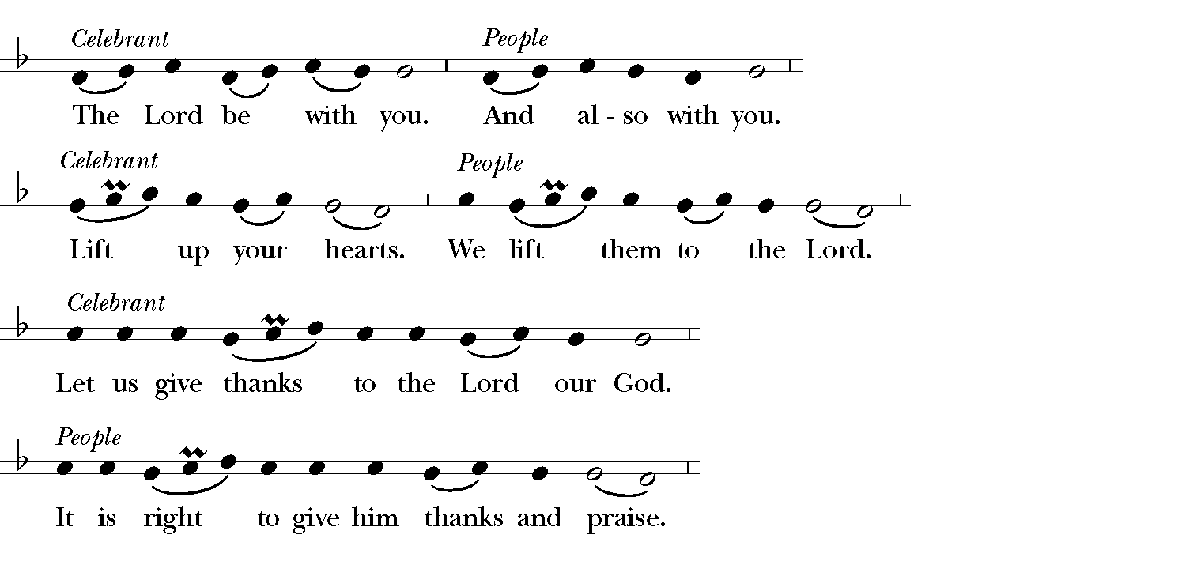

SANCTUS AND BENEDICTUS S 129 Robert Powell
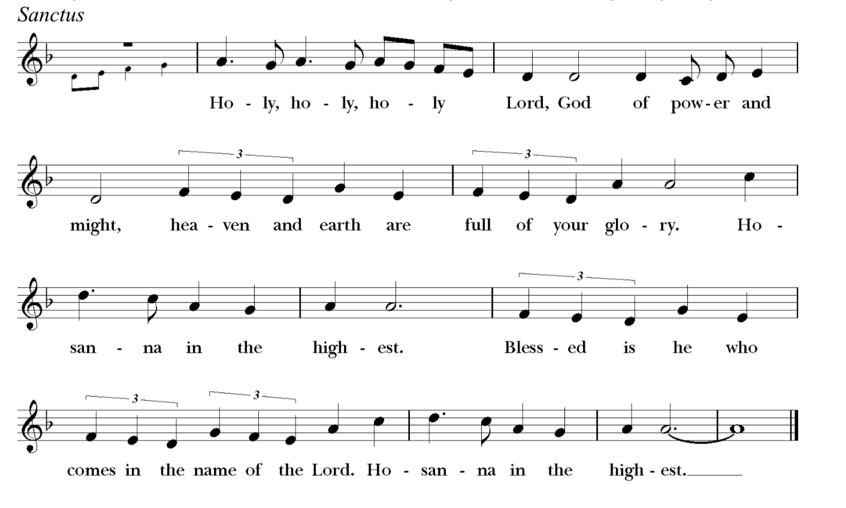

MEMORIAL ACCLAMATION
Christ has died. Christ is risen. Christ will come again.
THE LORD’S PRAYER BCP p. 364
Celebrant And now, as our Savior Christ has taught us, we are bold to say,
Our Father, who art in heaven, hallowed be thy Name, thy kingdom come, thy will be done, on earth as it is in heaven. Give us this day our daily bread. And forgive us our trespasses, as we forgive those who trespass against us. And lead us not into temptation, but deliver us from evil. For thine is the kingdom, and the power, and the glory, for ever and ever. Amen.
THE BREAKING OF THE BREAD The Celebrant breaks the consecrated Bread. Silence is kept.
Celebrant Alleluia. Glory in God’s holy Name;
People Let the hearts of those who seek the Lord rejoice. Alleluia. (Psalm 105:3)
INVITATION TO COMMUNION
Celebrant The Gifts of God for the People of God. Come and meet the Risen Christ.
You are welcome to say (on mute) A Prayer for Spiritual Communion found below while Holy Communion is shared in church. To have Communion brought to you at home locally, contact Pastor Beth.
Optional for those at home:
A PRAYER FOR SPIRITUAL COMMUNION (St. Alphonsus de Liguori, 1696-1787)
My Jesus, I believe that you are truly present in the Most Holy Sacrament. I love you above all things, and long for you in my soul. Since I cannot now receive you sacramentally, come at least spiritually into my heart. As though you have already come, I embrace you and unite myself entirely to you; never permit me to be separated from you. Amen.
POST COMMUNION PRAYER BCP p. 365
Celebrant We have been fed holy food for holy service. Let us stand and pray.
Eternal God, heavenly Father, / you have graciously accepted us as living members
of your Son our Savior Jesus Christ, / and you have fed us with spiritual food
in the Sacrament of his Body and Blood.
Send us now into the world in peace,
and grant us strength and courage / to love and serve you
with gladness and singleness of heart; / through Christ our Lord. Amen.

THE GREAT “I AM” STATEMENTS from the Gospel of John Celtic Worship Through the Year p. 5
Leader Jesus said: I am the light of the world. Michele Esposito-Edwards in church
People Your light drives out the darkness.
Leader I am the way, the truth, and the life.
People Your way has brought true hope.
Leader I am the resurrection and the life.
People You broke the power of death.
Leader I am the bread of life.
People You feed and fill the hungry.
Leader I am the true vine.
People Your life becomes our life.
Leader I am the good shepherd.
People You guide and lead us on.
THE BLESSING
May Christ who out of defeat brings new hope and new alternatives, bring you new life and may God the Father, God the Son, and God the Holy Spirit, bless, preserve, and keep you, now and always. Amen.

RECESSIONAL HYMN 544 Jesus shall reign where’er the sun
1 Jesus shall reign where’er the sun  doth his successive journeys run;  his kingdom stretch from shore to shore,  till moons shall wax and wane no more. | 2 To him shall endless prayer be made,  and praises throng to crown his head;  his Name like sweet perfume shall rise  with every morning sacrifice.
3 People and realms of every tongue  dwell on his love with sweetest song;  and infant voices shall proclaim  their early blessings on his Name. | 4 Blessings abound where’er he reigns:  the prisoners leap to lose their chains,  the weary find eternal rest,  and all who suffer want are blest.
5 Let every creature rise and bring
peculiar honors to our King;
angels descend with songs again,
and earth repeat the loud amen.

THE DISMISSAL
Celebrant We are raised to new life with Christ. Go in Christ’s peace. Alleluia, alleluia!
People Thanks be to God. Alleluia, alleluia!

POSTLUDE

ASSISTING TODAY AT OUR SERVICE  Celebrant & Preacher The Rev. Beth Rauen Sciaino  Director of Music Dr. Martin Sedek  The St. Bernard’s Choir  Lectors Jane Rauen, Michele Esposito-Edwards, Paul Edwards  Usher Paul Edwards | St. Bernard’s Wardens and Vestry  Christopher Thomas, Paul Edwards, Wardens  Michael Myers, Treasurer; Linda Engleby, Clerk  Thomas Brooks, Zach Conway, Linda Engleby,  Anne Fritts, Beth Gustafson, Taylor Hwong,  Mary Kempen, Jennifer Moss, Michael Myers, Sue Smith

