

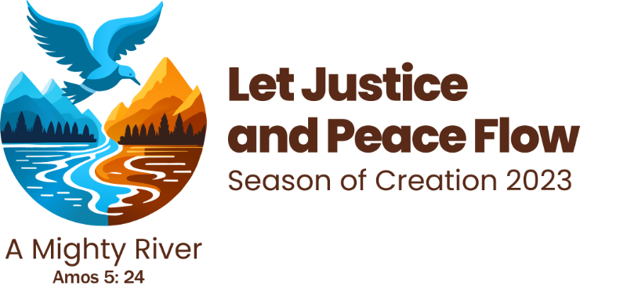

Season of Creation Prayer Day 1

Creator of All,
From your communion of love life sprung forth like a mighty river and the whole cosmos came into being.
On this Earth of overflowing love, the Word was made flesh and went forth with the life-giving waters proclaiming peace and justice for all creation.
You called human beings to be in right relationship with each creature, but we failed to listen to the cries of the Earth and the cries of the most vulnerable. We broke with the flowing communion of love and sinned against you by not safeguarding the conditions for life.
We lament the loss of our fellow species and their habitats, we grieve the loss of human cultures, along with the lives and livelihoods that have been displaced or perished, and we ache at the sight of an economy of death, war and violence that we have inflicted on ourselves and on the Earth.
Open our ears to your creative, reconciling and sustaining Word that calls to us through the book of Scripture and the book of creation. Bless us once again with your life-giving waters so that the Creator Spirit may let justice and peace flow in our hearts and overflow into all creation.
Open our hearts to receive the living waters of God’s justice and peace, and to share it with our suffering brothers and sisters, all creatures around us, and all creation.
Bless us to walk together with all people of good will so that the many streams of the living waters of God’s justice and peace may become a mighty river all over the Earth.
In the name of the One who came to proclaim good news to all creation, Jesus Christ.
Amen.

From The Liturgy Committee

