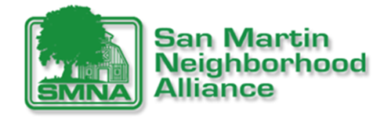
San Martin Neighborhood Alliance Town Hall Meeting Agenda
February 25th, 2021 from 6:30 P.M. to 8:30 P.M.

Welcome ALL
Salute the Flag
President’s Message
Treasurer’s Report
Presentation: Supervisor Wasserman and Staff:
- Covid-19 update
- South County Community Meeting Date—Review of all Airports presentations and information
- Updates regarding the Reid Hillview & San Martin Airports
- New Animal Center
- Other things happening

Presentation: Trina Hineser, Chair of the San Martin Planning Advisory Committee (SMPAC)
- What is SMPAC? Why is it important

Presentation: Greg Williams, Valley Water, Raw Water Division:
- How is the water?
Keeping San Martin Clean: Will you volunteer?

Virtual/Website Fundraiser: What do we have for YOU!
Thank you for attending! Stay safe and healthy!

Next meeting: May 20th, 2021

