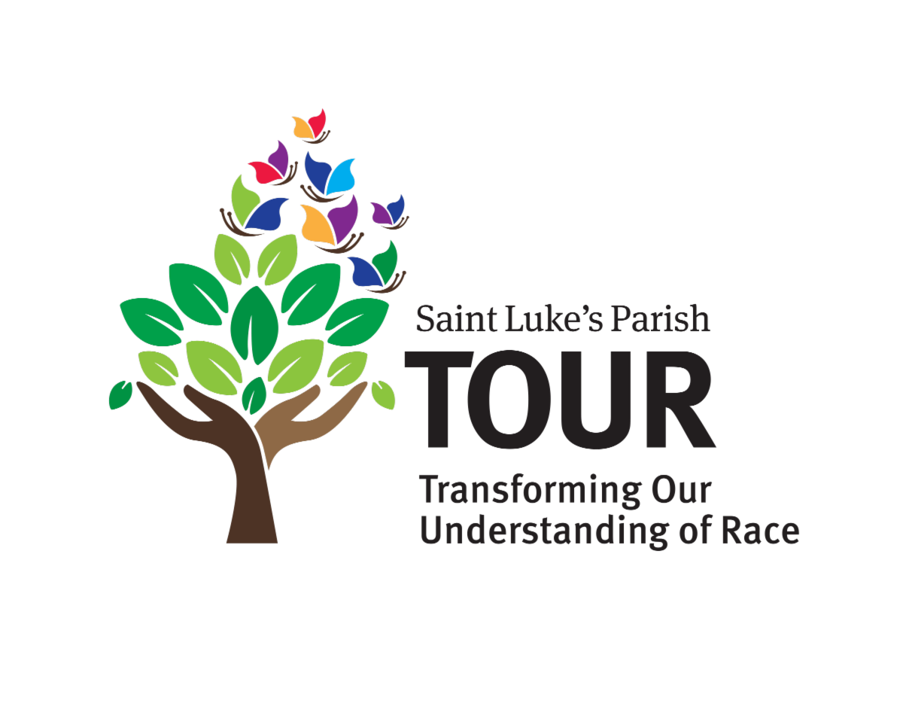
Visit to the Pequot Museum in Mashantucket, CT on November 15 at 11am with TOUR!
The Pequot Museum brings to life the story of the Mashantucket Pequot Tribal Nation. This is a perfect time of year to remember and honor the First Peoples who lived and thrived in our region several centuries ago. We visited the museum recently and found it informative, interesting and accessible. Bring your children or grandchildren. They’ll love the re-creation of the tribal village and the craft activities! For more information on the Museum, click here.
Our visit, led by a museum guide, begins at 11:00 am. The driving time from Darien is about 1 hour 50 minutes. Tour price is $18 for adult, $16 for seniors and $13 for youth.
Sign up by filling in THIS FORM, then make your payment by dropping off a check or cash to Ron Wilson in the Parish Office or call Ron at 203-655-1456 with your credit card details.
Questions? Contact Evelyn Llewellyn at drevelynllewellyn@gmail.com
Planned with great enthusiasm by the TOUR Planning Committee!

Want to find out more about TOUR (Transforming Our Understanding of Race) at Saint Luke's?

TOUR's mission is to transform the understanding of race within and beyond our community, building toward a vision of racial equity through education and engagement. From book studies to film screenings, excursions to events, TOUR offers a wide range of ways to learn & grow. Click here to find out more!
TOUR is led with love by Anne Lynn, Beverly Kelsey, Dawn Stegelmann, Fran Principe, Hannah Pommersheim and Jennifer Boyd.
To learn more or add or remove your name from our email list, email jboyd@boydandassociates.com

