January and MLK Edition
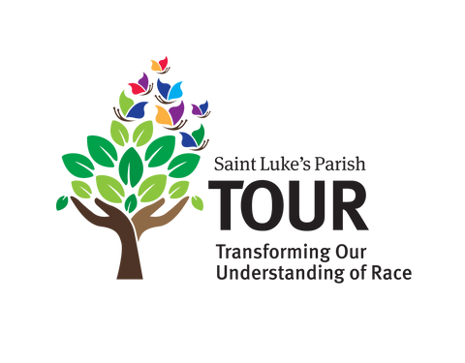
Our mission is to transform the understanding of race within and beyond our community, building towards a vision of racial equity through education and engagement.
Film Series
Monday January 26/ 6:00 p.m. Darien Library/ 1441 Post Road, Darien
TOUR is sponsoring a special screening of "The Tuskegee Airmen," followed by a conversation with Gordon Smith, son of a Tuskegee Airman and expert on the history of this remarkable group of aviators.
This film is the true story of how a group of African American pilots overcame racist opposition to become one of the finest United States fighter groups in World War II. The “Fighting 99th’s” exceptional performance helped pave the way for racial integration of the US military. Starring Laurence Fishburne, the film received several Primetime Emmy’s and wide praise.
We hope to see you there! The event is free, but you are asked to register. Please use this link: Monday Night Movie and Discussion: "The Tuskegee Airmen"

Sacred Ground
Session V/Winter/Spring 2026
TOUR’s core program is Sacred Ground, offering a deep dive into our country’s treatment of non-white peoples throughout its history. And it informs our understanding of race relations today. Sacred Ground V launched on January 7 with a new class of enthusiastic participants. It’s led by Sacred Ground alums Matt Sandoval, Sharon Moore and Wilder Gleason. For more information, questions or put yourself on the wait list for the next session, contact Wilder Gleason: wilder.gleason@gleasonllc.com

Courageous Conversations (For Sacred Ground Alums)
Tuesday March 10/ 6:30-9 p.m./ AYCC
Save the date! Courageous Conversations is a dinner and discussion event held quarterly for those who have completed Sacred Ground. It was inspired by participants who want to continue to explore and discuss racism in our society. Join us to watch a podcast on the evening’s topic, followed by discussions in small groups. The topic for March is immigration – details to follow. Contact Janet Lewis (jblewis40@hotmail.com ) or Jennifer Boyd (jboyd@boydandassociates.com)

COMMUNITY EVENTS

Ferguson Library Film Showing
Saturday January 17/12:30 p.m./1 Public Library Place, Stamford
“King in the Wilderness,” an HBO documentary that follows Dr. King during the last years of his life.

Westport Library

Saturday January 17/1 p.m./20 Jesup Road

20th Annual Rev. Dr. Martin Luther King Jr. Celebration is an annual event commemorating the life and values of Dr. King. The keynote speaker is Peabody Award-Winning Journalist and Scholar Jelani Cobb, a renowned journalist, scholar, speaker, and current Dean of the Columbia University Graduate School of Journalism. According to Hendrik Hertzberg, quoted in the The New Yorker, Cobb “combines the rigor and depth of a professional historian with the alertness of a reporter, the liberal passion of an engaged public intellectual, and the literary flair of a fine writer.”

Interfaith Council of New Canaan
Monday, January 19/10 a.m./ United Methodist Church/165 South Avenue, New Canaan
The Interfaith Council of New Canaan will host its 24th Annual Celebration of the life of the Rev. Martin Luther King Jr. The service will include music, speakers from the ABC House and keynote speaker the Rev. Richard Williams, Executive Director of Pivot Ministries.

NEWSLETTER UPDATES

Check the on-line version of this newsletter on the St. Luke’s Parish website. We will update it with news of TOUR and community events and other items of interest. Here is the link:
Transforming Our Understanding of Race | Saint Luke's Parish

TOUR is led with love by Anne Lynn, Beverly Kelsey, Dawn Stegelmann, Evelyn Llewellyn, Fran Principe, Hannah Pommersheim, Sara Brown and Jennifer Boyd.

To learn more or to add or remove your name from our list: Contact jboyd@boydandassociates.com

