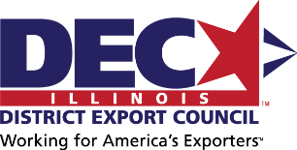
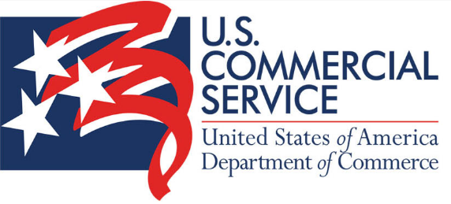

The IL DEC Delegate Trip to the MENA Region
September/October tba, 2025

The Executive Committee of the IL DEC has been putting together a delegation to go to Qatar, UAE, Saudi Arabia, and Jordan September/October 2025, with an add on to go to Israel and back to Qatar.

We are looking for 30 participants to go with the Delegation. The trip will be focused on building business, match making and building long lasting relationships for future cooperation.

Key Objectives:
- Mega Infrastructure Projects in Transportation (Rail, Airports, etc.)
- Construction Alliances / Joint Ventures with Illinois Companies/Organizations
- Consumer Goods Opportunities in Beverages, Spirits, and Other Products
- The Jordan Valley Gateway Project Opportunities with U.S. Support and Companies for Value Creation
- Match-Making and business development collaboration in each focus country

Basic Itinerary:
- September 30th: Departure from Chicago (ORD), IL, USA via Qatar Airways (QR)
Oct 1st: Arrival in Doha (DOH), Qatar
- Oct 2nd to 3rd: Meeting days
- Oct 4th to 6th: Dubai
- Oct 7th to 9th: Saudi Arabia
- Oct 10th to 15th: Jordan

Add-ons for those who want to continue:
- Oct 15th to 17th: Israel
- Return to Chicago on the 18th.

The delegate trip is an investment in your business, with an estimated cost of $15,000 per person (please see page two for ISTEP promotion program of _XX_% reimbursement) for a premium experience, assuming single occupancy in a hotel room. This fee includes coach class airfare, a stay in a top-tier, four-star hotel, ground transportation, breakfast, and most meals. Expect to enjoy specially arranged luncheons and dinners with influential VIPs hosted by the local countries. Please be aware that travel and medical insurance will be your responsibility (check with your local insurance providers).

The program is designed to offer exclusive access to high-level meetings with local industry officials and government representatives tailored to your sector. You'll benefit from local consultants and liaison services, providing essential on-the-ground support. Additionally, you'll have access to translators and matchmaking services, connecting you with targeted representatives, distributors, and direct clients, ensuring every opportunity to elevate your business.

The State of Illinois offers a program to help fund trips aimed at developing export business opportunities. Below, you’ll find the login details and instructions on how to apply for the program.
The IL DEC Chair and Secretary, Sam Odeh and Lisa Waller, recently benefited from this program during the May Tradewinds trip, which significantly helped offset their expenses.
For the upcoming IL DEC Delegation Trip, we estimate an out-of-pocket cost of $15,000. Under the ISTEP program, the State of Illinois could cover 50% to 75% of this amount. Reimbursement is provided after the trip, contingent upon submission of expense documentation and a completed cost sheet.
Login Information:
This is the link to apply for ISTEP (Illinois State Trade Export Promotion) program:
https://oti.ceo.illinois.gov/app/forms/dceo_oti_istep

And this is where there is more information about Illinois ISTEP:
https://dceo.illinois.gov/smallbizassistance/export/istepprogram.html
Instructions on How to Apply:
- Log In: Access the application portal using the login information provided above.
- Create an Account: If you’re a new user, you’ll need to create an account by providing your business details and contact information.
- Complete the Application: Fill out the grant application form, including details about your planned trip and how it will contribute to your export business development.
- Attach Supporting Documents: Upload any required documents such as a detailed trip itinerary, business plan, and financial statements.
- Submit Your Application: Review your application for completeness and accuracy before submitting it through the portal.
- Confirmation: You’ll receive a confirmation email once your application has been successfully submitted.
For further assistance or questions, please contact the program support team at [Insert contact information here].

