Teacher Application for Children’s Book Festival
A free virtual event on Friday, Nov. 12, 2021
Earn an opportunity to have your class visit with an author in a private Zoom session.
All students in selected classrooms will receive a featured book.
Teachers in these classrooms will receive a teaching book set.

Grades K- 4 • General Session 9:00 – 10:15 am
Private Classroom Zoom with an Author 10:30 – 11:00 am

Tricia Elam Walker  New Book: Dream Street, published 11/16 | Yuyi Morales  Lucero – in Spanish | Sheila Modir & Jeffrey Kashou | Jane Yolen | Traci Sorrell  New Book: We Are Still Here
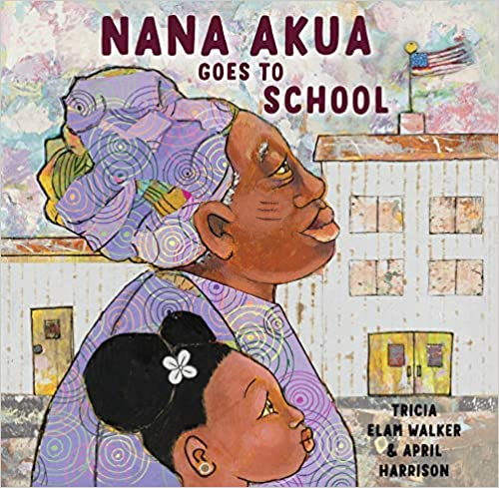 | 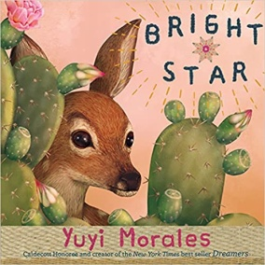 | 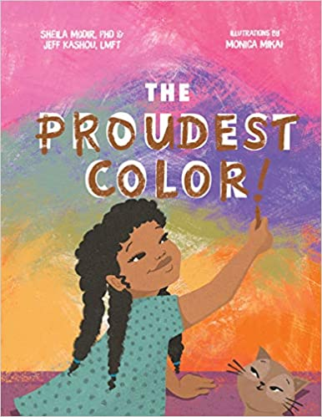 | 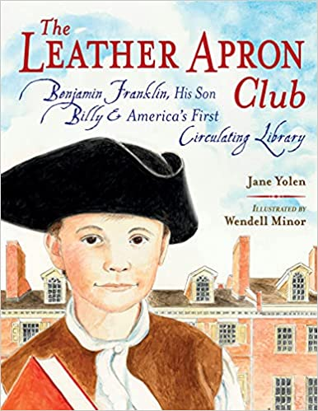 | 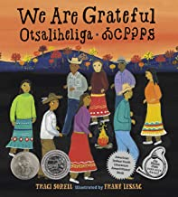

Grades 5-8 • Private Classroom Zoom with an Author 12:15 – 12:45 pm
General Session 1:00 – 2:15 pm

Jewell Parker Rhodes | Karla Arenas Valenti | Varian Johnson | Tracey Baptiste
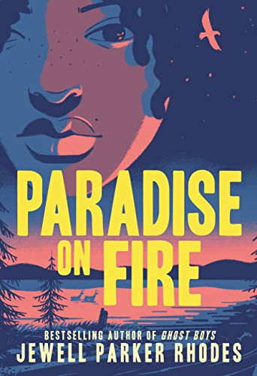 | 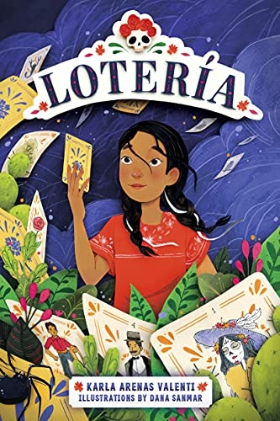 | 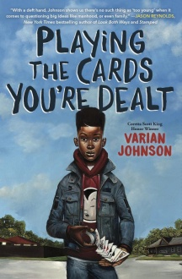 | 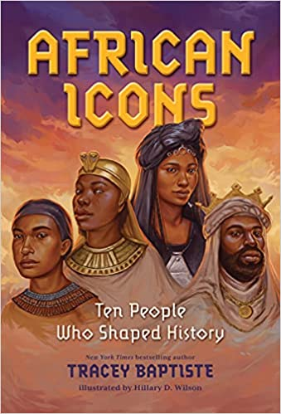

Please submit the attached application no later than Oct. 22, 2021 to CU.bbs.childrensbookfest

For questions about the application process, contact Jacalyn Colt at above email.

Free teaching resources and registration: https://www.colorado.edu/event/bookfest/

What to expect: If you would like to conduct an author or book project with your class and participate in your very own Zoom session with the author, please apply! The project involves reading at least one of the author’s books and conducting a response to the book prior to the festival. It would also be helpful if you and your students brainstormed a list of some questions that they would like to ask the author.
At the time of the private session, you will log into Zoom, and project the Zoom on screen so that your students can see the author clearly and hear what they are saying (some teachers like to gather students on a rug in front of the screen).
One of the festival committee members will host this event, introducing the authors and facilitating the process for the author and for your students (with you, of course!). The author will most likely do a read aloud and share more about themselves and their artistic processes. There will be plenty of time for Q&A. Authors love to see student work, so there may be a few minutes in which a few students could share an artifact (a piece of art, a poem, a video, etc). We will allot 5 minutes for this, if you so desire.
If you are selected, a festival committee member will contact you to have a brief phone call to discuss the event and answer any questions you might have.
We think this will be a wonderful opportunity for your students, and hope you agree!

Teacher Application for Private Zoom Session with Author

Teacher’s Name: School: Grade:

District: Email:

Telephone:

Number of students in class:

Address where you’d like your books delivered if your application is selected:

Your affiliation with CU:
Current Student Cooperating Teacher (current or past)
Alumni Other: None

Commitment to engage in a book/author study prior to this event? Yes No
Additional information:

Choose grade level and then rank order your choices:
Grades K – 4 |  | Grades 5-8
 | Tricia Elam Walker |  | Jewell Parker Rhodes
 | Yuyi Morales English Spanish |  | Karla Arenas Valenti
 | Sheila Modir and Jeffrey Kashou |  | Varian Johnson
 | Jane Yolen |  | Tracey Baptiste
 | Traci Sorrell

Please submit this application no later than Oct. 22 to Jacalyn Colt, CU.bbs.childrensbookfest
We will respond to your application via email as quickly as possible.

