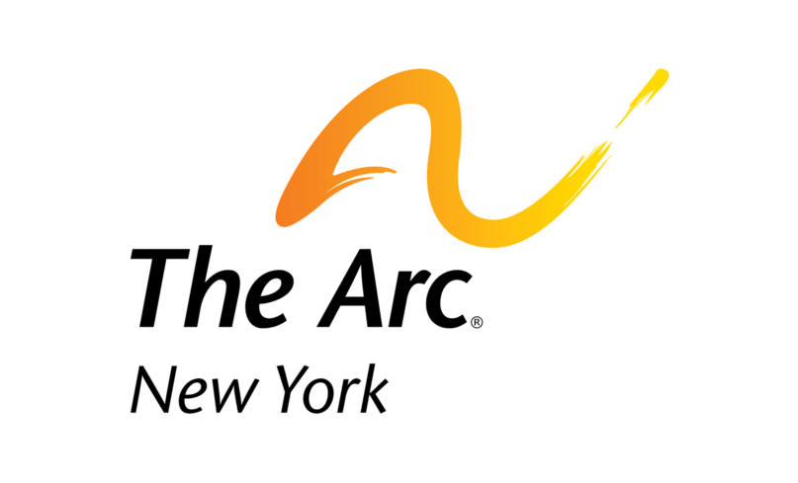

Write the Governor and OPWDD
to avoid drastic cuts in funding

The topic
On May 27, 2020, the Department of Health published a public notice in the New York State Register announcing proposed cuts in reimbursement for IRA and ICF residential programs by eliminating the occupancy adjustment resulting from vacancies and slashing reimbursement by 50% for retainer days when residents are in the hospital or are taking therapeutic leave days for family visits. Finally, after cutting reimbursement by 50% for leave days, the proposal also would impose an annual “cap” of 96 days of therapeutic leave days, after which reimbursement would be reduced to zero.

Ostensibly, this is being done to save taxpayers from paying for “empty beds,” which implies services aren’t delivered. But you know these are not empty beds, they are the homes that our loved ones return to, and you know that service doesn’t stop simply because they’re not in their bed.

If you would like to write your own letter in opposition to the vacancy rate cuts, we have provided some context below for how the proposed cuts would affect service to people with I/DD.

Tips for writing your letter:
Identify yourself
Say why you are writing and who you are. List your credentials, your relationship to the I/DD field, and state that you are a constituent. It also doesn't hurt to mention if you voted for or donated to them.
Personalize
Tell your elected official why this legislation matters to you and the people you know. If you have one, include a personal story that shows how this issue affects you and your family.
Be emotional and factual
Provide detail without exaggeration about how the vacancy rate cuts would affect you and others.
Close with a request
Close by requesting the action you want to be taken. Ask that the state do away with cuts to the vacancy rates and find savings elsewhere.

Talking points
The proposed vacancy rate cuts in reimbursement for IRA and ICF residential programs would:
- Take about $200 million every year from our loved ones with I/DD.
- The proposed cuts will severely limit funding for individuals simply because they require hospitalization due to medical or psychiatric illness or choose to take a therapeutic leave to spend time with family members.
- Reduce reimbursement by as much as 7.5% for certain residential programs with significant vacancies, including vacancies due to deaths from COVID-19.
- Disproportionately harm individuals with serious medical or psychiatric conditions, as they spend more time away from a residence and therefore create more “empty beds.”
- Drastically cut funding to providers in the wake of the COVID-19 pandemic, after providers were seemingly abandoned to the point of having to purchase their own personal protective equipment.
- Come at a time when voluntary providers are already owed funding from the state. The proposed cuts will directly offset rate enhancements previously provided by the NYS Legislature in 2019. The Legislature approved two 2% salary enhancements for direct care and clinical staff working in OPWDD residential programs – one increase to be implemented on January 1, 2020, and the second on April 1, 2020. Neither has been implemented as of this date but remain “under review” with the Division of the Budget.

Where to send your letter
OPWDD Commissioner Dr. Theodore Kastner
Written comments on the proposed cuts will be accepted from June 1, 2020 through July 1, 2020 and may be submitted by mail to:

OPWDD, Division of Policy and Program Development
44 Holland Ave
Albany, NY 12229

or by e-mail to: peoplefirstwaiver@opwdd.ny.gov.

Gov. Andrew Cuomo

Mail: The Honorable Andrew M. Cuomo
Governor of New York State
NYS State Capitol Building
Albany, NY 12224

Phone: 1-518-474-8390

Submit a message online at https://www.governor.ny.gov/content/governor-contact-form

Template Letter

Dear Governor Cuomo and Commissioner Kastner:

My name is [Insert Name] and I am a constituent and [parent/family member/caregiver/supporter] of a New Yorker with an intellectual and developmental disability.
I am writing in extreme opposition to cuts in reimbursement for IRA and ICF residential programs as published in the State Register.
These cuts would eliminate the occupancy adjustment resulting from vacancies and slash reimbursement in half for days when our brothers, sisters, sons, and daughters must go to the hospital, receive therapy, or visit family.
Ostensibly, this is being done to save taxpayers from paying for “empty beds,” which implies services are not being delivered. But these are not empty beds, they are the homes that our loved ones return to, and this cut would jeopardize that simple security.
Just as my own basic expenses don’t go away when I’m on vacation or in the hospital, the cost to a provider for caring for my loved one doesn’t simply vanish when they are away from home.
The costs for direct care staffing - 80% of which is the salary paid to direct care staff, clinical staff and residence supervisors - are fixed and can’t be reduced simply because my loved one is out of the house. Staff provide care around the clock for everyone in a home, and if one person is in the hospital, providers can’t just place a staff member on unpaid leave until the hospital stay is over.
Voluntary providers have been cut to the bone after years of underfunding by the state. This cut will no doubt cause a decrease in the number of residential openings in the state at a time when there is a waiting list in the thousands for these coveted spots.
New York has a constitutional obligation to care for its most vulnerable citizens. It is a promise this state has made to my loved one, and to every New Yorker with I/DD. Where you see wastefulness in paying for empty beds, we see the state’s proposed cuts as the delivery of an empty promise.
This empty promise would:
- Take about $200 million every year from our loved ones with I/DD.
- Reduce reimbursement by as much as 7.5% for certain residential programs with significant vacancies, including vacancies due to deaths from COVID-19.
- Disproportionately harm individuals with serious medical or psychiatric conditions.
- Drastically cut funding to providers in the wake of the COVID-19 pandemic, after providers were seemingly abandoned to the point of having to purchase their own personal protective equipment.
Don’t make empty promises.
Allow our family members to have the dignity and stability of returning to the same friends, staff, comforts, and level of service they left. Rethink your proposed cuts to the vacancy rates and find savings elsewhere.

Sincerely,

Insert Name

