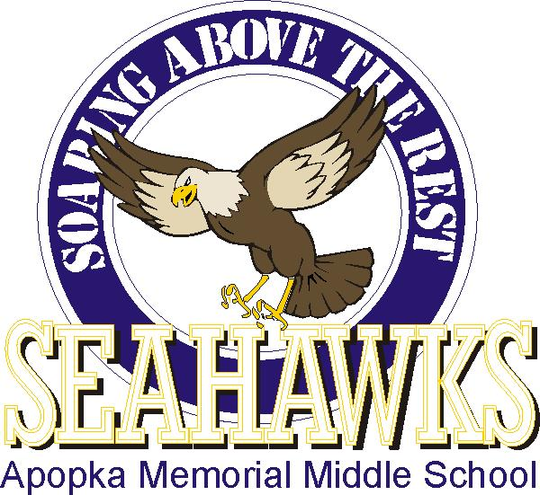
OPEN CAMPUS 2021

Come meet your teachers, find your classrooms and pick up a class syllabus. Printed copies of your schedule will be available, or you can find it on your student’s Skyward.
6th grade students
Thursday, August 5th
Orientation in the auditorium at 4:30 pm
Walk campus from 5:00 pm to 6:30 pm
Get early seating at 3:30 pm if you join the PTSA

7th and 8th grade students
Wednesday, August 4th
4:30 pm to 6:30 pm
Come early if you join the PTSA: 3:30 pm

*You can join the PTSA online anytime or in person on the days of the events. Join here: https://ammsseahawksfl.memberhub.com/store
If you cannot make it by the school on these days, you can come to the office to pick up your schedule anytime between the hours of 8:00 am to 4:00 pm before school starts. Teachers may not be available, but you can walk the campus to find your rooms.
The first day for students is Tuesday, August 10th. All students will get a new schedule on Tuesday morning in their homeroom class.
**Do not bring supplies to Open Campus. Your teachers will let you know what supplies students will need on their syllabus. General supplies for the first week of school are: laptop computer; backpack; notebook paper; pen/pencil; two-pocket folders (7, one for each class) or one binder with 7 dividers to put papers in for each class; refillable water bottle.

Follow us on Twitter: Apopka Middle@ApopkaMS_OCPS
Be sure to come by the front office and give us your email address so you will receive the weekly school announcements. If you have questions, please call 407-884-2208 and hit “0” to get our receptionist. You can also email apopka_ms@ocps.net anytime.

