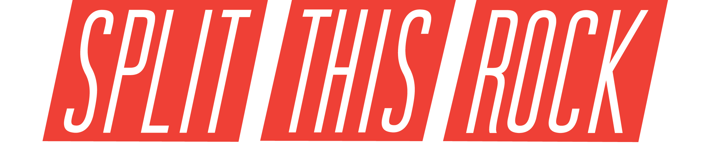

poetry festival: poems of provocation & witness

March 26-28, 2020 | Washington, DC

2020 Registration Form
Split This Rock Poetry Festival: Poems of Provocation & Witness 2020 calls poets, writers, educators, activists, and dreamers to Washington, DC for three days of readings, workshops, panel discussions, youth programming, open mics, and activism. Featuring some of the most socially significant and artistically vibrant poets today, the Festival offers opportunities to speak boldly for justice, build connection and community, and celebrate the many ways poetry can be a practice for social change.

Festival Dates
The Festival occurs Thursday, March 26 through Saturday, March 28, 2020.

Registration Deadline
Registrations are due by Friday, February 28, 2020 (midnight EST). If submitting by mail, registrations must be postmarked no later than Friday, February 14, 2020.

About Festival Registration Fees
Split This Rock is committed to making the Poetry Festivals financially accessible. We keep fees low, offer a registration subsidy fund, and provide opportunities to attend the Festival for free through volunteering. Historically, income from registration fees covers less than a third of Festival costs, so we now registration options to better support the Festival. We estimate the cost of the Festival to be at least $300 per person, and we invite everyone who is able to pay at that level. For those with a greater capacity, please consider giving an additional amount to cover subsidized registrations and the full cost of the Festival. You can also help us keep Split This Rock Poetry Festival financially accessible by recruiting people and organizations in your network to sponsor the Festival, purchase program book ads, and reserve a table at the Book Fair. Contact poetryfest@splitthisrock.org for more information.
You can also donate directly to Split This Rock to support all programs. Whether you're able to give or not, we thank you mightily for the ways you carry and embody the work of Split This Rock. Donations can be made online at Split This Rock's website.

Group Rates, Volunteer Opportunities, Registration Subsidy Fund
Group rates are available for groups of 10 or more people. Volunteers who serve for 3 ½ hours or more receive free registration. A Festival Registration Subsidy Fund is available based on financial need. For instructions on accessing these rates, visit our website, email us at poetryfest@splitthisrock.org, or call 202-787-5210.

Where to Submit This Form
Mail your completed registration form with payment to: Split This Rock, 1301 Connecticut Ave NW Suite 600, Washington, DC 20036 or poetryfest@splitthisrock.org. Please use only one form per person.

For More Information
Contact us at poetryfest@splitthisrock.org or 202-787-5210. To learn more about Split This Rock, visit www.splitthisrock.org.

SPLIT THIS ROCK POETRY FESTIVAL 2020 REGISTRATION FORM - PAGE 2

Please supply the information requested on each row:
First Name:
Last Name:
Name As You’d Like It On Your Name Tag (If different than above):
Organization/Affiliation (if any):
Mailing Address:
Email Address:
Home Phone Number:
Cell Phone Number:

Please select a fee from the list below by putting a check next to your desired fee.
Check one | Fee Categories | Fee
 | General Registration - I want to cover actual costs! | $300
 | General Registration – Investor Level | $400
 | General Registration – Supporter Level | $350
 | General Registration – Helping Hand Level | $250
 | General Registration - On Your Side Level | $200
 | General Registration - Early Bird Rate (expires 1/31/2020) | $150
 | General Registration – After 1/31/2020 | $200
 | Presenter Registration – Early Bird Rate (expires 1/31/2020) | $120
 | Presenter Registration – After 1/31/2020 | $150
 | General Registration for Institutions – Early Bird Rate (expires 1/31/2020) | $250
 | General Registration for Institutions – After 1/31/2020 | $300
 | Student Registration – Early Bird Rate until 1/31/2020. (For current students only. Please bring student ID to check in.) | $50
 | Student Registration – After 1/31/2020. (For current students only. Please bring student ID to check in.) | $75
 | Student Registration - Supporter Level (For current students only. Please bring student ID to check in.) | $100
 | Just Friday | $100
 | Just Saturday | $100

SPLIT THIS ROCK POETRY FESTIVAL 2020 REGISTRATION FORM - PAGE 3

WOULD YOU LIKE TO ORDER T-SHIRTS?
Indicate below if you would like to purchase a t-shirt by entering the number of shirts desired and total for your purchase.
NUMBER OF SHIRTS | SIZE | PRICE | TOTAL
 | Small | $20
 | Medium | $20
 | Large | $20
 | Extra Large | $20
 | 2XL | $20
 | 3XL | $20

To pay by credit card, please supply the information requested on each row:
Name on Credit Card:
Type of Credit Card:
Credit Card Number:
Amount:
Expiration Date:
Security Code:

TOTAL AMOUNT ENCLOSED:_________________________

