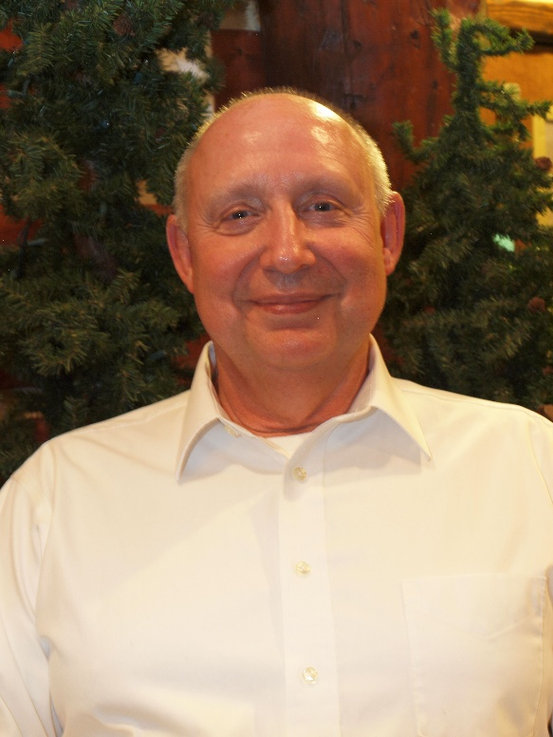
Obituary for Robert Craig Berthold
Robert Craig Berthold, 73, passed away on February 27, 2026, in Bogotá, Colombia, after a brief illness. Robert was born on June 1, 1952, in Chicago, Illinois, to Dr. Arthur and Jean Berthold, both of whom preceded him in death.
Robert is survived by his wife of 50 years, Mary; his daughters Marissa and Melinda (husband Dr. Jerrod Nordberg) and their son Oskar; his brother Richard Berthold; and his sister Barbara Vercimak (née Berthold) and their families. He will be remembered with deep love by his family, friends, and the many communities he served.
A lifelong learner, Robert earned a Bachelor of Science in Forestry from the University of Illinois at Champaign–Urbana, attended Luther Seminary in St. Paul, and then completed a Doctor of Ministry at the Lutheran School of Theology in Chicago, Illinois. His intellectual pursuits were matched by a deep commitment to ministry. Over the course of his 40-year career as a Lutheran pastor, he served congregations in Shakopee, Minnesota; Wales, Alaska; Hannaford and Sutton, North Dakota; Jamestown, North Dakota; Carrington, North Dakota; Moorhead, Minnesota; Clara City, Minnesota; Oakland and Moscow, Minnesota; and Welch and Cannon Falls, Minnesota. Through countless weddings, funerals, baptisms, and weekly services, he ministered to thousands with warmth, compassion, and unwavering faith.
Robert’s love of travel and the outdoors shaped both his family life and his personal adventures. He cherished family and ministry trips to the Boundary Waters Canoe Area, Rocky Mountain National Park, and Grand Teton National Park where he experienced the closeness of God through nature. His global travels took him to the USSR in 1983, to Nepal for a month of trekking to Everest Base Camp, and later to Africa for a month-long journey that included climbing Mount Kilimanjaro. He additionally led mission trips to Israel, visiting the Churches of Revelation in Greece and Turkey, and Haiti with various congregational members. After the age of 60, he began studying Spanish in earnest, becoming fluent through multiple immersion trips. He went on to visit nearly every country in Central and South America providing a personalized ministry of outreach to the poor.
He was a former high school wrestler and soccer player at Main East High School in Park Ridge, Illinois, as well as a devoted fan of the University of Illinois basketball and football, cheering on the Illini with lifelong enthusiasm. Above all, Robert was a man of deep faith, integrity, and kindness. His greatest joy was his family, and he held immense love and respect for his wife, Mary, his partner in every season of life.
Robert’s legacy is one of service, love of learning, and steadfast belief in the promise of life everlasting through Jesus Christ our Savior. He will be profoundly missed and lovingly remembered.

In lieu of flowers, the family requests that memorial gifts be made in memory of Rev. Robert Craig Berthold to Mayo Clinic, designated to the Poverello Foundation. Donations can be made by phone, online, or by mail:
Phone: Please call 1-855-852-8129 to speak with a team member who can facilitate a secure gift over the telephone.
Online: Visit https://give.mayoclinic.org/mc and complete the online form. Select “Tribute Information,” check “in memory of,” and enter Rev. Robert Craig Berthold. Please note Poverello Foundation as the designation.
Mail: Checks may be made payable to Mayo Clinic and sent to 200 First Street SW, Rochester, MN 55905. In the memo line, please write in memory of Rev. Robert Craig Berthold and Poverello Foundation.

