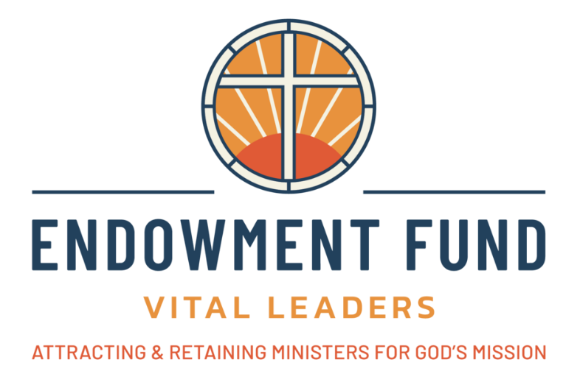
EASTERN NORTH DAKOTA SYNOD VITAL LEADERS ENDOWMENT FUND

Purpose: The Vital Leaders Endowment Fund exists to sustain rural ministry and enhance the quality of rostered ministry within the synod.
LEADERSHIP GRANTS
Leadership Grants are available through the Vital Leaders Endowment Fund to support and advance the development of Rostered Ministers and to enhance mission and ministry in the Eastern North Dakota Synod. Leadership Grants are not intended to replace continuing education funds which are to be part of a compensation agreement.

Application Process:
- Complete and submit the application and email to endowment@eandsynod.org.
- A Leadership Grant Review Committee may review proposals and forward its recommendations to the Vital Leaders Endowment Fund Steering Committee.
Request Amount:
Leadership grants are typically in the range of $500 to $2,000.

Application Deadlines:
Applications are received twice a year. Deadlines are April 7 and October 14.

QUESTIONS: Please contact Pastor Jon B. Olson at endowment@eandsynod.org or 218 205-4748.

Eastern North Dakota Synod Vital Leaders Endowment Fund
Leadership Grant Application

DATE:
NAME:
CONGREGATION/MINISTRY:
EMAIL:
PHONE:
ADDRESS:
CITY:
STATE:
ZIP:

GRANT REQUEST AMOUNT:

PLEASE PROVIDE AN OVERVIEW, TIMEFRAME AND DETAILED BUDGET OF HOW THE REQUESTED DOLLARS WILL BE USED.

HOW WILL THIS INVESTMENT BENEFIT YOUR MINISTRY?

DESCRIBE THE ANTICIPATED OUTCOME?

HOW WILL THIS INVESTMENT BENEFIT MISSION AND MINISTRY IN THE EASTERN NORTH DAKOTA SYNOD?

HAVE YOU RECEIVED A VITAL LEADERS LEADERSHIP GRANT IN THE PAST? IF SO, WHEN AND FOR WHAT PURPOSE WAS THE GRANT MONEY USED?

WILL YOUR MINISTRY SITE CONTRIBUTE FUNDS TOWARD YOUR PROJECT/ACTIVITY OR WILL THERE BE OTHER SOURCES TO HELP SUPPLEMENT YOUR FUNDING REQUEST?

