
“Anyone considering giving should know that their support directly impacts real people and real ministries in our Synod. Even a small gift helps sustain programs that are vital to the church.”
-Clara Kjelland
EaND Synod Council Youth Representative
“Anyone considering giving should know that their support directly impacts real people and real ministries in our Synod. Even a small gift helps sustain programs that are vital to the church.”
-Clara Kjelland
EaND Synod Council Youth Representative

Please consider making a gift to the Eastern North Dakota Synod on Giving Hearts Day - February 12, 2026!
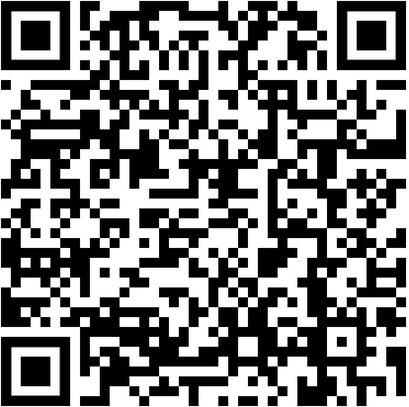
Early giving is open now!
Give by check:
EaND Synod, PO Box 2019, Fargo, ND 58109
Put “Giving Hearts Day” in the memo line.
Give online: https://app.givingheartsday.org Scan to Give.
Please consider making a gift to the Eastern North Dakota Synod on Giving Hearts Day - February 12, 2026!
Early giving is open now!

Give by check:
EaND Synod, PO Box 2019, Fargo, ND 58109
Put “Giving Hearts Day” in the memo line.
Scan to Give.
Give online: https://app.givingheartsday.org


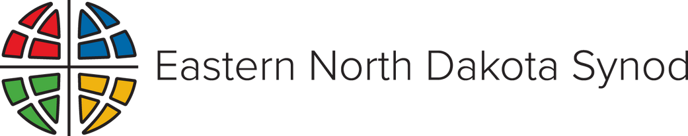

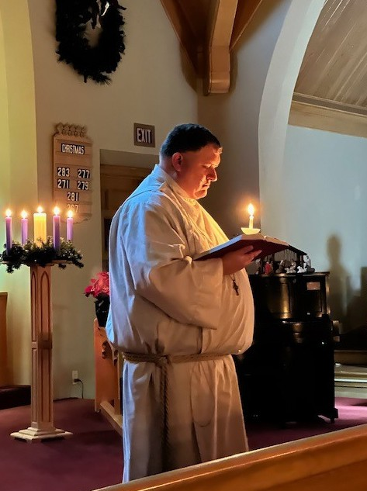
“The Synod equips us who are already in positions of leadership with the tools and resources to encourage and lift up people who maybe never considered ministry as vocation. I am proof of that.”

-Pr. Steve DeKrey
Northwood/Washington Parish
“The Synod equips us who are already in positions of leadership with the tools and resources to encourage and lift up people who maybe never considered ministry as vocation. I am proof of that.”

-Pr. Steve DeKrey
Northwood/Washington Parish

Please consider making a gift to the Eastern North Dakota Synod on Giving Hearts Day - February 12, 2026!
Early giving is open now!
Give by check:
EaND Synod, PO Box 2019, Fargo, ND 58109
Put “Giving Hearts Day” in the memo line.
Give online: https://app.givingheartsday.org Scan to Give.
Please consider making a gift to the Eastern North Dakota Synod on Giving Hearts Day - February 12, 2026!
Early giving is open now!

Give by check:
EaND Synod, PO Box 2019, Fargo, ND 58109
Put “Giving Hearts Day” in the memo line.
Give online: https://app.givingheartsday.org Scan to Give.



