Workflow for Affiliate Fund Grant Request



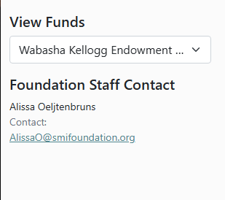
- Select the fund granting dollars (Endowed Fund, General, or the Program Fund money will come out of)
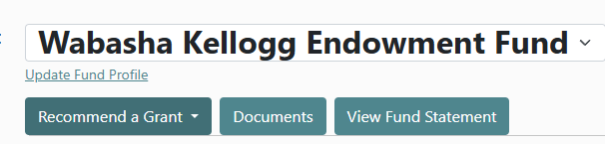
- Select “recommend a grant” – This selection is for any request where a check will be cut using the specified fund’s money. This is the terminology the Database Designer Uses, SMIF is unable to rename it at this time.
  - Current selection – use Business/Individual for bills, invoices, reimbursements, grants, or scholarships
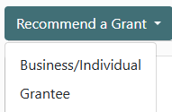
  - Only use Grantee exclusively for if you want to make an interfund transfer from a fund under SMIF to another fund under SMIF, or to another Community foundation
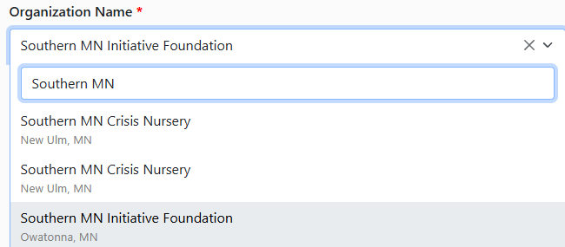
- When requesting a check, search if there is an existing record for the individual or organization to be paid through the Organization Name Search.
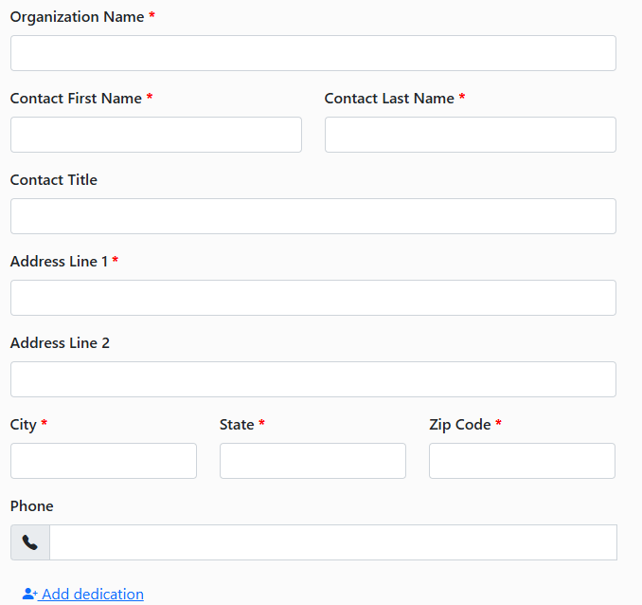
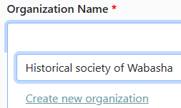
- If the search does not find the desired recipient, select create new organization, and fill out fields to process – This must be done for individuals or Businesses if you are unable to find them in the search.
  - For new Individuals:
    - Organization Name is “First Name Last Name”,
    - Contact First Name and Contact Last Name are their respective names
    - Address information is the contact address to be mailed to.
  - For a new Business:
    - Organization name is the Business’s name
    - Fill in contact information if available. If there is not a contact for the bill/invoice, fill in the contact first and last name as a period “.” – the contact name entries are currently a required field to process from the portal into the database. SMIF is working to remove this requirement from the request form.
- Fill in the Amount filed with the total to be granted/made out for on the check
- Leave the Grant Type field as General Operation / Unrestricted
- For file upload, the system only can accept 1 file per request; so please follow the below for streamlining the process:
  - If check request is for Grants: upload the grant application
  - If check request is for Reimbursement: upload receipt(s) they are being reimbursed for
  - If check request is for Bill/invoice payment: upload Receipt, invoice, or billing statement
  - If check request is for Donation (no invoice): upload minutes approving the donation and amount
- Please note, with the new system limit on file uploads and to fast-track check processing, SMIF will not require minutes be submitted with the check requests below a $2,500 threshold. Any check requests at or above a $2,500 total will not be processed until SMIF receives minutes. SMIF still does require all minutes be submitted promptly for Audit purposes – for smaller item we can accept the minutes coming a little later.
- Recommendation notes: any necessary information for the grant being recommended – i.e. noting the program for the check memo of the check if dollars are for specific project.
- Comments: Please use this to note what the check will be for:
  - Reimbursements – use “Reimbursement for” and what the person is reimbursed for summarized
  - Grants – please note the grant program or project to be noted on the check memo. This would often be the Project on the grant application.
  - Donations – note any restrictions – if no comment on a donation, will set the memo to “General Support”
- Check the box for “I certify the information submitted…”
- Press Submit Now to have the grant move into the SMIF database automatically for processing – you will receive an email confirming the successful grant submission.
  - You may also select Submit later if you are waiting on information for the check request, or want to set up a payment in advance and hold off on submitting the request for the time being.

