GGC PAC Contribution Form

Through the years, the Illinois Asphalt Pavement Association (IAPA) and its Good Government Council Political Action Committee (GGC PAC) have supported elected legislators and officers of Illinois who understand the critical role that highway infrastructure plays in Illinois’ economy. Through these efforts and the hard work of member companies and staff, IAPA is recognized as a leader for our industry.

Contributor Information
Contribution Type ¹ | Individual | Business/Group | Political Action Committee
Name
Address
City, State Zip
Phone
¹ Contribution limits per election cycle is based on contribution type: a. $11,600 from an individual; b. $23,200 from a corporation, labor organization, association, or Political Party Committee; c. $57,800 from a Political Action Committee or Candidate Political Committee.

Contribution Amount
$500 (Smooth) | $1,000 (Full-Depth) | $5,000 (Perpetual Pavement) | Other $

To make a contribution, return this form with a check for the contribution amount to:

Good Government PAC
241 N. 5th Street
Springfield, IL 62701

For copies of required reports or for more information, visit the Illinois State Board of Elections website at www.elections.il.gov. Thank you for your continued support.

Sincerely,
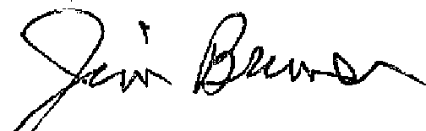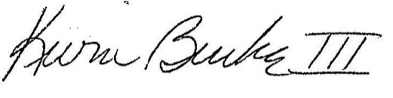
James P. Bruner Kevin Burke III. P.E.
Good Government Council Chairman Executive Vice President
Illinois Asphalt Pavement Association

