Join Brays Oaks Super Neighborhood Council #36
Tuesday, January 6, 2026 @ 6:30PM
10611 Fondren Rd @ Creekbend in Fellowship Hall

I: President’s Call to order: @6:30p

II: Old Business:
- Review and Approve May, June, September & December Meeting Minutes

III: New Business:
- Treasurer's Report
- Elections for President & Secretary February 2026

IV: Skip Reeder; Update on Ruffino & Doty Landfill Detention & Flooding Preparedness

V: Guest of Honor:
Metro’s Chief Strategy Officer
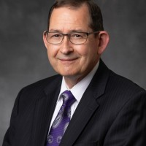
Alan C Clark

VI: Community Announcements

VII: Meeting Adjourns

NEXT MEETING: Tuesday, February 3, 2026

Website: https://braysoakssnc36.org
Follow us on:

Facebook@Brays Oaks Super Neighborhood Council #36 Instagram@braysoakssnc36

