Join Brays Oaks Super Neighborhood Council #36
Tuesday, August 4, 2026 @ 6:30PM
10611 Fondren Rd @ Creekbend in Fellowship Hall

I: President’s Call to order: @6:30p

II: Old Business:
- Vote for Stakeholder Representative, Southwood Place Civic Club

III: New Business:
- Treasurer's Report

IV. Sharon Young Shares Cultural Arts Video
Unveiling of the Riceville Memorial, Juneteenth 2026

V: LaTasha Smith, City of Houston Housing and Community Development Department, Disaster Recovery Programs

VI. Sophie Adams, Community Affairs Advisor
Harris County Budget Season Community Outreach & Engagement

VII: Special Guest: Council Member
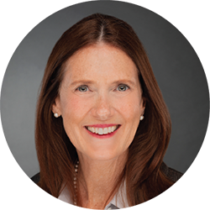
Sallie Alcorn, At-Large
Position 5
VIII: Community Announcements

IX: Meeting Adjourns
NEXT MEETING: Tuesday, September 1, 2026
Website: https://braysoakssnc36.org
Facebook@Brays Oaks Super Neighborhood Council #36 Instagram@braysoakssnc36

