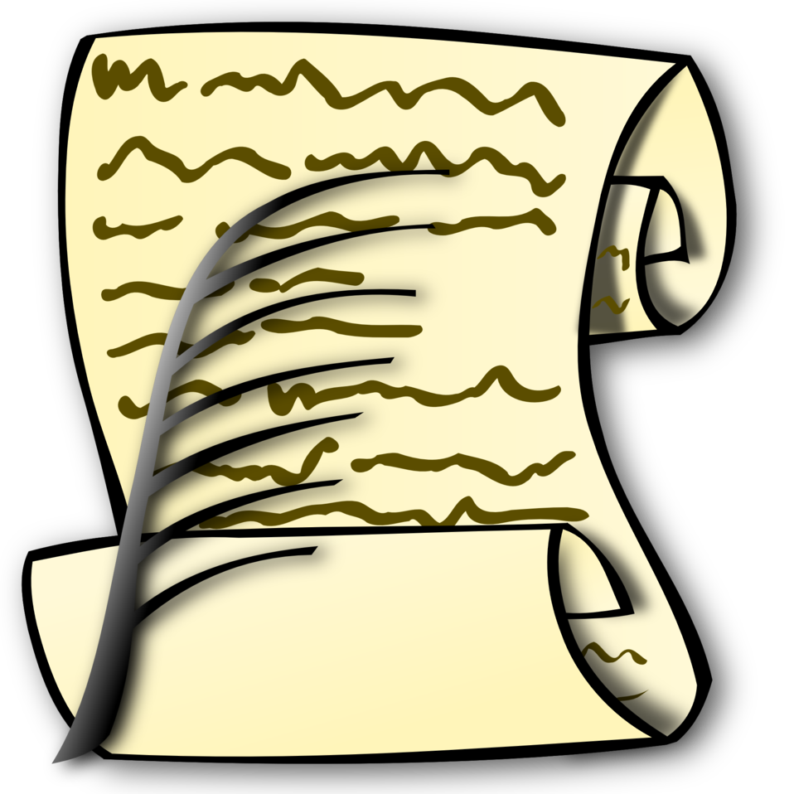
Constitution and Bylaws Committee

The C & B Committee has put together a sample governing document based on the sample in National’s Unit Handbook and the Department of KS C & B.. If your documents are very old, missing or not digital you may copy the document then fill in the blanks. Read through and make adjustments based on your unit. The Unit will need to adopt all updates or changes with a ⅔ vote for the Constitution and Bylaws and a majority vote for the Standing Rules. There are items in gray to give direction that can be delegated when that section meets your Unit’s needs.
When you click on the link it will ask/require you to make a copy.

Constitution, Bylaws and Standing Rules Sample link

When your Unit has adopted updated governing documents, we ask if you would please email me a copy at s.wiley160@gmail.com . The committee plans on creating a file of digital copies.
Attached you will find the chart that we have so far.

Constitution and Bylaws Chart link

Sonia Wiley
Units please check the date your Constitution and Bylaws was updated. Anything before 2019 will need to be reviewed and updated. That is when the word wife changed to spouse.
Department C&B Chair

