SJA Dinner Night Out
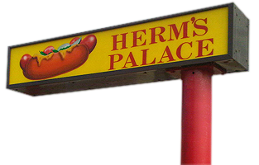

Thursday, November 10th
Take a break and enjoy dinner or lunch out at
Herm’s Palace
3406 Dempster St, Skokie
847-673-9757
Lunch & Dinner - Dine In or Delivery
Menu available hermspalace.com
Herm’s will donate 20% of all purchases to
St Joan of Arc. Print this flyer or make sure you mention SJA Night Out when ordering!
**It’s Teacher Conference Day, perfect time to eat out.

