
Digital Signage | LED Signage | Interactive Display | Commercial TV
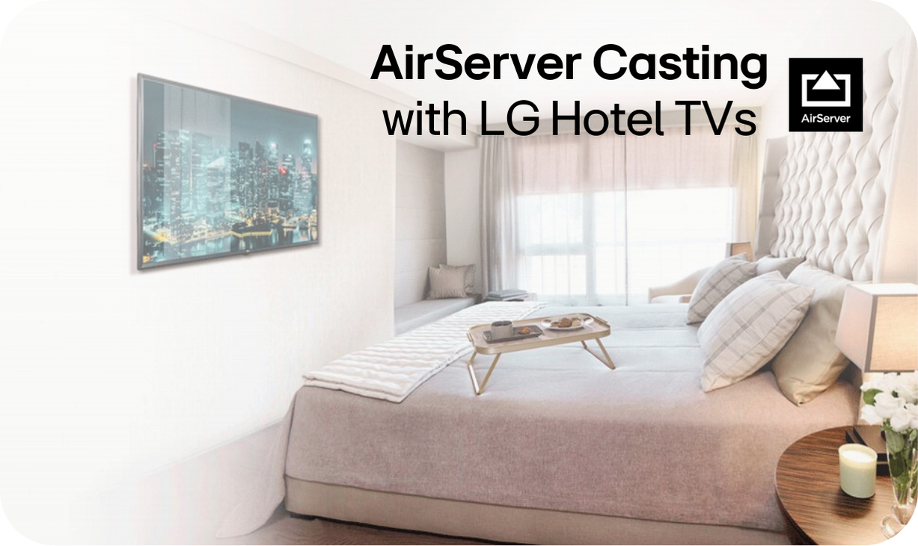

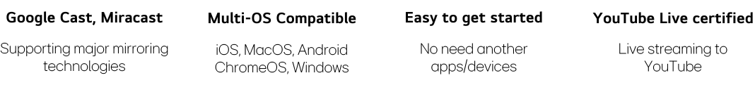
Our newly launched built-in AirServer elevates LG TVs into wireless multimedia hubs, enhancing guest experiences. Contact us for a live demo of the exclusive Hotel TV solution plan.

Experience the ultimate in-room entertainment with LG Hotel TVs, now featuring built-in AirServer. Elevate your your guest's stay with seamless device mirroring, compatible with iOS, Android, Windows, and Chrome OS. Enjoy the convenience of Google Cast, allowing guests to stream their favourite content effortlessly.

Upgrade to LG Hotel TVs with AirServer and offer unparalleled entertainment options. Contact Us for Offers of LG Commercial TVs x AirServer.

Contact LG Hospitality Solutions Team

Need a Personalised Consultation?
Find the perfect solution for your System Integration Projects

Click to Enquire

Privacy ㅣ Unsubscribe | 
LG may make changes to specifications and product descriptions without notice.  Copyright © 2024 LG Electronics Inc. All rights reserved. “LG Life’s Good” is a registered trademark of LG Corp. The names of products and brands mentioned here may be the trademarks of their respective owners. | 

