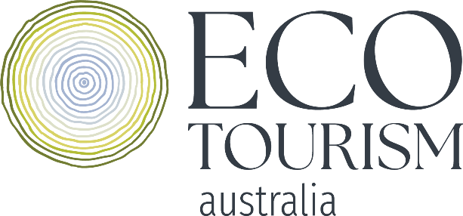

Start your sustainability journey with Ecotourism Australia

Sustainability is everywhere these days and rightfully so, it’s a big deal! Consumers are behind the push for more eco-friendly and responsible travel with 80% of global travellers confirming sustainability is important to them and 3 in 5 opting for more environmentally friendly lodging between 2020 and 2022.

Tourism businesses and accommodations across Australia are at the forefront of the sustainability transition for Australia’s visitor economy, implementing new technologies, developing sustainability plans, and gaining recognition for their best-practice efforts and you can join them!

But maybe you’re not sure where to even begin? Perhaps you’ve already started to dip your toe in the water but want some reassurance. Or you’ve already taken the full plunge but you’re not sure where to go next. Sustainability is a journey, not a destination and wherever you are on your pathway, Ecotourism Australia is here to help.

The important part to remember is you don’t have to be perfect! “You don’t have to be great to start, but you do need to start to be great” – Zig Ziglar

Begin with the Strive 4 Sustainability Scorecard
The best place to start your sustainability journey is with the Strive 4 Sustainability Scorecard. Founded in partnership with Tourism Australia, the Scorecard is a pre-certification pathway program to see how you compare to our globally recognised criteria for sustainable tourism. Accommodation Australia believe in the power of sustainability for the accommodation sector and are a key Industry Partner supporting the Strive 4 Sustainability Scorecard program.

The Scorecard program will help you assess your current activities across the four pillars of sustainability: environmental, socio-economic, cultural and sustainable management, with a simple Scorecard demonstrating to your peers and guests what you are doing well and your commitment to continuous improvement.

Why should you complete the Scorecard?
- Educational | De-mystify what sustainability looks like with 50 criteria addressing the four pillars of sustainability and a comprehensive feedback report from our coaches with practical suggestions for improvement.
- Personalised | Your Scorecard and feedback report will provide you with tailored recognition of what you are doing well and suggestions for improvement, specific to your business.
- Quick | Your application should take less than a day (excluding any time spent creating and/or sourcing documentation). Using our straight-forward online portal, you can save your progress and complete your application over multiple sessions.
- Affordable | Your Scorecard is a once-off $250 + GST payment which includes a personalised feedback report, Scorecard and Certificate (if over 50%) to display valid for 12 months. There may even be grants available in your region.
- Benchmark | 40% of all Scorecard registrations are from accommodation businesses so you can see how you compare against your sector and the wider industry.
- Exposure | Our partners including Tourism Australia, ATDW, Big Red Group and Accommodation Australia are providing opportunities to feature businesses that have completed the Scorecard on their platforms and through promoting case studies.
- Make change | Be part of a movement that strives for a more sustainable future.

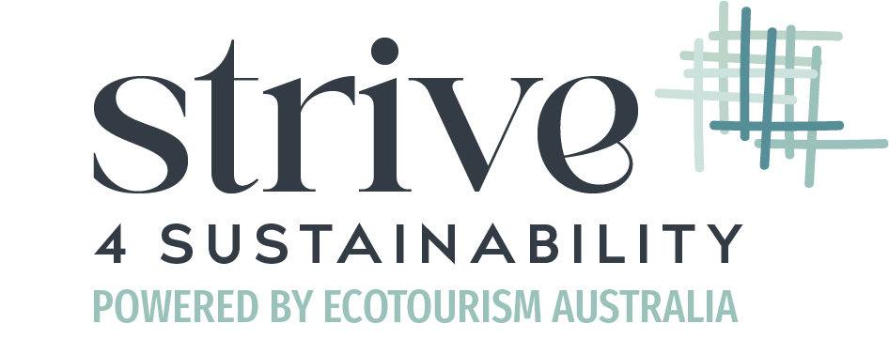
But don’t just take it from us! Explore our library of case studies from businesses that have completed the Scorecard and then get started on your application today.

Achieve globally recognised Certification standards
Are you wanting to take the next step and achieve globally recognised sustainable tourism standards? Ecotourism Australia has two primary Certifications available for accommodations – ECO Certification for nature-based accommodations and Sustainable Tourism Certification for urban accommodations.

If you’re an Accommodation Australia member and have completed the Scorecard, you are eligible for a $100 discount on your Certification registration fee!


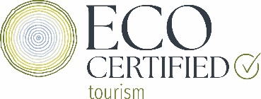
Please contact our friendly team on eco@ecotourism.org.au for any questions about our Certifications and Programs.

Secure your spot at the Global Sustainable Tourism Summit
With just 6 weeks to go, Ecotourism Australia’s inaugural Global Sustainable Tourism Summit will bring together industry leaders and sustainability experts in Meeanjin/Brisbane, on 4-6 June 2024 to discuss the current opportunities and challenges for the sustainable tourism industry.

Following the theme “People, Planet, Place, Purpose” the program will feature a wide range of topics across the four pillars of sustainability from international case-studies and leading accommodation sector businesses. The program includes targeted topics for accommodation providers including conversations with Accor Pacific, YHA, Accommodation Australia and ECO and Sustainable Tourism Certified accommodations so you can learn more about the latest innovations, best-practices and practical insights to help you grow on your sustainability journey.

Discover the full program and register today! Accommodation Australia members receive an exclusive 10% discount on registrations through this special link.

*Article resources and further reading:
Booking.com Sustainable Travel Report 2023 – Booking.com
Expedia Sustainable Travel Study 2022 – Expedia Group
What is Sustainable Tourism? – Ecotourism Australia
National Sustainability Framework and Sustainable Tourism Toolkit - Austrade

