

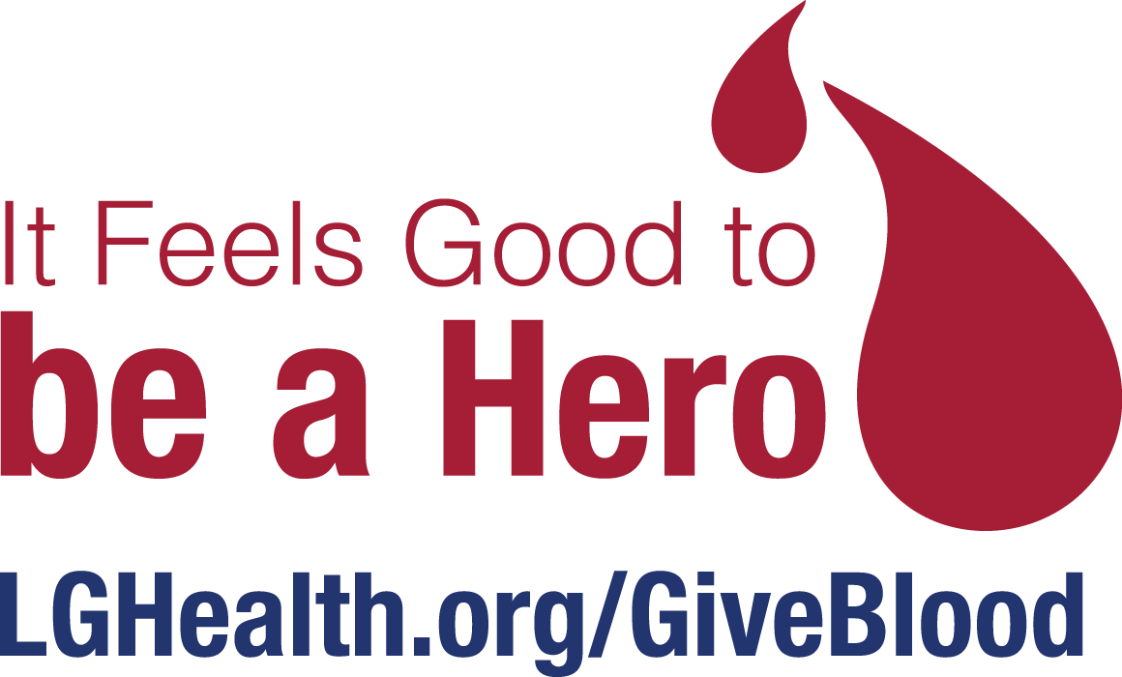

**FOREST HILLS MENNONITE CHURCH**

**BLOOD DRIVE**

**When:** Thursday, May 14, 2020

**Where:** 100 Quarry Rd. Leola

**Time:** 2 pm – 7 pm

**All Donors will receive a $5 Sheetz gift card.**

**You must sign-up by using link below:**

[**https://www.signupgenius.com/go/30E0B45ABA722A1FC1-penn15**](https://www.signupgenius.com/go/30E0B45ABA722A1FC1-penn15)