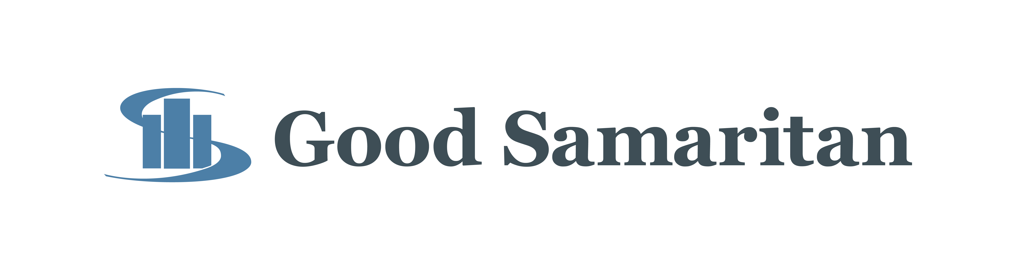
FOR IMMEDIATE RELEASE
June 25, 2020

Contact: Tiffany Conover | 812.885.3336 | tconover@gshvin.org

Good Samaritan Welcomes New Board Member

During Thursday’s Board of Governors meeting at Good Samaritan, the Board welcomed their newest member, Stan Deweese, RPh. Deweese is a registered pharmacist and owner of Family Pharmacy Inc. in Bicknell, Indiana. He graduated from North Knox High School in 1971 and received his Bachelors in Pharmacy from Butler University in 1976.

“I am very excited to join the Good Samaritan Board of Govornors team,” said Deweese. “In order for a community to thrive, it is extremely important for each individual to contribute in some fashion. Serving on the hospital board is one way I can give back to our community. Over time, I hope together we can guide Good Samaritan to be the model county hospital of excellence in quality care and compassion.”

In addition to now being a hospital board member, Deweese is also a Deacon at Mariah Creek Christian Church, president of the Bicknell Bulldog Development Corporation and president of the North Knox Scholarship Foundation. He and his wife, Brenda, who is a retired Kindergarten teacher from the North Knox School Corporation, have been married for 46 years and reside in Bicknell. The couple have two sons, Ryan and Jay, and an honorary son, Zac Jackson. In his free time, Deweese enjoys spending time with his family, especially his grandchildren. He is an avid golfer, a rescue scuba diver and fan of Butler University basketball.

During Deweese’s first board meeting, the Board voted in favor to utilize EPIC electronic medical record system for the outpatient offices of the Samaritan Center.

Currently, the outpatient services are using Medinformatix as their electronic medical record system. Switching to the EPIC system will allow the Samaritan Center to no longer be on a separate EMR system than the hospital and physician practices. In addition, EPIC will decrease prescribing errors and will develop comprehensive reports to assist in tracking quality and financial metrics.

The purchase is unbudgeted; however, the recent grant dollars received by the Samaritan Center will help with the purchase. Receiving the Certified Community Behavioral Health Clinic Expansion Grant (CCBHC) from the Substance Abuse and Mental Health Services Administration (SAMSHA) also increases the Samaritan Center’s need for data collection and integration that is required as a recipient of the grant.

The initial implementation and licensing cost from Deaconess for the Samaritan Center is $258,225 with an annual fee of $100,000.

Another purchase approved for the Samaritan Center during the board meeting was a mobile unit. The unit is a 40’ self-contained mobile clinic with two exam rooms, a nurse’s office, reception area, and restroom, all handicap accessible. It will be used to provide primary care and behavioral health care to Good Samaritan’s 11-county service area to those with limited access to health care services and transportation. The mobile unit will be staffed by a psychiatric nurse practitioner, family nurse practitioner, registered nurse, therapist, case manager and unit coordinator.

“We could not be more excited to offer this mobile clinic to patients,” said Kristi Scherer, Executive Director of the Samaritan Center. “This unit will allow us to reach patients that do not have access to behavioral health care. We will now be able to bring the office to them and improve the mental health of our communities.”

The vehicle will be purchased from La Boit Specialty Vehicles for the amount of $351,902 with the monies awarded from the SAMSHA grant.

The hospital’s Pharmacy Department was also approved to make a purchase of new Automated Dispensing Cabinets (ADCs). The support for Pharmacy’s current cabinets, Med Carousel and NarcStation will end in December 2021. The department will be replacing the aging equipment and software with 29 ADC units, 11 for inpatient and 18 for outpatient, two Med Carousels, and one Controlled Substance Manager.

The lead time for replacing the current equipment is expected to be six months or longer. “These new automation pieces will give Good Samaritan state-of-the-art medication distribution capabilities,” said Shane Wilson, Director of Pharmacy. “The software that comes with the new equipment will also give Pharmacy and Nursing better tools to analyze drug usage and remotely manage patient medication distribution, as well as controlled substance waste documentation.”

Implementation of all equipment in one year will avoid a required software upgrade resulting in a savings of $120,534 and a yield savings of $142,500 in support fees. These potential savings will allow pharmacy to purchase the new equipment for a total price not to exceed $1,585,590.

###

ABOUT GOOD SAMARITAN
Good Samaritan, Knox County’s largest employer, is licensed for 158 in-house patients. Annually, Good Samaritan has more than 560,000 outpatient visits and an additional 34,000 plus visits to its emergency room. Offering a wide variety of health services, from radiation oncology to the birth of a baby, this growing health care provider balances quality patient care with preventive education to fulfill its mission. Good Samaritan provides a superb level of care while maintaining fiscal integrity and expanding facilities to meet the needs of the community. For more information, visit www.gshvin.org.

Mission: Provide excellent health care by promoting wellness, education and healing through trusting relationships.

Vision: To be the regional center of excellence in health care to support the communities we serve.

