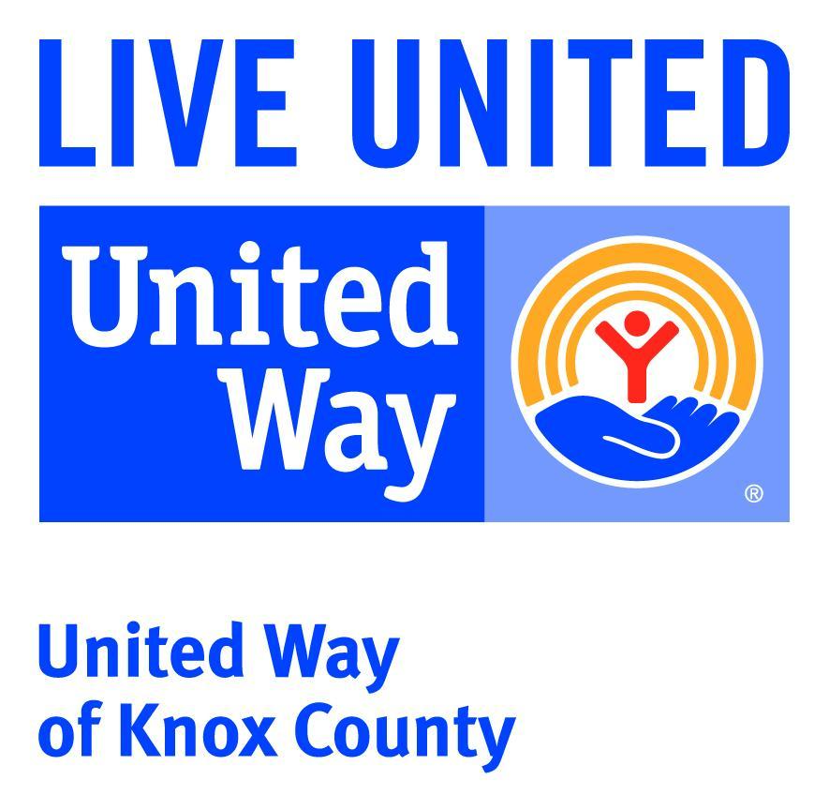

PRESS RELEASE
FOR IMMEDIATE RELEASE

Questions, please call: 812-882-3624
director@unitedwayofknoxcounty.org
Mark Hill, Executive Director

NEW DIRECTOR OF UNITED WAY OF KNOX COUNTY

The United Way of Knox County board has determined a new director for the agency, Scott Charleston. Scott has most recently been the Assistant Store Manager of the local Lowes store and has significant experience in leadership, operations, customer service and business management. He has a strong background in marketing, public relations, and community service.

He is married to Ashley Charleston who is employed as the School Services Supervisor with the Family Health Center, and they have two children Gavin, and Cala. Scott is excited about the opportunity to become more involved in the community through this next chapter in his family’s life.

Scott will begin his onboarding with the United Way on April 7th.

