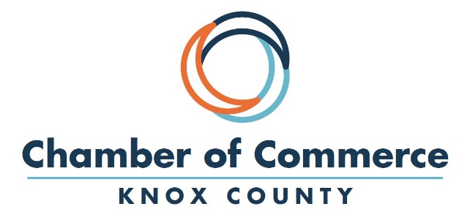

2020 Knox County Chamber of Commerce
Ambassador Program

Knox County Chamber of Commerce
316 Main Street
PO Box 553
Vincennes, IN 47591
info@knoxcountychamber.com
www.knoxcountychamber.com
Office: 812-882-6440
Fax: 812882-6441

Chamber Staff
Jamie Neal, President, jamie@knoxcountychamber.com
Courtney Welage, Marketing and Events Coordinator, courtney@knoxcountychamber.com

STRONG BUSINESS – STRONG COMMUNITY
Connecting for Success

The Knox County Chamber of Commerce is a membership-driven organization focusing on the economic vitality of Knox County and the increased visibility and advocacy of its members.

We have been in existence for over 100 years and our members are regarded as our greatest asset. The Chamber's intention is to assist its members in the success and promotion of their business.

The advantages of membership in the Knox County Chamber of Commerce are many and varied. Members have access to special member benefits, unique networking opportunities that enable them to establish new business relationships and much more.

Program Introduction

Program Mission:
It is the mission of the Knox County Chamber of Commerce Ambassador Program to promote member commitment and retention by:

- Raising awareness of Chamber activities and benefits
- Informing and involving new Chamber members to promote strong continuing membership
- Encouraging meaningful and beneficial participation in Chamber's programs
- Serving as a liaison between the Chamber staff and membership

Who are the Chamber Ambassadors?
The Ambassador Program consists of a group of diverse volunteers from the Chamber membership who donate their time to assist the Chamber in various activities. Ambassadors serve a term of one calendar year, beginning in April of each year. Ambassadors are entitled to serve after the one-year term if agreed upon by the Ambassador and the Chamber President.

Program Benefits
Program Benefits for the Ambassadors

- Increased name and face recognition for individual/business
- Increased networking opportunities including:
  - Connecting one-on-one with new and existing Chamber members
  - Gaining referral opportunities through other Ambassadors
  - Presenting a business introduction at an Ambassador meeting
- Potential media coverage from attendance at Chamber events
- Opportunity to place one promotional piece in new member bags (as approved by Chamber)
- Opportunity to get insider’s perspective of the local business community
- Opportunity to meet local business and community leaders
- Opportunity to help the community/show community pride
- Possible recognition via Ambassador awards and “Ambassador Spotlights.”

Program Benefits for the Chamber

- Increased visibility within the community
- Better understanding of membership needs
- More involvement of existing Chamber Members
- Ability to manage events more effectively
- Increased recruitment opportunities
- Member retention

Program Benefits for the Membership

- Increased access to points of contact who can provide assistance and answer questions
- More frequent Chamber communication
- Potential for increased referrals
- Members will feel more connected to the Chamber

Ambassador Roles and Responsibilities

Requirements
As an Ambassador, you are required to

- Must be a current member of the Knox County Chamber of Commerce
- Have your employer’s approval to participate in the program
- Participate in the Ambassador Orientation Program
- Serve for a period of at least one year
- Attend at least 4 out of 6 Ambassador meetings per year
- Attend at least 2 Chamber events per month
- Always promote the Chamber in a positive manner

Service Opportunities and Responsibilities
As an Ambassador, you have the opportunity to select what activities you want to complete to fulfill your program service requirement. The opportunities may vary from year to year, but can include:

- Staffing the welcome/registration table at Chamber events and meetings
- Attending ribbon cutting / grand opening celebrations
- Serving as a mentor for new Chamber members and check in with existing members as they renew
- Deliver Chamber materials to members
- Delivery and pickup of event items / supplies
- Serve as a welcoming committee for new Chamber members
- Chamber member recruitment
- Refer potential ambassadors to the Chamber staff
- Promote and spread the word about Chamber events
- Other varied duties as specified

Ambassador Application & Agreement

_________________________________________________________________________________
Name Title

_________________________________________________________________________________
Employer / Business Email Address

_________________________________________________________________________________
Work Address

_________________________________________________________________________________
Office Phone Mobile Phone

Educational Background: ____________________________________________________________

List any civic, community, business or social organizations in which your involved:

Why do you want to participate in the Ambassadors program?

I understand the mission and purpose of the Ambassador Program and agree to devote the time necessary to accomplish the goals of the program. I understand that my responsibilities are to:
- Serve as an Ambassador for a period of at least one year. I can be re-elected for another term.
- Attend Ambassador Orientation
- Attend at least 2 Chamber events per month and at least 4 Ambassador meetings per year
- Carry out the responsibilities of an Ambassador
- I further understand that if my schedule does not allow me to fully support my duties as an Ambassador, I will resign until I am able to fully participate.
- I have the permission of my employer to participate in the Ambassador Program.

Signature: __________________________________________ Date: _______________________

Return application to the office at 316 Main Street or email jamie@knoxcountychamber.com

