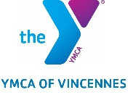

Y Column for June 23rd, 2020

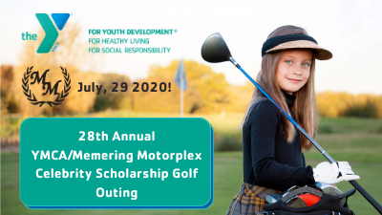

The 28th Annual YMCA/Memering Motorplex Celebrity Scholarship Golf Outing has been rescheduled for July 29, 2020!
Over the years this charity event has helped thousands of kids learn to grow and thrive at the YMCA of Vincennes through memberships and other programs. Your involvement helps provide more opportunities to the children of Knox County.

DATE: Wednesday, July 29, 2020
WHERE: Country Club of Old Vincennes
TIME: 9:00 am to 5:00 pm
FEES: $495 per team of 5, $99 per individual

Please visit our website at: https://vincennesymca.org/ymca-memering-motorplex-celebrity-scholarship-golf-outing/

Sponsorships and door prizes welcome! Please contact Rebecca Richardville at: marketing@vincennesymca.org.

The Summer 150 Virtual Run is BACK! June 20 – September 22, 2020
Last day to register is on July 4th, 2020!
Back for the second year by popular demand, our Summer Virtual 150 Run is here to challenge you! We have added an extra twist this year. You can challenge yourself with 150 miles or a 500K! That’s right 310.7 miles. Challenge starts on June 20, 2020 and lasts all summer long; Plenty of time to log those miles. The registration fee is only $30.00. Participants get a personalized race bib and a t-shirt. For those who reach their miles, a race medal! Keep yourself motivated all Summer Long and join our virtual challenge today! For more information visit: https://vincennesymca.org/summer-150-virtual-run-challenge/

The YMCA Annual Fish Fry Fundraiser is Scheduled for August 28, 2020!

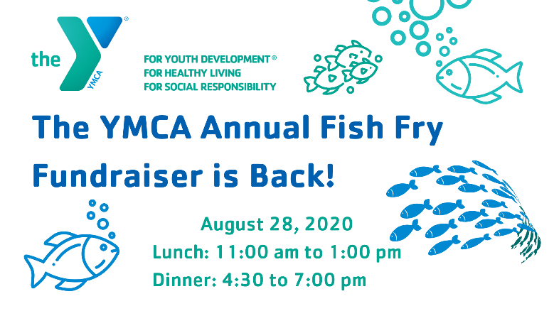

Where: The YMCA of Vincennes Gymnasium
When: August 28, 2020
Times:
Lunch will be served from 11:00 am to 1:00 pm
Dinner will be served from 4:300 pm to 7:00 pm
Cost: $10 for adults, $5 for children under the age of 12.

Tickets for sale at the front desk of the YMCA of Vincennes

STARTING JUNE 15, 2020 NEW HOURS AND PROGRAMS!

Members Only still allowed in the building through the end of June 2020.

Updated Facility Hours starting on June 15, 2020:
Monday through Friday from 5:30 am to 7:00 pm
Saturdays from 6:00 am to 4:00 pm
Sundays Closed

- Group Exercise Classes will start by booking through our new YMCA member App or appointments through our Wellness Coordinator Amanda Smith at: wellness@vincennesymca.org.
- Open to all members 16 years or older
- Members under 16 must have a parent/adult age of 18 or older that are also members accompany them.
- Child Watch will be available Mondays through Thursdays from 8:00 am to 12:00 pm, 4:30 pm to 7:00 pm, and Saturdays 8:00 am to 12:00 pm
- Family Swim Times will be available by appointment only with Aquatics Director Tiffany Petts at: tpetts@vincennesymca.org. (More details TBA)
- Pickleball will be open play, Monday through Fridays, in Gym #2, 9:00 am to 11:00 am.

