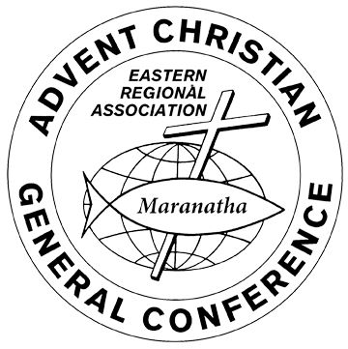
  - Eastern Regional Association Convention 2023

Camp Reports

Camp |  | Page #
Mechanic Falls |  | 2
Lakeside |  | 3
Sports and Music Camp |  | 4
Alton Bay |  | 5-6
Big Lake Campmeeting |  | 7

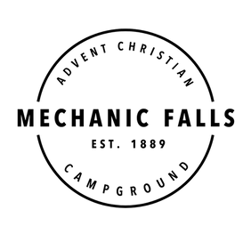
Mechanic Falls AC Campground: Summer 2023
When reviewing our youth camps and camp-meeting we are filled with gratitude for many blessings and answered prayers.
Our speaker (returning) was Pastor Josh Tate from Northern Maine, our Bible teacher (returning) was Levi (Harry) Soucy, and our worship leader (returning) was Carrie Rice. She was joined with an able team of teens and young adults. The preaching theme centered on “conversion stories” in the Book of Acts. Along with these services and instruction we hosted a VBS (with Roger Brown as director). The theme: Hometown Nazareth: When Jesus Was A Kid. There were 16 helpers who gave all or some of their days at camp to aid this special “biblically” oriented VBS. On Saturday night we presented a Song Celebration with special music, hymns, and choruses. Pastor Heath Keniston of Crossroads Church in Ossipee, NH led our final Sunday communion service. We stood in a circle of campers of all ages (including our oldest member, Pearl Grant-98) rejoicing in our salvation and enjoying the presence of God’s Spirit together.
There was a very positive annual meeting with new members added to the association and the welcome of two new supporting churches (Crossroads Church and Calvary Bible Church). God continues to bless us financially. A special addition to our campground was a brand-new playground set for the younger attendees. A cottage changed hands and we welcomed the Logsdon’s from Western MA to our “ranks”.
Our pool remained very busy, youth enjoyed the return of our tetherball set-up, and the snack shack never lacked for attention.
Our staff worked hard all week, the dining room bustled, and a strong spirit of family in Christ permeated the grounds. To God be the Glory!
Pastor Roger J. Brown (President)


Lakeside Camp

﻿ Lakeside Camp had a very blessed week of Campmeeting. God's presence was felt throughout the entire encampment.

Rev. Brent Carpenter was on the program to be our daily Bible teacher, but due to flight cancellations he was unable to complete his journey to Maine; but God provided Micah Bickford who led us in a study of the book "With All Your Heart by Craig Troxel". We were challenged to orient our mind, will, and desires to Christ.

Rev. Brent Ross was our evangelist who spoke each night about the second coming of Jesus Christ. God has blessed Brent with a great ability to communicate God’s Word with energy and love. We were encouraged to live confidently and faithfully in light of Jesus’ soon return.
Mrs. Bree Libby of the Beals AC Church led the music each night and the old tabernacle rang with praise and worship.

The week culminated with two young ladies from our youth camp programs being baptized in Messalonskee Lake.

We started the week in need of $30,000 to cover the balance of the installation of a new roof on our Tabernacle. Within (4) days God provided well over the $30,000 needed for this important project. Praise God from whom all blessings flow!

Respectfully submitted,

Alan Sturtevant, President
Lakeside Advent Christian Campmeeting Assoc.
North Belgrade Maine

 Sports and Music Camp

God was gracious to us at Sports and Music Camp 2023! 91 campers between the ages of 12 and 18 (average age of 14) gathered at the Alton Bay Christian Conference Center on Sunday, June 25 th to walk through the Psalms with the assembled ‘SPAM’ Staff and Camp Speaker, Luke Middleton. Our theme for this 50th encampment (or 51st depending on who’s history you check) was “Eyes Up” and was anchored in the theme verses of Psalm 121:1-2, guiding the campers toward a hope directing their eyes upward toward Jesus Christ amid an everchanging and uncertain world.

While the weather initially was looking grim for the week, the Lord was merciful in holding it back in a way that we could accomplish the planned programming that was packed in. A sure sign of a successful camp week was tired, yet joyful campers lifting their voices in song together and echoing back the promises of the Word in the final evening service on Friday night.

For those who’d like to look in on what’s been going on at the camp, we invite you to visit an follow our Facebook page at https://www.facebook.com/spamcamp to see photos and video of the activities and evening services from Camp 2023.

We are thankful for those who lifted us up in prayer before and during the week of camp and covet your support and prayer as the board begins looking ahead to planning for SPAM Camp 2024!

-Rev. Joshua Blackstone, Director of Counseling

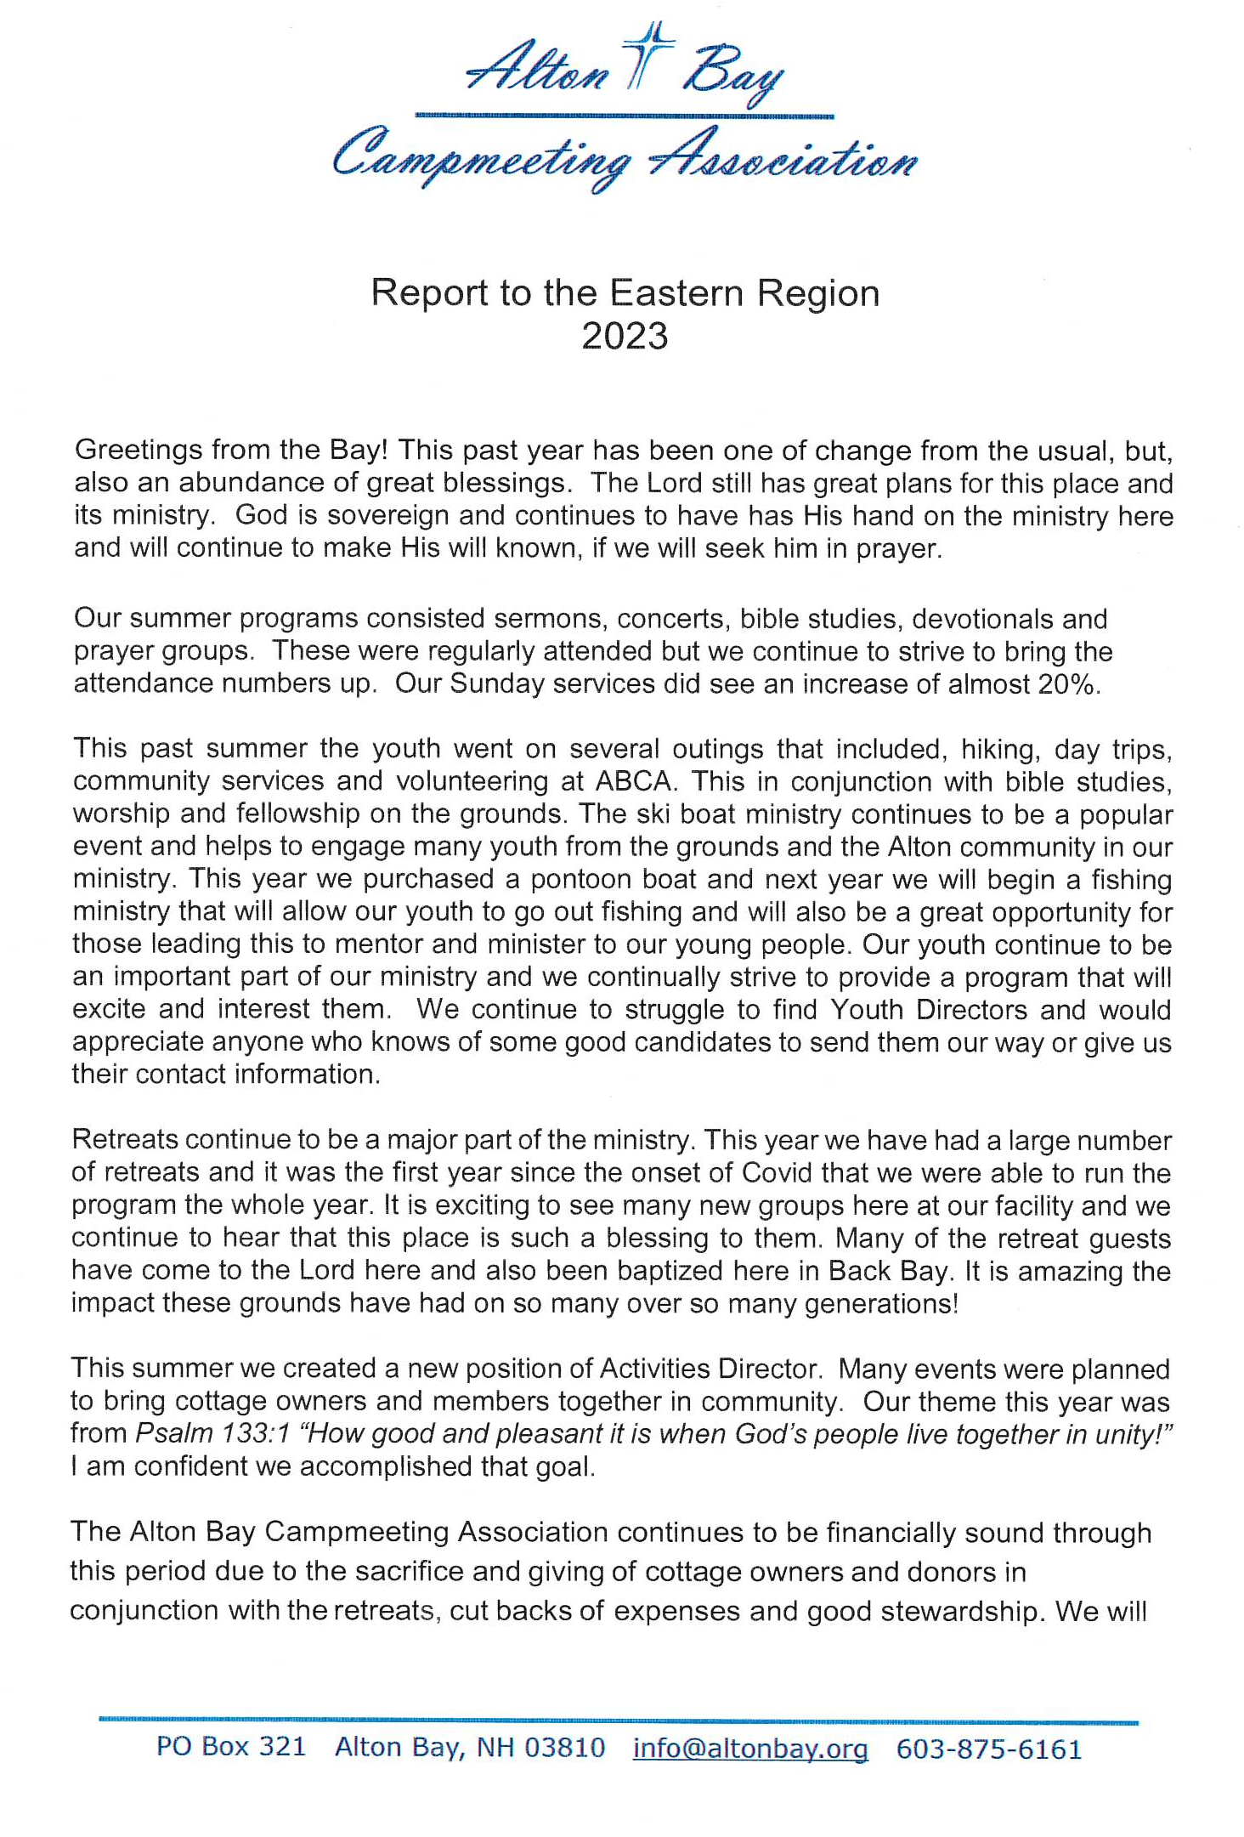
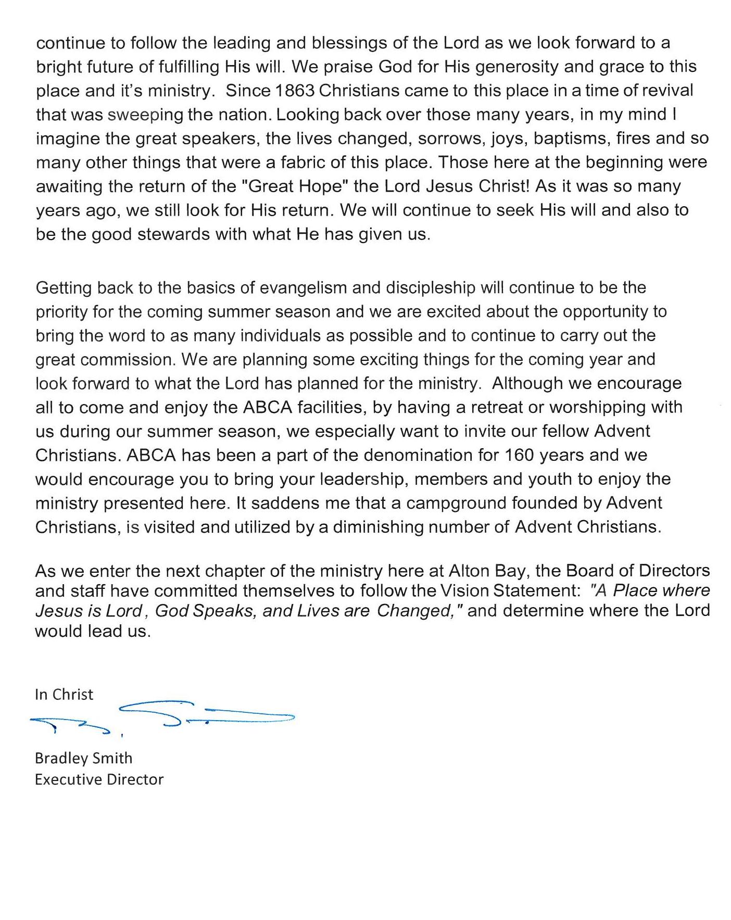

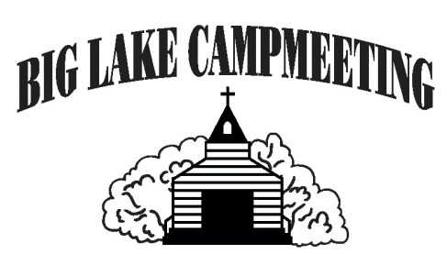
Big Lake Campmeeting

The close of Big Lake Campmeeting 2023 was triumphant in its completion and culmination of a year of prayer, planning and hard work. Jesus’ name was praised, and hearts were changed.

4 Baptisms happened in Big Lake Friday afternoon of camp, with 3 more Baptisms planned later and 3 of the younger children prayed a prayer of salvation. Our camper numbers were well over 55 with overnight campers, day campers, and morning and afternoon VBS combined. They filled our campground with so much laughter, joy, and love.

Many thanks go out to our volunteers and staff who worked tirelessly (many behind the scenes), to make everything flow smoothly this summer!

Please pray for the 4 that were baptized by Josh Cheney, our evangelist.
Kaylee Denney, Bryce Kenny, Jarrod Leeman, and Cash Berry.



