

LIBRARY SPOTLIGHT
In this issue, we are thrilled to highlight The Old Bridge Public Library Comic Con. Thanks to Lauren Parnagian, Youth Services Librarian, for reaching out about their event. We were so happy to contribute and happier still to see such a fantastic turnout!
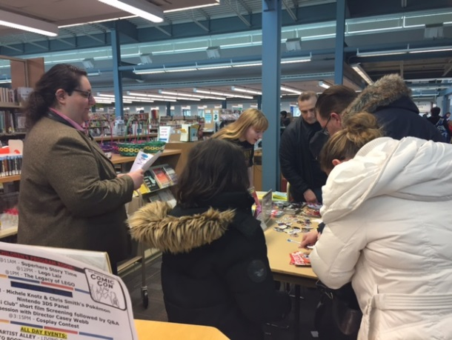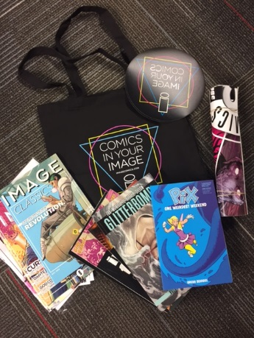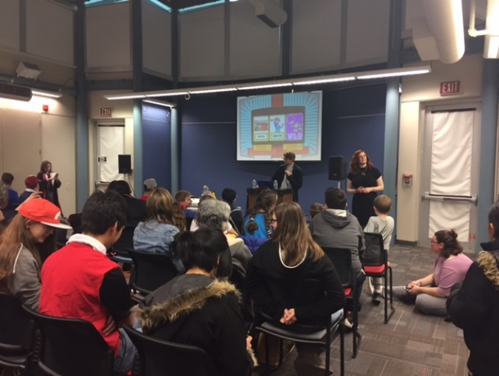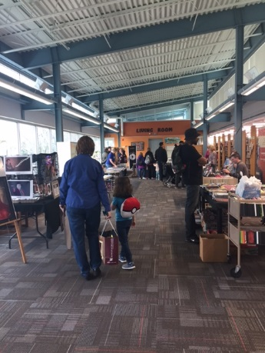
"The Old Bridge Public Library is located in Middlesex County in New Jersey. We have a population of over 66,000 people, and have 12 public elementary schools, 2 public middle schools, and a large public high school. We love the idea of giving to our diverse community and we were excited to provide a Comic Con experience that everyone could access and enjoy. This con was only the second one we have worked on, and we were determined to make it much larger and encompassing than the first.
We incorporated an Artist’s Alley made up of local artists in the community and invited special panel guests such as Michele Knotz, a well-known voice actress who ran an engaging Pokémon Party Panel, and Casey Webb, the co-creator of the award winning short film "Jedi Club." We also created many photo opportunities, including a visit from Star Wars costumers 501st Legion, and had special giveaways throughout the day. Overall, all of the ages that attended were amazed at what a normal library space can become when dedicated to such a fun event. We will definitely be doing this again in the future and we were glad we could showcase what a library can offer, the amazing talents of the community, and the many creative works that library patrons have access to every day." - Lauren Parnagian
Check out this awesome Tumblr the library set up to promote their event: https://obplcc.tumblr.com/

