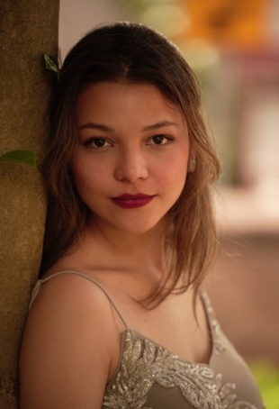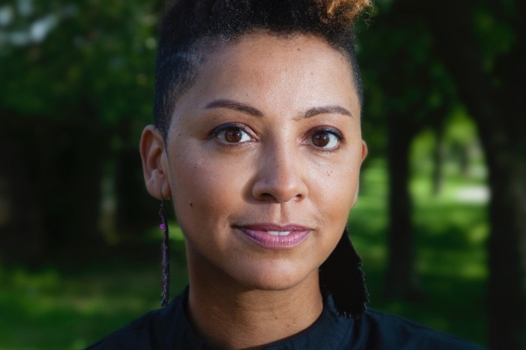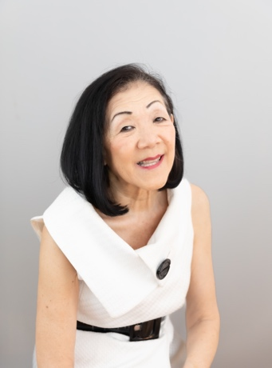

2024 UN International Day of Peace Boston

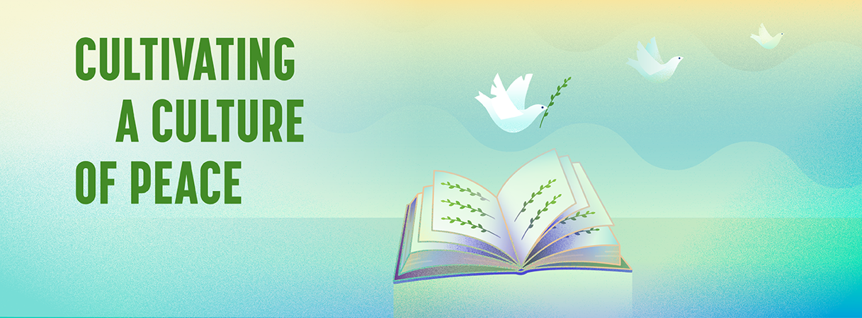

Sunday, September 22, 2024, 2-4pm ET

The Cathedral Church of St. Paul

138 Tremont Street, Boston

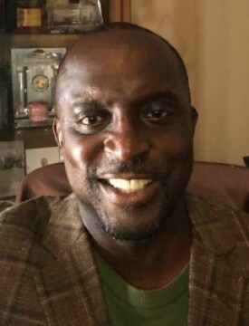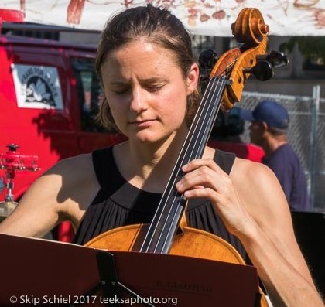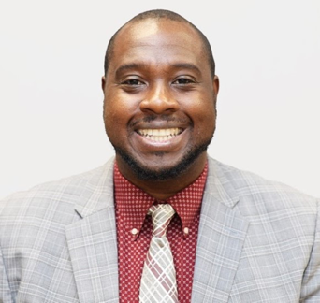

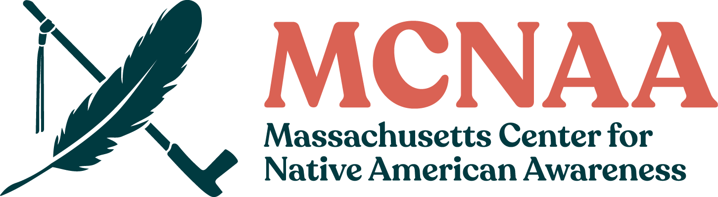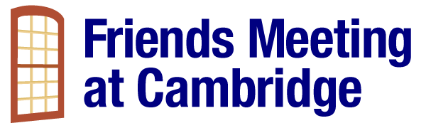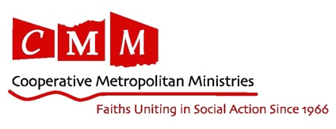
2024 UN International Day of Peace Boston Program

Opening Dawn Duncan, MCNAA

Land Acknowledgement Dawn Duncan, MCNAA

Sara Ting CEO, World Unity, Inc.

Rev. Vernon Walker Robert Schalkenbach Foundation

Leigh Meunier Climate CREW/Better Future Project

Miranda Henne (cellist) Albinoni’s “Adagio in G Minor”

Karilyn Crockett Hacking the Archive (MIT)

Zakiya Alake Fair Housing and Equity, Boston

Lina Marcela Sarmiento Tellez Singing (acc. by: Fernando Crespo)

Joanna Don Emerson Prison Initiative

Ron Bell Dunk the Vote

Zenaida Peterson (poet) Spoken Word

In Honor of Ian Harrington John Bach, Harvard Quaker Chaplain

In Honor of Victims of Violence

Walk to Garden of Peace

We also have a few tables set up for information about these organizations and others, including Alda Witherspoon of The Witherspoon Institute and the Department of Public Health.
Bios of Participants (in order)

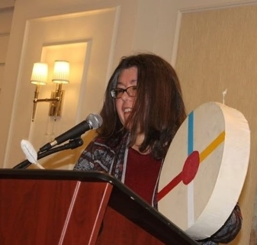
Dawn Duncan, MSW, MSc is the President of the Grant Connection, a company that specializes in helping nonprofits navigate the often-complex grant funding maze and access private and government grant funds for their programs. Dawn has raised more than $40 million in grant funding over the past 30 years. Dawn holds a Master of Science Degree in Maternal and Child Health from the Harvard T.H. Chan School of Public Health and a master’s degree in social work from Boston University. She is part Cherokee and Powhatan (indigenous) and is passionate about public health, racial justice, indigenous culture, hemp/cannabis equity and singing.

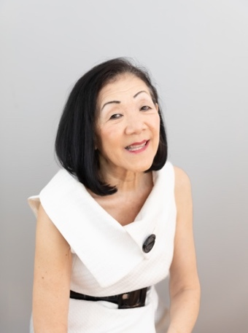
Sara Ting is a visionary, TEDx Speaker, diversity inclusion trainer and author. She has dedicated her life to promoting equality, diversity, and inclusion since 1985. She organized a citywide multimedia public service campaign promoting equality, racial and ethnic harmony throughout Boston and NYC in the mid-80's. In 1994, she founded World Unity Inc., a non-profit promoting equality by raising self-awareness through the “Sun Poem.” In the 90's, she spent 10 years as a freelance TV reporter covering stories impacting Asian Americans. For 20 years, she taught poetry writing to children. She has always been guided by faith and love for people.

Rev. Vernon K. Walker is an Associate Minister at the Massachusetts Baptist Church located in Cambridge and the new Director of Content and External Strategy for the Robert Schalkenbach Foundation, starting October 2024. Rev. Walker has an extensive background in climate justice work. He attended Penn State University for college, where he earned a Bachelor of Science degree with a major in Organizational Leadership and a minor in Psychology. After graduating from Penn State University, Rev. Walker attended Boston University and earned a master’s degree in theological studies (MTS). After graduating from Boston University, Rev. Walker attended Tufts University and earned a master’s degree in public policy (MPP).

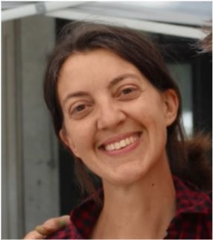
Leigh Meunier (pronounced myoon-yay) serves as program manager with Communities Responding to Extreme Weather (CREW), a program that focuses on supporting communities and local leaders to prepare for and respond to climate impacts and extreme weather, like flooding and extreme heat. She has had the honor of serving her community in many capacities – public education, songwriting and performance, community organizing, and ecological landscaping. She feels most at peace and joyful when she gets to be creative, curious, and connected to nature, and when she can support others in accessing these as well.
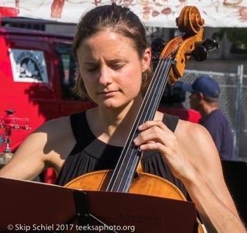
Cellist Miranda Henne performs classical repertoire as a soloist and chamber musician, composes and improvises for theater productions and studio recordings, and performs folk music and bluegrass. Highlights of Miranda’s stylistically varied career include a solo concerto performance with the Gettysburg Chamber Orchestra and two appearances at the Amelia Island Chamber Music Festival. An avid chamber musician, Ms. Henne performed with internationally acclaimed artists Andres Diaz, David Halen, Robert McDuffie, Amy Schwartz-Moretti, Christopher Rex, Elizabeth Pridgen, Paul Murphy, Kurt Muroki and Renée Skerik. She has also shared the improv, rock and folk stage with the likes of Mike Mills from R.E.M, Abigail Washburn, Mike Block, Rushad Eggleston, fiddler Bruce Molsky and the piri and Saengwhang player Gamin. In 2012, Miranda collaborated with Shen Wei, choreographer of the 2008 Beijing Olympic Ceremony, to create and premiere The New You, featuring her musical improvisation. She has also worked with and premiered pieces by composers such as Joseph Gregorio and Libby Larson. One of Miranda’s central goals since childhood has been to promote peace. In high school, as co-president of the Amnesty International club, she helped with protests and benefit concerts. In college, she organized concerts such as a Daniel Pearl World Music Days Concert and Music for Haiti, which raised funds for earthquake relief. She also designed an independent study called “Music and Social Change,” studying ways to use music for peace. Miranda maintains a private cello studio in Boston, MA and coaches chamber music for the Northeast Massachusetts Youth Orchestras. Miranda holds a B.A. in Music with a minor in English from the McDuffie Center for Strings at Mercer University and a M.M. from Southern Methodist University.

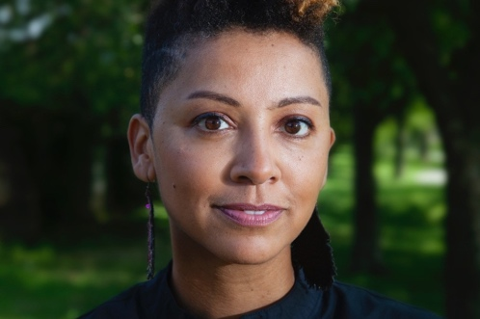
Dr. Karilyn Crockett’s research focuses on large-scale land use changes in twentieth century American cities and examines the social and geographic implications of structural poverty and racial formations. Karilyn’s book, People before Highways: Boston Activists, Urban Planners, and a New Movement for City Making (UMass Press, 2018), investigates a 1960s era grassroots movement to halt urban extension of the U.S. interstate highway system and the geographic and political changes in Boston that resulted. In 2019, this book was named one of the “ten best books of the decade,” by the Boston Public Library Association of Librarians. Karilyn holds a PhD from the American Studies program at Yale University, a Master of Science in Geography from the London School of Economics, and a Master of Arts and Religion from Yale Divinity School. She served for four years with the Mayor's Office of Economic Development as the Director of Economic Policy & Research and the Director of Small Business Development for the City of Boston and was later appointed the City of Boston's first Chief of Equity, a Cabinet-level position. She is a professor of urban history, public policy and planning at MIT, and currently leads the Greater Boston Chamber of Commerce in a partnership with the Boston Federal Reserve Bank to revisit the 2015 “Color of Wealth'' report on closing the racial wealth gap.
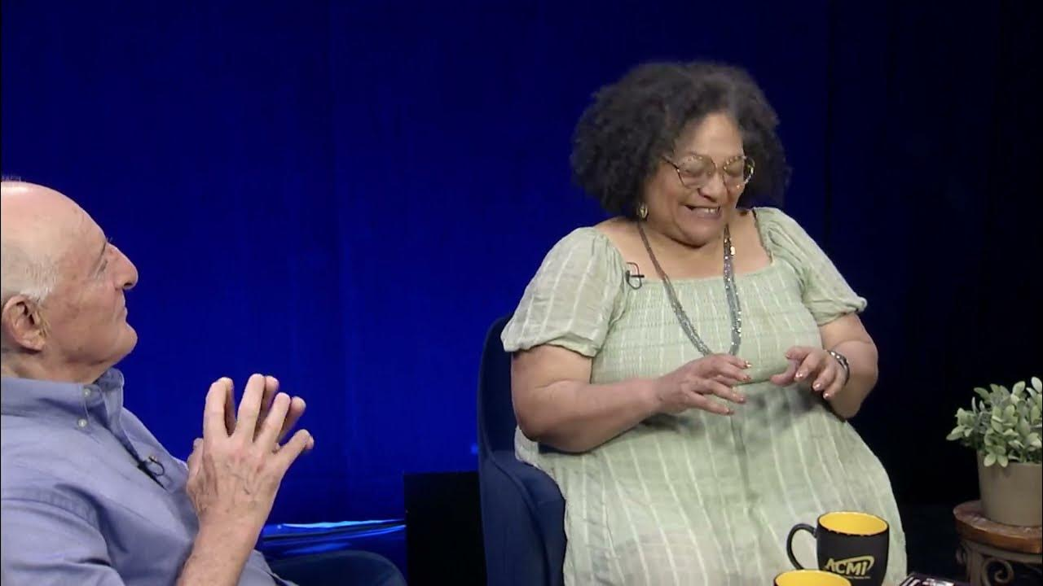
Zakiya Alake (Education & Outreach Manager, City of Boston Department of Fair Housing & Equity) has been community organizing for decades on housing and other issues. From 1977-1979, she was a paralegal student in DC’s then Antioch School of Law. A few years later, as a student of UMass Boston’s legendary CPCS (College of Public & Community Service), she helped lead an organization of student parents dependent on welfare while completing college and raising families working on welfare reform. Zakiya’s forty plus years in Massachusetts have been devoted to community organizing praxis on various campaigns including substance abuse addiction treatment in black communities, violence both in the community & interpersonal, voting rights, stopping sexually transmitted infections in vulnerable populations through education and support groups, environmental racism/justice, gentrification and displacement and deeply so with affordable housing, and most recently equitable food ecosystems. The most successful campaign Zakiya worked on, ’95-98, brought largely black Roxbury and white South Boston together with Dorchester and the South End to the development of an asphalt plant near an elementary school, a jail and several residential neighborhoods and a shopping mall. She is a contributor to Dig Boston and a board member of the Boston Institute for Nonprofit Journalism.

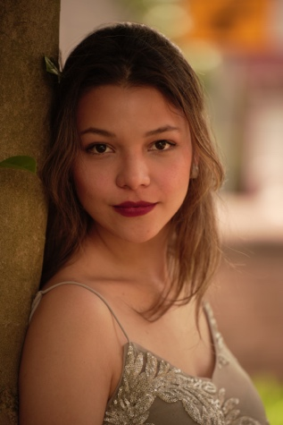
Lina Sarmiento is a Colombian artist whose interests include music, drawing, and theater. In 2016, she was admitted to the EAFIT University music undergraduate program under the direction of Professor Sandra Caicedo, receiving her diploma in 2021. During the second semester of 2017, she took singing lessons with sopranos Nuray Karabay-Ammicht and Christine Wagner in Vienna. She also studied with Professor Gretchen Windt from the University of Kentucky. Lina Sarmiento was part of the Macondo choir and a member of the international category Cecilia Espinoza chamber choir. She was also a member of the “Madriguera” theater group at EAFIT University, with whom she debuted in many theaters in Medellin. The soprano has performed many solo roles in sacred music, including Schumann's "Requiem für Mignon," Faure’s "Pie Jesu" from his Requiem, and solos in Rutter’s Requiem. She has also sung solo roles in operas and zarzuelas such as Raquel in “La corte del faraón,” Coral in “La leyenda del beso,” and Suor Dolcina and Suor Genovieffa in “Suor Angelica.” Additionally, she has performed in musicals such as "Sondheim on Sondheim," interpreting songs originally sung by Leslie Kritzer. Lina holds a master’s degree in Vocal Performance from the Longy School of Music of Bard College, where she studied under Professor Carol Mastrodomenico.

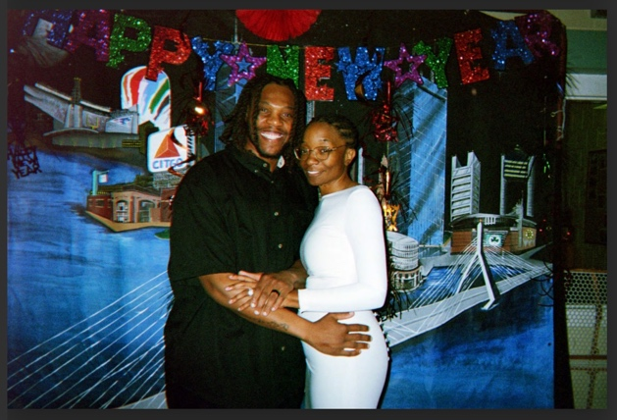
Joanna Don is the wife of Amos Don, whose poetry she is going to share with you today. Amos Don is enrolled as a student in the Emerson Prison Initiative (EPI), which since 2017, provides students incarcerated at Massachusetts Correctional Institution at Norfolk (MCI Norfolk) with an opportunity to earn a bachelor’s degree in media, literature and culture from Emerson College. She is so proud that her husband Amos Don is an EPI student, working toward his college degree. She would also like to share that the children’s books done by her husband, Rainbow Terrace (see next page), are about creating peace and educating our children about cultural sympathy and empathy towards other’s differences, as well as accepting one’s own differences.

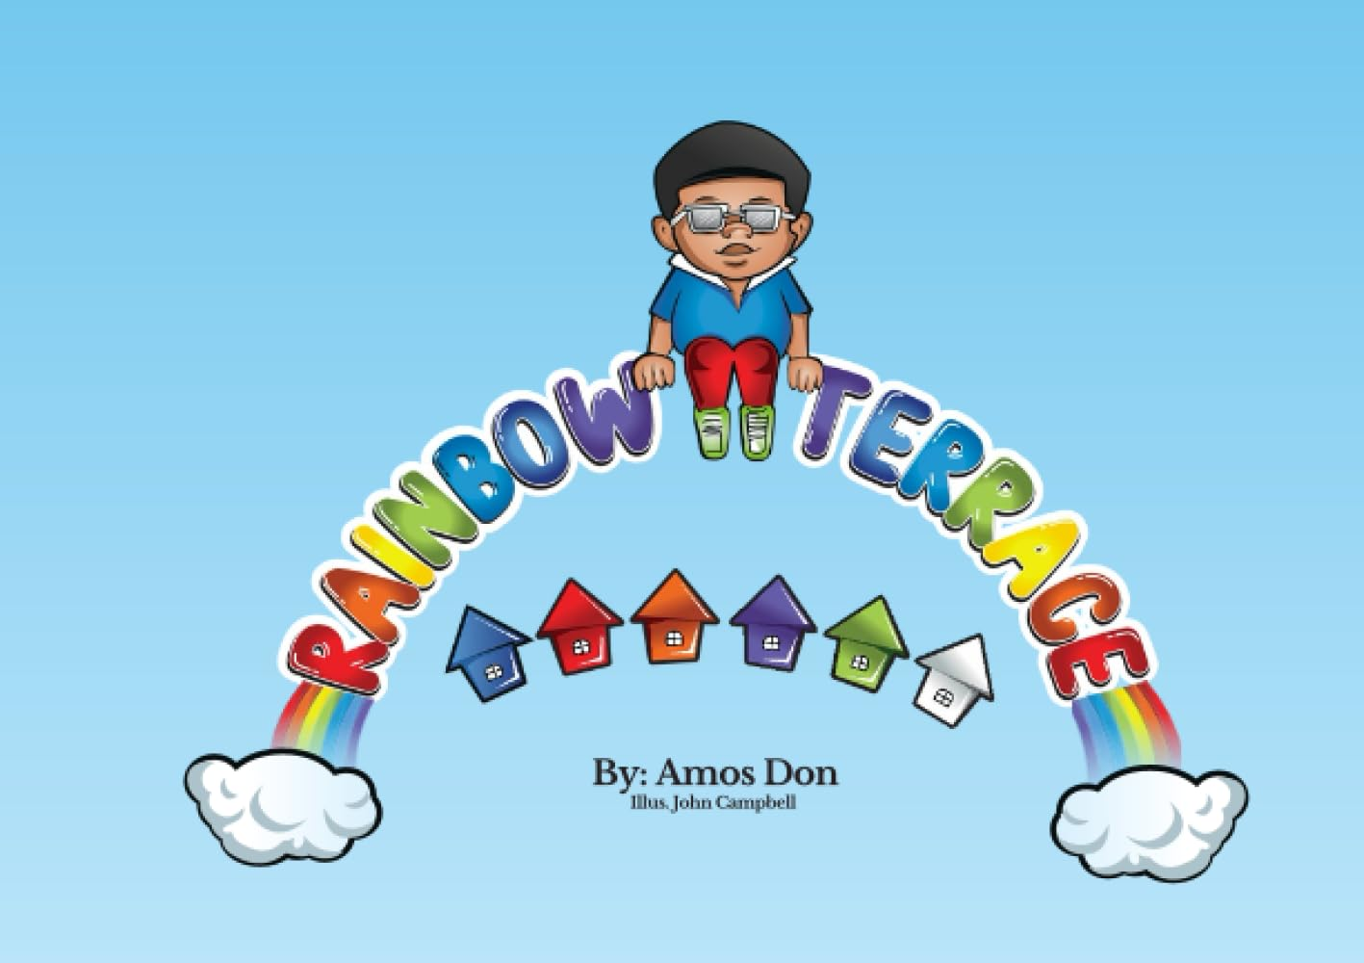

Ron Bell, Founder of Dunk the Vote, is a civic engagement and voting rights organizer with a distinguished track record of developing the infrastructure of public participation in community and government. Founder of the nonpartisan nonprofit, Dunk the Vote, which since 1992 has registered over 100,000 voters in Massachusetts, Mr. Bell has built a career in bringing an innovative, results-driven approach to citizen self-advocacy, leadership training and education, political campaigns, and justice-focused coalitions. A sought-after consultant and speaker, he is a former Senior Advisor for Community Affairs for Massachusetts Governor Deval Patrick, and has served on many campaigns at the state and city-wide level. He attended Bentley University and has completed fellowships at UMass Boston, Harvard University’s Kennedy School of Government, and MIT Department of Urban Studies and Planning (DUSP). He has received President Clinton’s Point of Light Award, the Lawyers Committee for Civil Rights Rosa Parks Award, the 2005 Freedom House History Makers Award, the University of Massachusetts Robert H. Quinn Award for Outstanding Community Leadership, the UMass Boston Center for Collaborative Leadership Leading the Way Award, the Get Konnected! Most Influential Men of Color Award, the Black Male Advancement Fathers Award, and the Franklin Park Coalition Community Award 2024. Mr. Bell serves as an advisor and board member for many organizations focused on educating the leaders of tomorrow and is also an anchor broadcaster on Boston Black News.

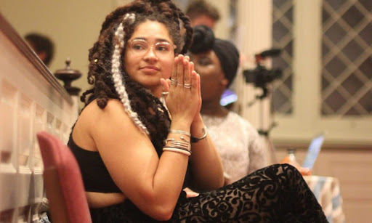
Zenaida Peterson (they/them) is a Quaker mystic, organizer, and a Black non-binary poet from Georgia currently living laughing and loving in a queer coop in Jamaica plain. You can find their work at Pizza Pi Press, Button Poetry and Wusgood Black. Their first full length book of poems is forthcoming with Game Over Books.

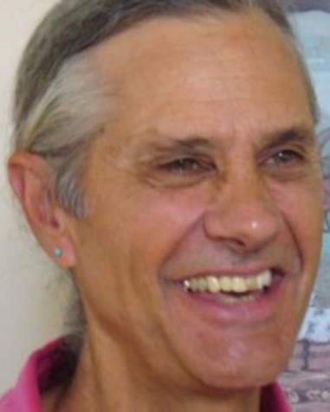
John Bach, Harvard’s Religious Society of Friends (Quaker) Chaplain, has been a member of the Religious Society of Friends (Quakers) for almost all of his adult life, and is pleased and honored to represent the Friends Meeting at Cambridge within the Harvard Chaplains community. He became a Quaker because he wanted to accompany Harriet Tubman and support Native Americans; to shelter Anne Frank, to consort with Gandhi and to march with Dr. King; to construct alternatives to violence; and to sit silently, waiting expectantly for the Spirit to speak. We worship in silence, speaking when called to speak. He endeavors to live an engaged life, taking part in the "burning issues of the day," as someone once put it, while also pursuing a spiritual path, and refusing to separate the one from the other. The joyful consequence has been years of imprisonment for reasons of conscience, deportations, border crossings, dealings with badly behaved people with guns, and an arrest record longer than both of his arms. As this trajectory unfolded, foundations shook and doors flew open, and he understood freedom was not determined by which side of a prison wall you were on or by paychecks or ability to consume, but rather being of service and faithful to ideals. And he is also fully engaged in the equally meaningful everyday acts of attention to the miracles of help and outreach, listening to the small, still voice that speaks with thunder and lightning. It is hard to corrupt a spirituality based on humility, simplicity, compassion, non-violence, moderation and contemplation. We believe that there is that which is godlike in all of us and that we do not need intermediaries to seek and discover the will of the divine spirit. The victory is in the struggle and in living in balance with nature. With a resounding NO to the murderous policies of the State and a seductive culture, and an equally resounding YES to everything else, as we lift up each other with tender hands. He eagerly looks forward to listening and sharing with any student or member of the Harvard community in a spirit of openness and humility.

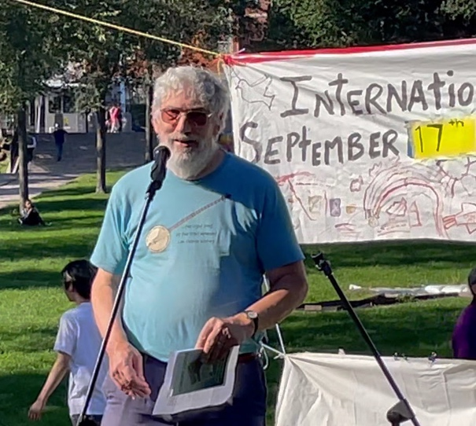
Ian Harrington served on the Planning Committee of International Day of Peace Boston since its inception in 2010. A resident of Wayland, MA, he was a life-long Quaker, a dedicated member of Friends Meeting at Cambridge (Quakers), a retired transportation planner, and an enthusiastic volunteer for the Friends Committee on National Legislation. He felt blessed to form a family with his wife, son, daughter-in-law, and three grandchildren.

In Memoriam – Ian Harrington, December 24, 2023

A Memorial to Ian Harrington, on the Occasion of the
UN International Day of Peace in Boston, September 22, 2024

Historians mark 1652 as the beginning of the Quaker movement, the Religious Society of Friends. We mark it by the day Ian Harrington climbed up this side of Beacon Hill and saw "a people in white raiment, coming to the Lord," remembering those who lost their lives to violence, engaged in what Quaker Friend James Nayler termed "the Lamb's war."

The weapons used in the Lamb’s war were the fruit of the spirit. These were well known to Ian, sometimes abbreviated by Quakers as "SPICES" – simplicity, peace, integrity, community, equality, and stewardship of the Earth.

Sometimes, when the Christ-light within wants fruit from us, it’s just not a good time for the “spice of life.” It’s just not a good time as we are caught up in the defensiveness and anger that seem natural to our narcissistic selves, and we have dried up from the roots. At times like these, it behooves us, particularly when we gather together, to invite each other to be open to the light, to turn away from the inner whirlwind and listen for the still small voice calling us to bear the fruit of the spirit.

So let us say together in memory of Ian Harrington: “But the fruit of the Spirit is love, joy, peace, forbearance, kindness, goodness, faithfulness, gentleness and self-control. Against such things there is no law.” (Galatians 5:22-23)

- Rev. Dr. Rodney L. Petersen
CMM Executive Director Emeritus

Our Thanks

This event was made possible by great contributions from the speakers and musicians on the program and the contributions of many others, including the following:

The Cathedral Church of St. Paul: stpaulboston.org

Cooperative Metropolitan Ministries: coopmet.org

Friends Meeting at Cambridge: fmcquaker.org

Massachusetts Center for Native American Awareness: mcnaa.org

Mass Cultural Council: massculturalcouncil.org

For more info, please visit: idpboston.org
Contact us at: InternationalDayofPeaceBoston@gmail.com

