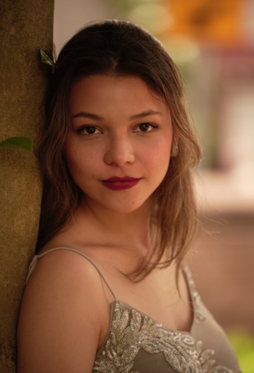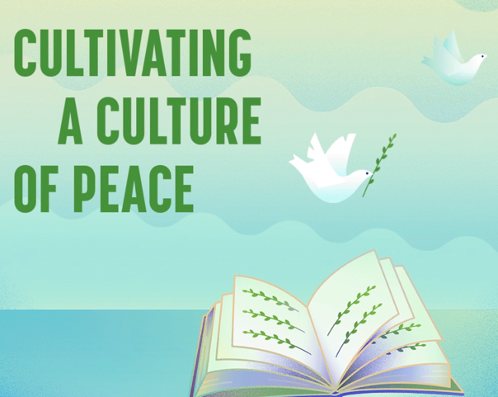

2024 UN International Day of Peace Boston

Cultivating A Culture of Peace

Sunday, September 22, 2024, 2-4pm ET

The Cathedral Church of St. Paul (138 Tremont Street, Boston)

Park Street MBTA Station

A program of Music, Arts, & Peace Education led by emcee Dawn Duncan, including brief presentations by peacemakers such as Sara Ting, Joanna Don, Karilyn Crockett, Zakiya Alake, Ron Bell, Leigh Meunier and Rev. Vernon Walker regarding their work, with artistic performances by Cellist Miranda Henne, Singer Lina Marcela Sarmiento Tellez, and Spoken Word Poet Zenaida Peterson. It will conclude with a tribute to longtime organizer, Ian Harrington, from our friend, John Bach, and a reading of the list of recent local victims of violence. We will then walk to the nearby Garden of Peace to pray for peace among stones engraved with the names of local victims of violence.

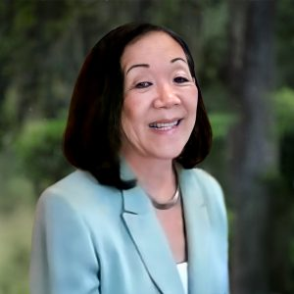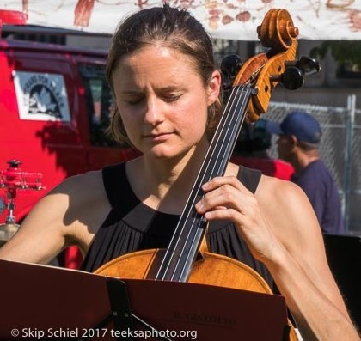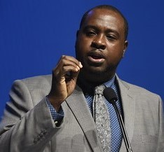

For more information: visit our website – www.idpboston.org

