Christ Episcopal Church
623 N. Fifth St.
Burlington, IA 52601
(319) 752-1381
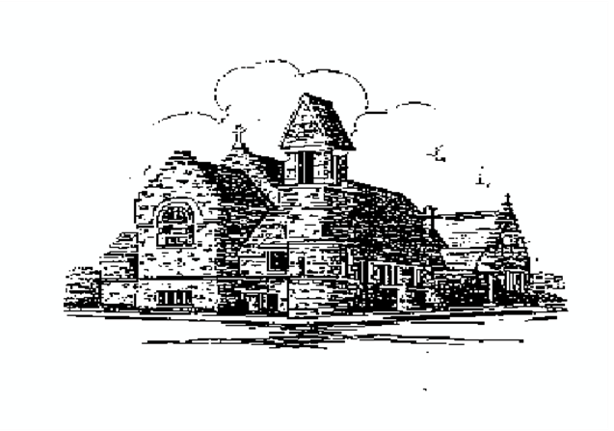
Presents in Celebration of its 175th Anniversary
A Lecture Series on the History of the Episcopal Church

Sunday, October 23, 2016, 7:00 p.m. The English Reformation: Religion and the Tudor State
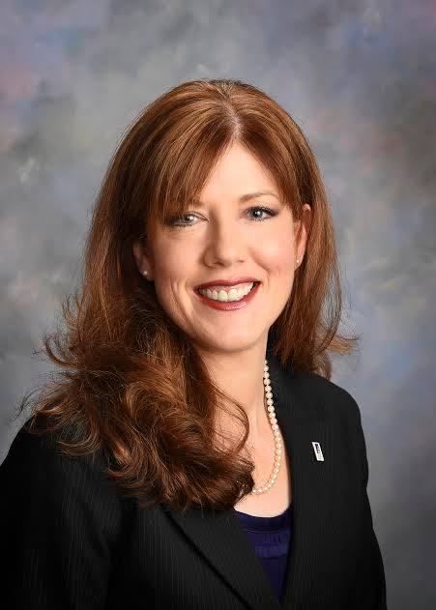
Dr. Jennifer McNabb, Professor and Interim Chair of Department of History at Western Illinois University
Dr. Jennifer McNabb will discuss the sixteenth-century English Reformation under the Tudor kings and queens in England. Dr. McNabb joined Western Illinois University’s Department of History in 2005. She teaches upper-division courses on Early Modern (Renaissance/Reformation) Europe, the History of Britain, Tudor/Stuart England, Topics in British History, and Medieval Europe, as well as introductory courses on World History. She has conducted research abroad in a number of English archives, including the Chester Record Office, the Borthwick Institute in York, the West Yorkshire Archives Service Office at Leeds, the Wiltshire and Swindon Record Office, and the UK National Archives in Kew, located just outside London, and she has published in numerous academic journals and edited collections. Dr. McNabb has also traveled extensively in England and Northern Ireland.

Sunday, October 30, 2016, 7:00 p.m. The Episcopal Church in Early United States History
Dr. Timothy Roberts, Associate Professor of History, Western Illinois University
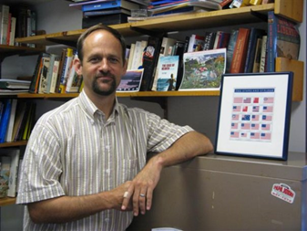
Dr. Timothy Roberts will be lecturing on Church and Religion during the Early American Republic Era (Post-Revolution to Civil War). Professor Roberts’s research focuses on nineteenth-century U.S. and Atlantic history. Joining Western Illinois University’s History Department in 2008, his courses include the Early American Republic/Antebellum era, American Civil War and Reconstruction, as well as American Legal History, U.S. History survey and graduate seminars on nineteenth-century U.S. History. Dr. Roberts has had published articles as well as book reviews in The American Historical Review, The Journal of American History, The Journal of the Early Republic, Patterns of Prejudice, Journal of the Historical Society. He has also written for The History News Network, The Chronicle of Higher Education, and The Diplomat.

Sunday, November 6, 2016, 7p.m. The History of Christ Episcopal Church in Burlington Iowa
The Rev. George Rogerson, Deacon
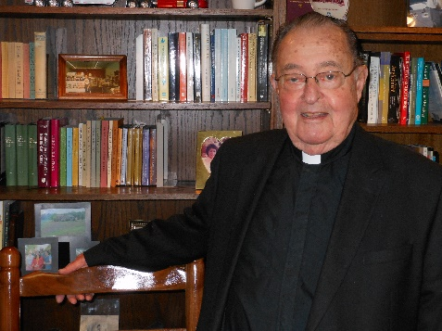
The Rev. George Rogerson served as Deacon at Christ Episcopal Church after being ordained in 2000. As a member of Christ Episcopal Church for fifty-seven years, Deacon George has played a vital role in the spiritual life of the Church. Prior to ordination, Deacon George served various times on the Vestry including the role of Warden. Before a longtime dedication to Christ Church, Deacon George served in the United States Coast Guard from 1948 to 1954 in the Air and Sea Rescue team in Alaska. Following his service to the country, he worked in the automotive industry in Burlington. Deacon George also served on the school board for the Burlington Community School District as well as a trustee on Southeastern Community College's Board of Trustees. In his spare time, he enjoys woodworking and spending time with his family.

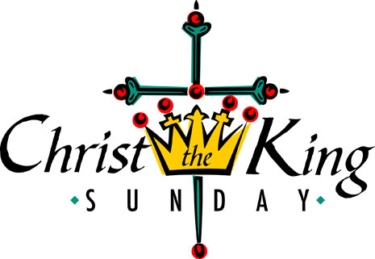
Sunday, November 20, 2016, 4:00p.m. Christ the King Sunday
The celebration will conclude with a special Eucharist beginning at 4:00 p.m. commemorating the Anniversary of the Dedication of Christ Church. The Rt. Rev. Alan Scarfe, 9th Bishop of the Diocese of Iowa, will preside. A reception will follow in the parish hall.

The community is invited to join Christ Episcopal Church as it celebrates its 175th Anniversary in Burlington. For questions regarding the lecture series or Christ the King Sunday, please contact Christ Episcopal Church at 319-752-1381.

