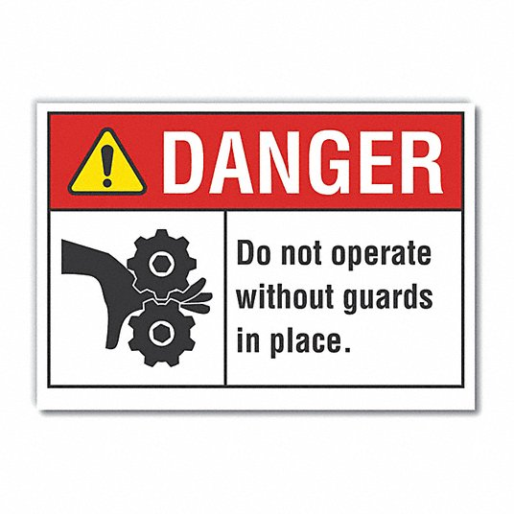
MACHINE GUARDING
Machinery can cause severe injuries like amputations, fractures, lacerations, or crushing incidents. Some injuries can be minor or close calls such as abrasions, sprains, burns and cuts.
How will employees be protected? The employer’s responsibility is to provide a safe working environment to employees. Having Safety Policies and Procedures on machine guarding is key.
Training employees on how to follow machine operation instructions leads to less risk of injury. Employees who understand the hazards can protect themselves from injury by ensuring that machine guards are in place. When training, use the Manufacturers Operating Instructions for the type and location of machine guards you will be working with. Hands on training is very effective when employees are shown what to look for and avoid. Record your training; make sure you have a sign in sheet with the subject you trained and date. Employees who follow the manufacturers operating instructions can ensure that the machinery is being used correctly and safely with all its parts and guards in place. If employees bring their own equipment, make sure to have an inspection checklist to assure its in good working order prior to use.
Making sure employees understand the fundamentals of machine guard safety is key in keeping them safe and at minimal risk of injury.
For more information on Machinery and Machine Guarding, safety questions or concerns, please contact PGM Safety Services, an affiliate company of Pro Group Management. We will be happy to assist when you visit us at www.pgmnv.com or call (800) 859-3177.
