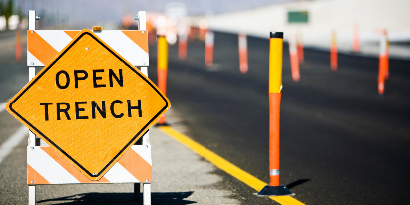

Trenching by The Numbers
While playing in the dirt was fun as a child, some of us still do it for a living. It is important to understand that Trenching and Excavation work is a very dangerous activity. Every company involved in Trenching and Excavation must have a designated “Competent Person” in position to conduct daily inspections of trenches if employees with be working in them.
Provided below are several key numbers that everyone needs to know before you start the job. Do not forget to call before you dig to have underground utilities located. Call 811 several days before the work begins. The competent person must conduct daily inspections prior to entry and in changing conditions. The CP must also conduct soil tests (1 visual, 1 manual) to classify the type of soil.
Numbers to Remember:
2 Feet – The distance the spoil pile, tools and objects must be kept away from the edge / The Distance that walkways must extent past both sides of a trench / The maximum height a trench shield can be from the bottom of the trench.
3 Feet – The distance that a ladder must extend above the top of a trench or excavation.
4 Feet – The depth when ladders or other systems must be used to enter and exit the trench / The depth where atmospheric testing is required to be conducted before entering the trench.
5 Feet – The depth that protective systems, sloping, or benching is required to be used to protect workers in the trench.
6 Feet – The depth that fall protection is required around the trench or excavation.
10 Feet – The minimum distance that equipment must operate from overhead electrical power lines.
15 Feet – Maximum width at the base to be defined as a trench. Greater than 15 Feet considered an excavation.
20 Feet – Maximum depth protective systems can be used without a (RPE) registered professional engineer’s design and stamp of approval.
25 Feet – Maximum lateral distance for any employee to have access to a ladder or egress point
By remembering these numbers, you can do your part to ensure everyone makes it home safely.
For more information on Trenching and Excavation Safety, or other construction safety questions or concerns, please contact PGM Safety Services, an affiliate company of Pro Group Management. We will be happy to assist when you visit us at www.pgmnv.com or call (800) 859-3177.


