Aerial Lifts
Aerial lifts are vehicle-mounted devices or individually powered equipment used to elevate workers. Aerial lifts are used to replace ladders and scaffolds at work sites due to their flexibility and mobility. The main causes of death with this equipment are falls, electrocutions, collapses or overturns.
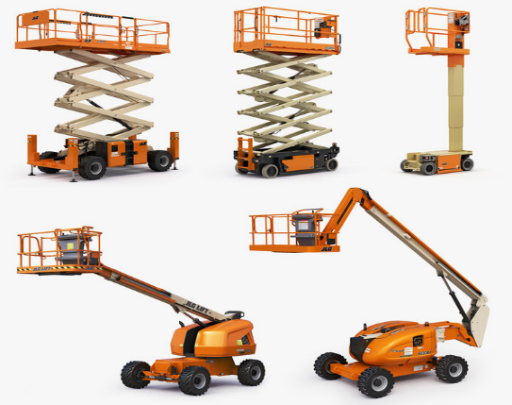
Risks of Aerial Lifts
- Falls from elevated work platforms
- Struck by objects that fall from higher elevations
- Structural overturns or failures (collapses)
- Electric shock (electrocution)
- Ejection from an elevation platform
- Contact with objects, roofs, and other fixed objects
Working practices for added safety
- Ensure that lift operators have training for the safe use of the equipment.
- Maintain and operate air lifts in accordance with manufacturer's instructions.
- Perform an inspection before the start of each work shift to verify that the elevator and all its components are in a safe operating condition.
- Never disable hydraulic, mechanical, or electrical safety devices.
- Workers cannot be placed in a hazardous location, such as between beams and basket rails. The movement of the elevator could crush the workers.
- Keep a minimum of 10 feet away from power lines.
- Treat power lines, cables, and other conductors as if they were always energized, even when they do not work or seem to be properly insulated.
- Use fall protection harness and lanyards connected to the basket/platform to prevent workers from being ejected out of the basket or falling from the platform.
- Apply the brake and use chocks on the wheels when operating or parked on sloping surfaces.
- Use outriggers / stabilizers if so equipped.
- Do not exceed the maximum load capacity of the equipment, always Include the combined weight of the worker, tools, and materials.
For more information on Aerial Lifts and other Construction Industry safety questions or concerns, please contact PGM Safety Services, an affiliate company of Pro Group Management. We will be happy to assist when you visit us at www.pgmnv.com or call (800) 859-3177.


