BLUEPRINT - MARCH

A Convenient, Cost-effective Fitness Solution for Employees!
As part of your Association Health Plan coverage from Prominence, members can enroll in Active & Fit Direct for access to 11,600+ gyms, 7,600+ on-demand videos and 1:1 well-being coaching for an affordable monthly membership fee. There are no long-term membership contracts or hidden fees. Active & Fit Direct is included in all Prominence commercial group health plan options and is easy to implement.

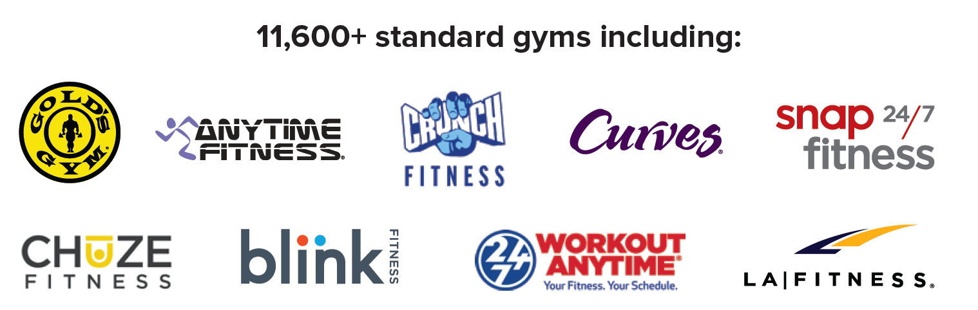

Businesses can enroll in an Association Health Plan from Prominence at any time, regardless of any current health coverage, and offer comprehensive benefits with access to the region’s most loved doctors.

Check out all seven health plans here >

Ready to learn more or request a quote?
Contact Prominence at 855-787-0747 or email PHPSalesTeam@uhsinc.com

