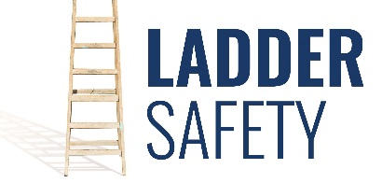
National Ladder Safety Month
If you work in the construction industry, chances are good that you are or will be using a ladder. For some of you, using a ladder is an every day event. Each year there are more than 164,000 emergency room-treated injuries and 300 deaths in the U.S. that are caused by falls from ladders. And did you know that most ladder deaths are from falls of 10 feet or less? So if you have employees using ladders, isn’t it worth your time as an employer to develop a ladder safety training program?
Employers often assume that the workers they hire know all they need to know about ladder use and that there is no need to train them to ensure their safety out on the job. This can be a tragic assumption. Failure to train employees in the safe use of ladders will lead to misuse and probable mishaps that could have been avoided.
What are you doing to make sure your employees have the best understanding of safe ladder use when they are out representing your company? Evaluation of the work environment and knowledge of what ladders are available will help your employees choose the right ladder for the job.
Ladders must be inspected for damage and signs of misuse each time they are placed into service. All parts, including spreader bars, bolts, rivets, rung to side rail connections, the condition of the anti-slip feet and the side rails themselves must be inspected before use. If any part of the ladder is not safe for use it must be removed from service. When removing a ladder from service, it should be tagged “Do Not Use” and locked out. Secure the ladder to ensure that no one can take it back out to the job.
If a ladder is permanently removed from service, it must be destroyed in such a manner as to render it useless. Another person must not be given the opportunity to use a ladder that has been deemed unsafe.
For more information on Ladder Safety, or other construction industry safety questions or concerns, please contact PGM Safety Services, an affiliate company of Pro Group Management, and we will be happy to assist when you visit us at www.pgmnv.com or call (800) 859-3177.

