Welding Safety
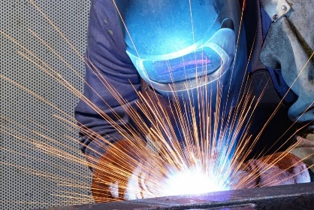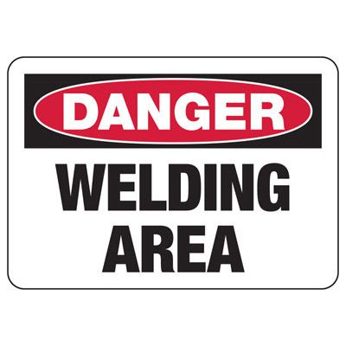
There are many different types of welding applications and knowing what you are welding is of primary importance when selecting the type of equipment to use. Ensure your welders are trained on all manufacturer safety guidelines and OSHA safety requirements found in 29 CFR 1910 Subpart Q for General Industry and 29 CFR, 1926 Subpart J for Construction.
These are some of the major hazards workers may encounter when welding and how to protect against them:
- Fires and Explosions – Ensure welding area is well ventilated and a suitable Class ABC fire extinguisher is on hand
- Burn Hazards – Always wear protective clothing when welding along with proper eye protection
- Electricity – Ensure all cable leads are not damaged or cut. Follow all electrical safety precautions
- Fumes and Gases – Use local exhaust and/or fans to divert fumes and gasses to a safe place
Welders should wear work or shop clothes without openings or gaps to prevent arc rays from contacting the skin. Employees working close to arc welding should also wear additional protective clothing. All clothing should always be kept dry, including gloves. When applicable, welding screens should also be used to protect others from the heat, hazardous light and fumes produced from welding. Comfort is a very important part of welding. No matter what welding technique you choose, being comfortable is key to good welding. Find a comfortable position and something to brace with while welding. The goal is to stabilize your body and hands, so you have full control over your safe welding technique.

For more information on welding safety, or any other safety questions or concerns, please contact PGM Safety Services, an affiliate company of Pro Group Management. We will be happy to assist when you visit us at www.pgmnv.com or call (800) 859-3177.


