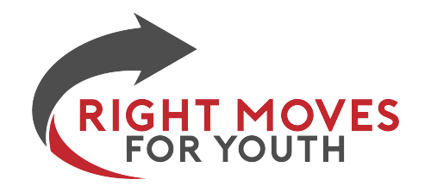

Volunteer at the 2025 PGA Championship & Support Right Moves For Youth! ⛳️
Be part of a major golf event and help a great cause!
Volunteer at a concession stand during the 2025 PGA Championship, and every hour you work helps Right Moves For Youth earn funds to support local students!
📅 Dates: May 12 – May 18, 2025
⏰ Shifts:
- Opening Shift: 6 AM – 4 PM
- Closing Shift: 9 AM – 7 PM
(Plan for parking + shuttle time)
📍 Requirements:
✅ Must be 18+
✅ Able to lift up to 10 lbs
✅ Must commit to the full shift
✅ Wear: Black bottoms, black shoes, white shirt (apron + hat provided)
✅ Volunteer parking at Carolina Place Mall (shuttle provided)
✅ Free lunch + breaks included
🔹 Mandatory Orientation Training: All volunteers must attend a 1-hour Zoom training a few weeks before the event. This will cover schedules, expectations, and logistics.
🔹 Be a Sub! Sign up as a sub and be on call if a volunteer spot opens up.
Sign up here: Sign-Up Genius
Questions? Email Amanda: aschneider@rightmovesforyouth.org

